



**SM6P07NI Digital Media Project**

**50% Individual Project**

**2022-23 Spring**

**Student Name: Ashraya Singh Khatri**

**London Met ID: 19031980**

**College ID: NP01MM4A190077**

**External Supervisor: Pooja Shrestha**

**Internal Supervisor Rakshak Bhushan Bajracharya**

**Assignment Due Date: Wednesday, Aril 26, 2023**

**Assignment Submission Date: Wednesday, April 26, 2023**

**Word Count: 2954**

*I confirm that I understand my coursework needs to be submitted online via Google Classroom under the relevant module page before the deadline in order for my assignment to be accepted and marked. I am fully aware that late submissions will be treated as non-submission and a marks of zero will be awarded.*

**Abstract**

This documentation gives a brief overview of the research and development aspect of the project for Digital Media Project (DMP). The content of this document provides a thorough explanation to the topic of the DMP, i.e., Low Poly Game Assets. It further explains the use of low poly modelling by indie game developers and it’s rise in the video game industry.

In the field of gaming industry and 3D animation low poly modelling has been an art from the very beginning since low polygonal resolution helps to reduce the render time and greatly speeds up the processing time to model the characters and props. Indie game developers these days mostly choose to create a game with low poly art has it gives them more time to model them and aren’t bothered by deadlines. Artists love to create their own 3D world, but not everyone knows how to model, so they download pre-made assets from resources like Unity or Synty studios. By using these assets, they can customize their scenes as they want and focus on other aspects like lightning, compositing, as can work on their work.

The following documentation contains the research to create a low poly stylized asset used for games. With the help of my supervisors, Rakshak Sir and Pooja Ma’am, I was able to finalize my concepts. My concept for DMP is to create low poly animations and models as assets to be used in-game development. This project will showcase all the research, and software to complete the project.

Contents

Introduction 1

Topic 2

Stylized Low Poly Assets 2

Aims of Project 3

Area of Research 4

3. Target Audience 6

3.1 Primary Target Audience: Game Designers/ Indie Artist 6

3.2 Secondary Target Audience: Gamers 6

4. Product Research 7

4.1 Blender Tools and techniques 7

4.2 Lighting Techniques 17

4.2.1 Key light 18

4.2.2 Fill light 19

4.2.3 Rim Light 20

4.3 Render Engines 22

4.4 Similar Product reviews 27

5. Technologies employed 30

6. Project Plan 31

7. Resources 33

8. Production Phases 34

Game development Life Cycle 34

8.1 Pre- Production 35

8.1.1 Concept Art and rough sketches 36

8.2 Production 37

8.2.1 Low Poly stylized Rocket 37

8.2.2 Low poly stylized house 46

8.2.3 Low poly stylized car 52

8.2.4 Low poly stylized witch room 58

8.2.5 Low poly stylized hammer 69

8.2.6 Low poly stylized outer space 76

8.2.7 Low poly stylized campfire 86

8.3 Post Production 102

9. Conclusion 103

10. Bibliography 104

**Table of Figures**

Figure 1 Reference of Fire camp 4

Figure 2 Reference of a house 4

Figure 3 Reference for prop 5

Figure 4 Bisect Tool 7

Figure 5 Knife tool 8

Figure 6 3 tips to increase low poly 9

Figure 7 Transferring animation data 10

Figure 8 Low poly Viking hut 13

Figure 9 Principal BDSF shader 14

Figure 10 Node Editor 15

Figure 11 Applying nodes to the object 16

Figure 12 3-point lighting 17

Figure 13 Key lighting 18

Figure 14 Fill light 19

Figure 15 Rim light 20

Figure 16 All 3 lights used properly 21

Figure 17 Eevee render engine 22

Figure 18 Bloom 25

Figure 19 Screen Space reflections 26

Figure 20 Previous timeline chart 31

Figure 21 New Timeline chart 32

Figure 22 GDLC 34

Figure 23 Concept art 36

Figure 24 Modelling of jet 37

Figure 25 creating landscape 39

Figure 26 editing animation loop 41

Figure 27 adjusting the light 44

Figure 28 modelling house 46

Figure 29 adjusting the light 50

Figure 30 editing the background 52

Figure 31 modelling the car 53

Figure 32 adjusting particle effect 54

Figure 33 editing animation loop 56

Figure 34 adjusting light source 58

Figure 35 modelling room's window 60

Figure 36 modelling low poly stones 61

Figure 37 modelling a brew 64

Figure 38 adjusting the camera 65

Figure 39 adding point lights to the scene 66

Figure 40 reviewing on material preview 67

Figure 41 adjusting transmission on node 68

Figure 42 final output 69

Figure 43 adjusting the bevel weight 70

Figure 44 using decimate modifier 71

Figure 45 handle for the hammer 72

Figure 46 using the bisect tool to model stones 73

Figure 47 adjusting the lighting 75

Figure 48 final output 76

Figure 49 using the displace texture 78

Figure 50 duplicating the asteroids 79

Figure 51 adjusting the camera 80

Figure 52 adjusting the animation 81

Figure 53 adding mix shader to the tail 82

Figure 54 creating outer space 83

Figure 55 instancing the stars 84

Figure 56 applying outer glow at the node editor 85

Figure 57 Final output 86

Figure 58 adjusting the values for emitter 87

Figure 59 creating the plane using proportional editing 89

Figure 60 adding displace texture 91

Figure 61 using the multiply shader 93

Figure 62 duplicating and adjusting the materials 94

Figure 63 applying shader to bush 95

Figure 64 applying shader to fire 96

Figure 65 adding cube for fog 97

Figure 66 adjusting the light 98

Figure 67 checking the scene 99

Figure 68 adding turbulence 100

Figure 69 final output 101

# Introduction

This document carries a brief overview of the second coursework for the module “Digital Media Project (SM6P07NI)”. The course covers 50% of the total assessment weight. For this semester the students are required to complete their individual projects and provide their internal and external supervisors the documentation, project files and google drive folder link which should contain overall production process, evidence, and testing of the project.

As mentioned in the previous document, the field of gaming development is a very vast one. But as the future for the gaming industry is on the rise, so have the artists. Many new and upcoming game developers are trying and making their own games. As an Indie game developer, they share knowledge, research and feedback, provide testing for one another. Therefore, this documentation covers the research and knowledge of an individual for creating game assets. It further covers the target audience, the software used, and the resources and techniques used to complete the project.

# Topic

## Stylized Low Poly Assets

The topic for my project is “Stylized Low Poly Assets” was inspired by numerous low poly asset packs which were being placed up by Asset artist who were creating amazing and entertaining looking assets for people to enjoy. It contains various different asset pack with different genre for everyone to enjoy.

The overall goal of the project is to provide multiple asset packs to individuals so that they can modify their own games utilizing these pre-made models. The project includes eight different asset pack that can be used in a variety of different game settings and environments. These low poly assets pack include 3D models, animation, special effects and particle effects. They’re awesome way to keep the games art looking consistent. The stylized art style gives it a unique visual design.

# Aims of Project

The aim of the project “Stylized Low Poly Asset’ is to simply create a low poly asset pack for the user, as it would lessen their production time and they will be able to finish their project in a faster and efficient way. Since there is rise of many assets’ packs in the internet this not only helps the user to save their time and increase their productivity, it also allows other who don’t have skills in the field of 3D and want to engage in it.

There is a production phases to create assets. There is the pre-production phase where the concept art, storyboard, references and functionality of the game is decided. After the finalization of the concept, during the production phases the production of the project is started. The process of creating assets includes, modelling mapping, UV baking, texturing, shading, lightning and compositing. So, there are many processes out there in the field of 3D. It is very vast and needs a deep level of creativity and understanding which might be time consuming and hard for many. Thus, the market of assets being available as a valuable research are very growing in the video game industry.

The low poly stylized asset includes a variety of different modular meshes, including campfire, outer space ship animation loop, car loop animation, tavern dungeon model and weapon packs. This allows the user to easily modify their game environment without having to focus on modeling and texturing. Low Poly is becoming more and more popular amongst Indie game developers’ these days, since it is less expensive and easier to create a game on. It decreases their cost and helps boost their production time and quality of the game. They can focus more on their game without worrying about their deadline and boost the quality of the game.

The goal of this project is to make a specific set of stylized assets that an Indie game developer can use it. If a game developer or a player who wants to mod their games or required assets which can be used in certain different gaming scenarios, then this is where the collection of the stylized asset pack comes to play. This helps the game to be more customizable and make the game look unique and beautiful by adding the personalized assets.

Finally, the key objective of this asset pack is to assist the game designers and people who want to learn and utilize more 3D as a stylish game packs that are easily usable and customizable. I hope that the project will also motivate more individuals to learn and experiment with 3D modelling and animation, as well as develop their own unique and creative products.

## Area of Research

The field of game industry is a very vast one. So, the amount of research and creativity is a very large one as well. Form modelling, lightning, texturing, to worldbuilding these topics had to be properly researched before starting the project. Firstly, I researched reference for the modeling.

After I properly researched and used the reference for modeling and started the process. Since, my shading is stylized low poly I began researching and collecting references for it as well. Thus, the research for modeling includes witch’s brew, dungeons, rockets, etc. In addition to the modelling, I wanted to provide animation loop for user could use in their required scenario.

As to further stylize the assets of specific shader there had to be followed to specific modeling with low sculpting and lightning to give it that look. After all the assets and textures that was created for the project were assembled in Blender. Therefore, there was extensive research for the use of the software with proper knowledge of lightning, texturing, shader setup.

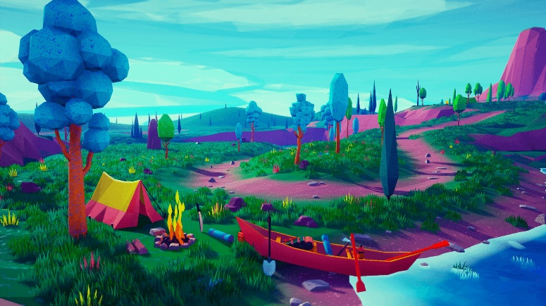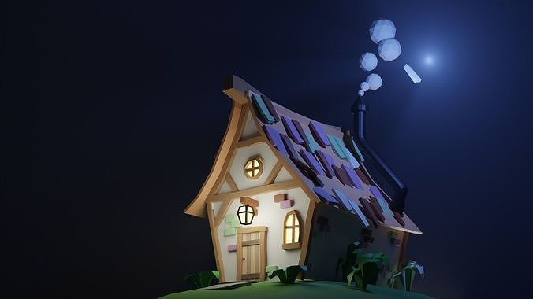

Figure Reference of Fire camp

Figure Reference of a house

In the images above, on the first one we can see it shows a stylized house with a dark background that focuses and brings more detail to the cottage. As seen in the second image, there is a campfire in the forest with several different color palettes, and the model is utilized as a single material and a texture map with a number of color palettes arranged. So, as such being inspired from this style I have taken them as a refence for the project.

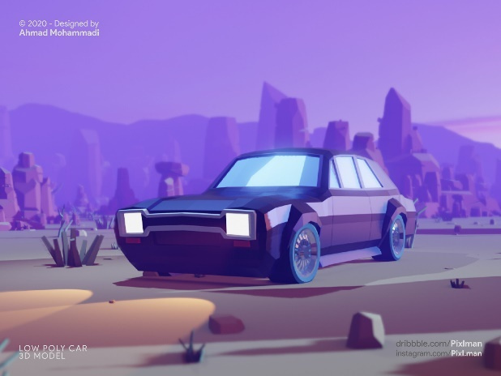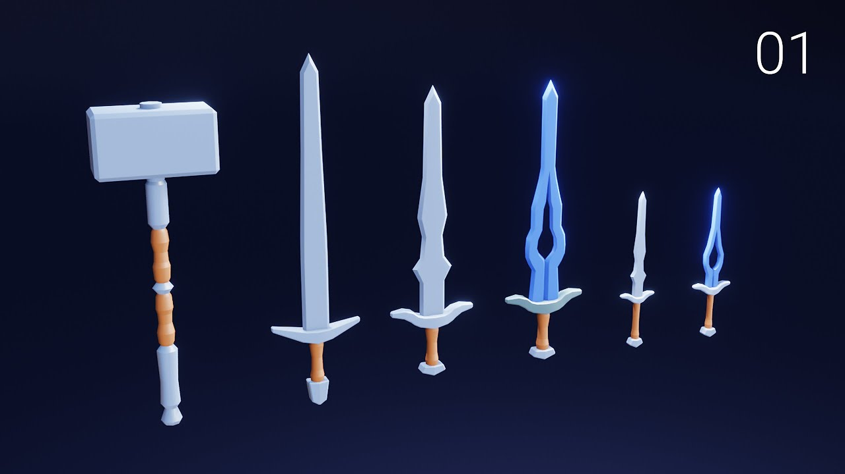

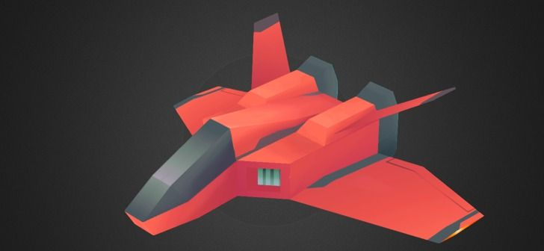

Figure Reference for prop

So, to model and animate different asset packs for various game scenarios, I have researched on various low poly models and watched videos and studies about them. Form the above references images, I got the idea and inspiration to model my assets for the project.

# 3. Target Audience

Identifying a target audience is very essential in a project production, there are two distinct audiences which have been researched for this project. Their details have been approached as follows:

## 3.1 Primary Target Audience: Game Designers/ Indie Artist

**Age:** 15 + above

**Gender:** All genders

**Ethnicity:** All Ethnic group of people

**Location:** Throughout the world

**Genre Specification:** Stylized Low Poly pack

As per the research and objective of the project, the primary targeted audience are comprised of the age group from 15 and above. As the process of creating asset is time consuming and leads to being hectic at times. The process of creating assets can be prove useful for them as they can be used for building their own games. This allows them to utilize their time and focus more on their production.

## 3.2 Secondary Target Audience: Gamers

**Age:** 15 + above

**Gender:** All genders

**Ethnicity:** All Ethnic group of people

**Location:** Throughout the world

**Genre Specification:** Stylized Low Poly pack

As per the research and objective of the project, the secondary targeted audience for the product are gamers or people interested in the field of 3D modelling. As there are gamers or viewers who want to use different 3D modelling software to customize their games. In gaming Industry modification of a game is very popular. Gamers or modders can use the assets and customize the games as their choice and release it in the market.

# 4. Product Research

## 4.1 Blender Tools and techniques

While researching the contents for my DMP, I came across a new software that was not taught to us here in college. I used Blender to complete my project, and I acquired many new tools and techniques from there which I have employed in my project.

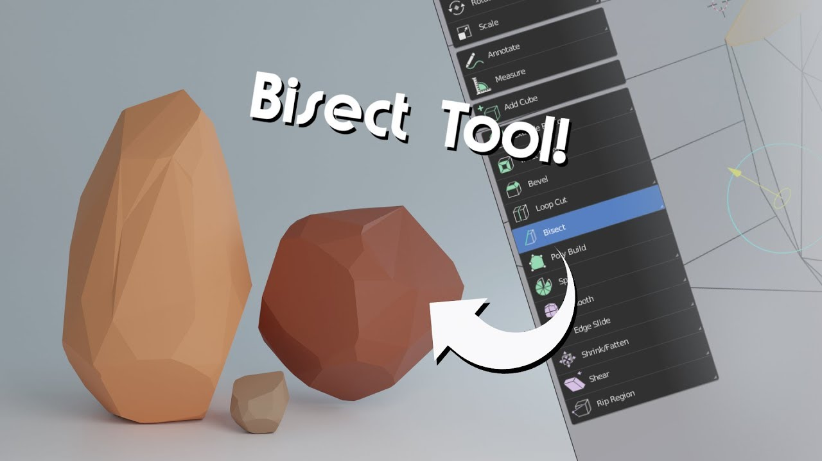

Figure Bisect Tool

As I started Blender, I leaned many new tools and techniques. Bisect tool is a very useful for low poly modelling. It helps in a quick way to cut a mesh in two along a common line. After selecting the object, we can bisect it in any three-dimensional axis. The tool allows us to bisect the object to clear in or clear it out. Clean in or clear outer removes the geometry on one side. Whereas the option fill allows us to cuts which can optionally make up the gaps they create with materials, UV maps, and vertex colors dependent on the geometry around them. I have used the bisect tool in my project to model low poly stones.

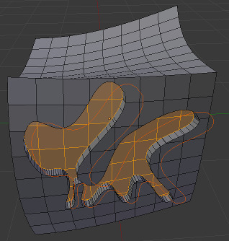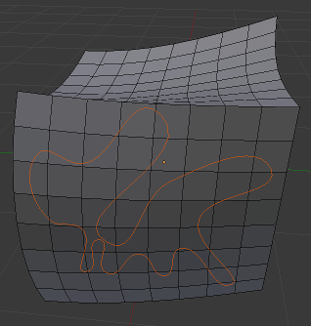

Figure Knife tool

Another very useful tool is the knife tool. The Knife tool can be used to reroute geometry in order to clean up the overall mesh topology. While activated, you can freely "draw" a series of vertices along many faces around your object. Begin by selecting an object and going into Edit Mode.

To activate the new edge, press Enter. The vertices you've added to your mesh are now active and modifiable. This gives you a lot more options than just using the loop cut tool. With the knife tool, any shape can be manually applied to a mesh.

To activate the new edge, we can press enter. The vertices which are added to the mesh now become active and modifiable. This allows us a lot more options than just using the loop cut tool. With the knife tool, any shape cab be manually applied to a mesh. (ex NIHILO digital, n.d.)

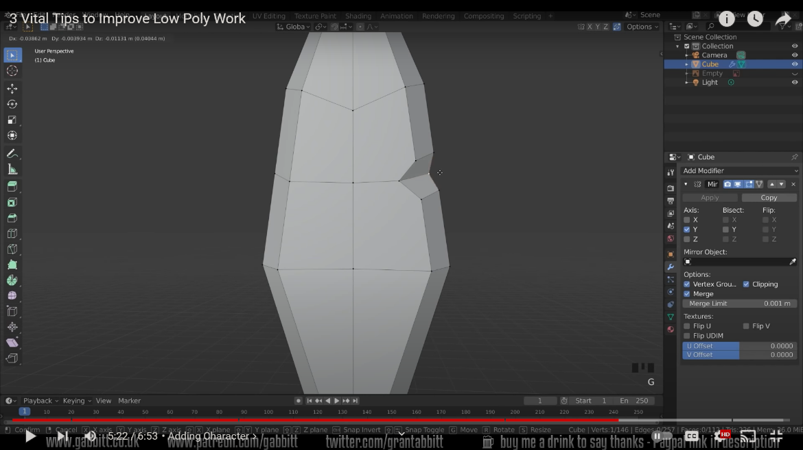

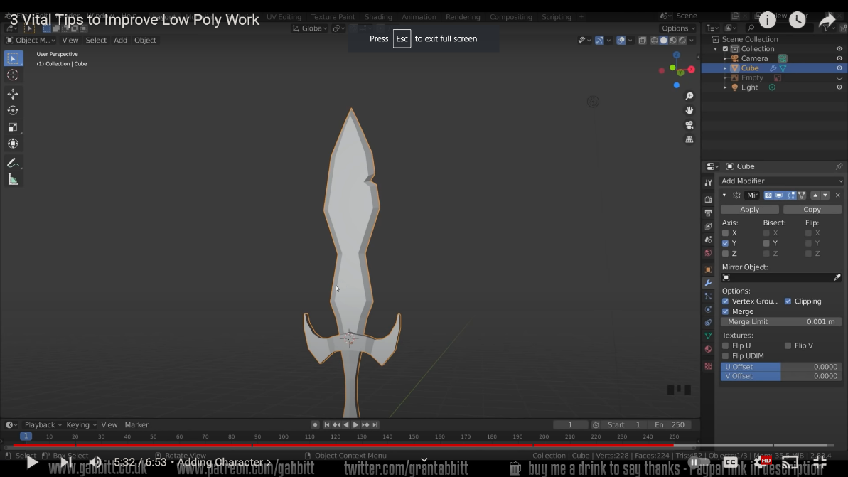

Figure 3 tips to increase low poly

Making a low poly model and giving it a more stylized look by adding and toying with the edges and beveling allows us to add a little more character. Bevels are simple to create, especially in low poly shapes.

While making a low poly model if we want to give it a more stylized look we can add play with the edges and vertices, then bevel it as it allows to add a little more character to the object. Bevels are simple to create, especially in low poly shapes. (Abbitt, 2021)

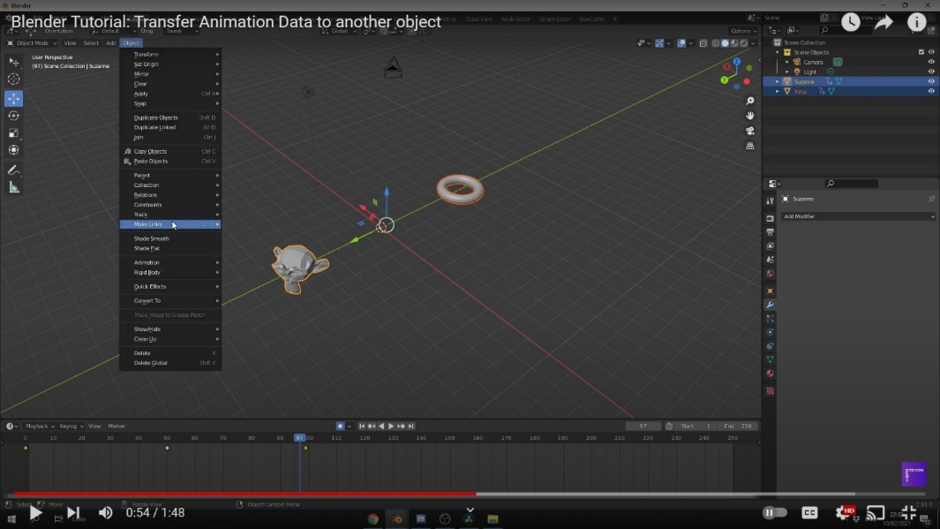

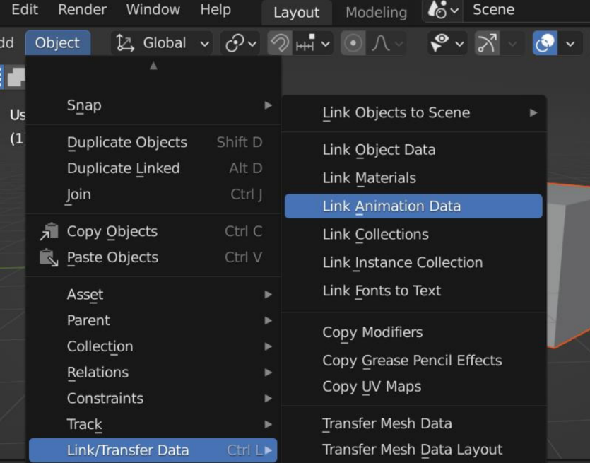

Figure Transferring animation data

Since, I am also making short animation loops, I am going to use the same animation data at three or four similar objects. For this I have researched how to copy and transfer animation data from one object to another. To copy and transfer data from one object to another we can follow the following steps as mentioned below: (Nguyen, 2022)

* Firstly, go to the Object
* Then scroll down to the Link/Transfer Data
* Then after we can transfer the animation data

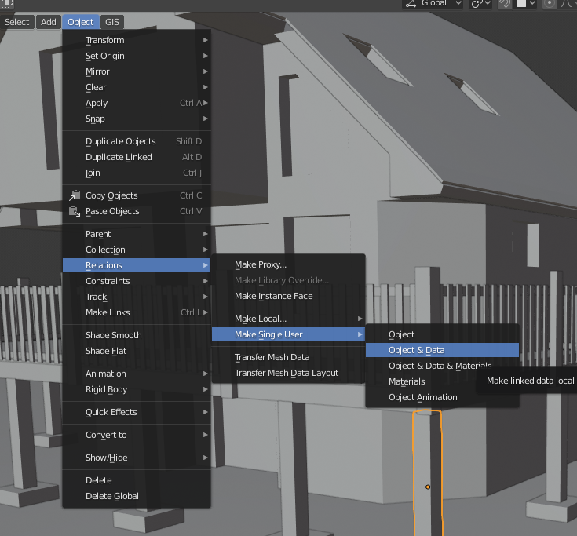

Then the animation data is now linked between the two objects. Whatever the animation data of the selected object is, the transferred object will have the same results. But, the linked animation data can also be changed from one object to another. To do so, select the object copied animation data to ‘Single User’. On the top menu, we can simply go to Object > Relations > Make Single User > Object Animation. This allows us to edit the animation of each object without affecting the other.

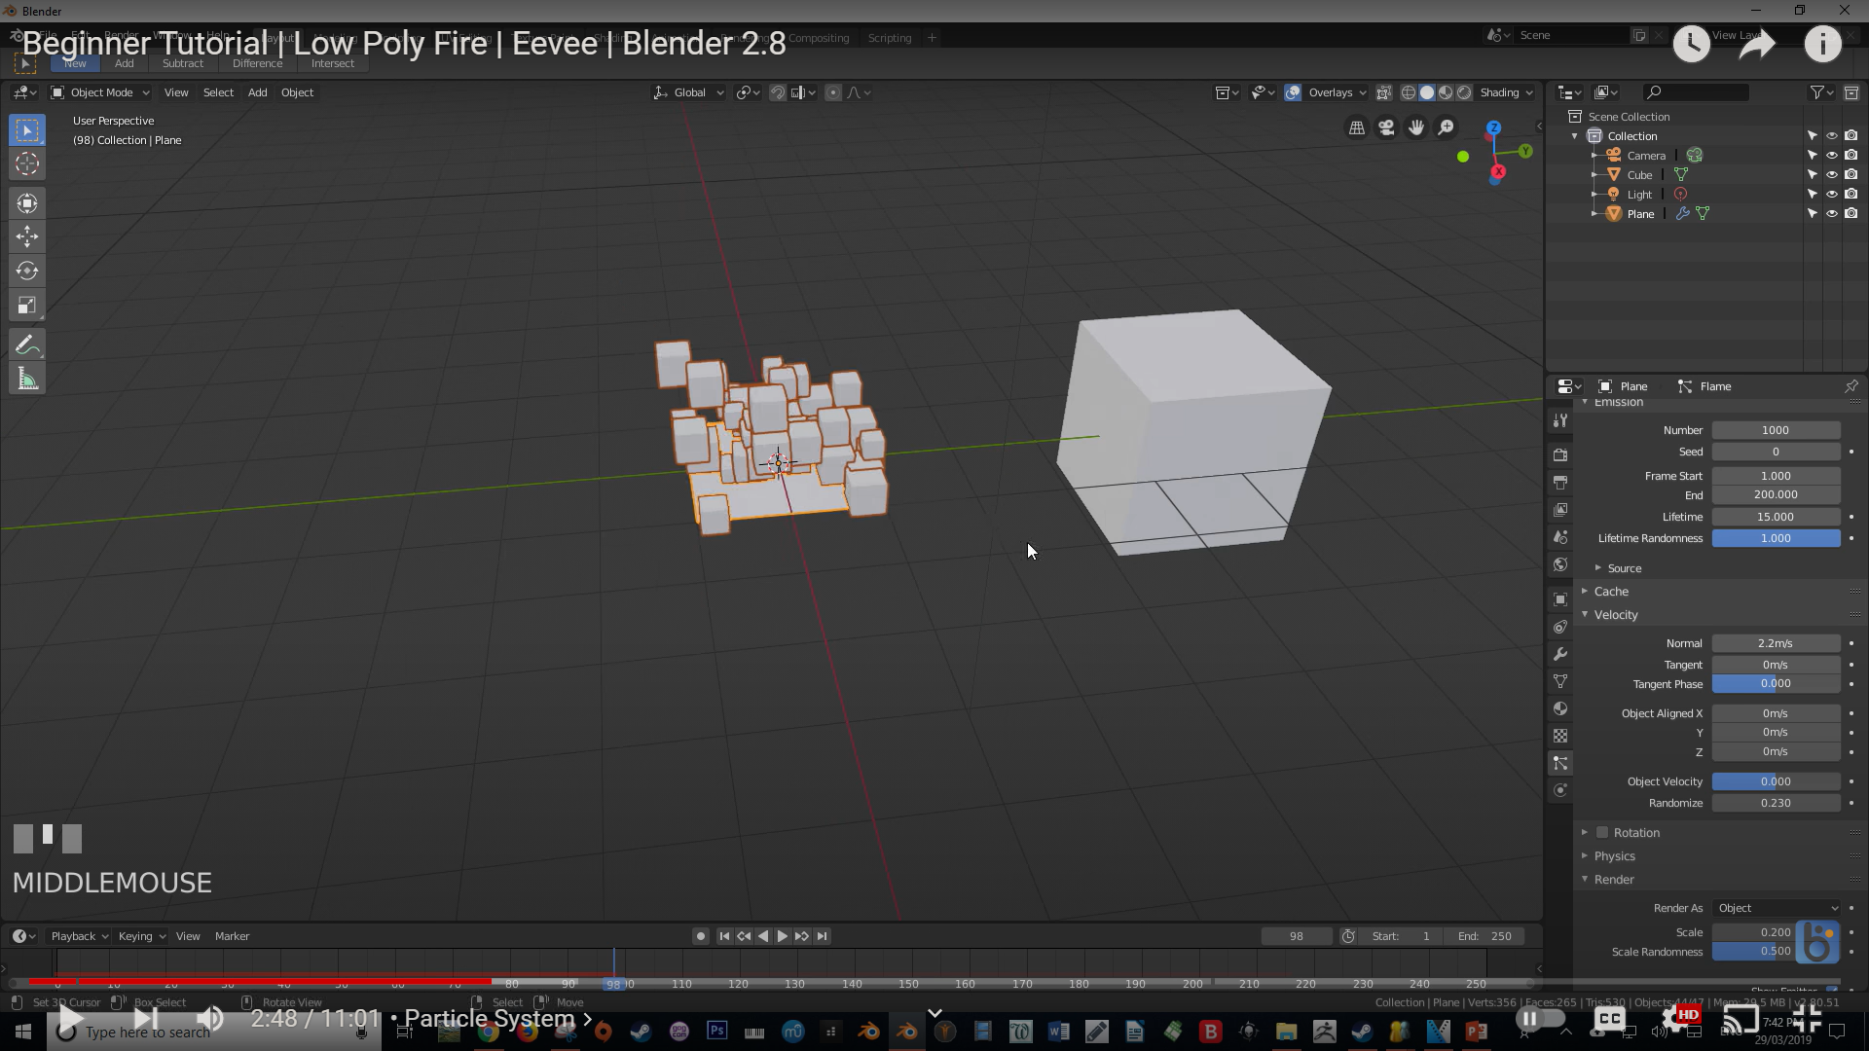

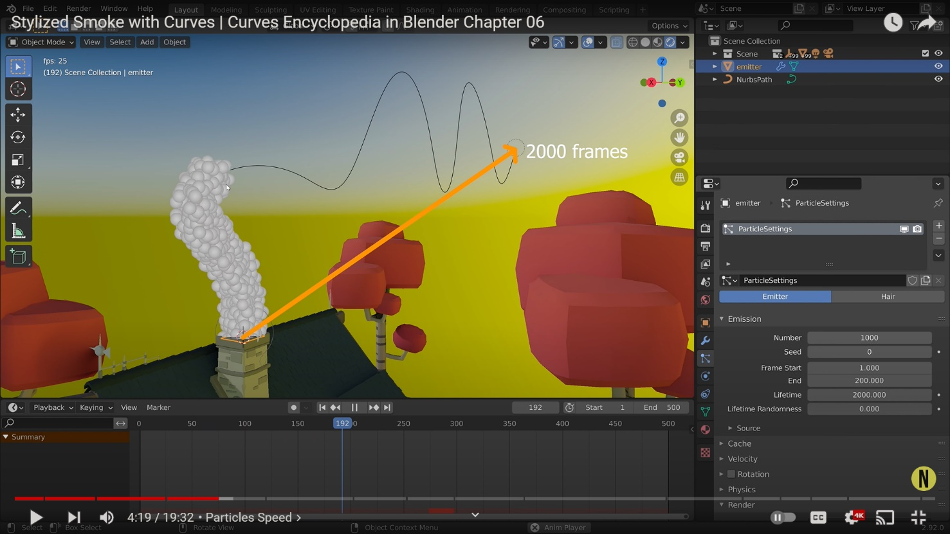

To initiate particles for my project, I have researched more about particle systems. By selecting the object, we can add a new particle system. Then we can play with its emission. We can arrange the Lifetime, velocity and physics. We can set the render to object as it allows us to instance the particles and play with its scale. Such we can change the gravity to make the particles per our environment. (Kottmann, 2020)

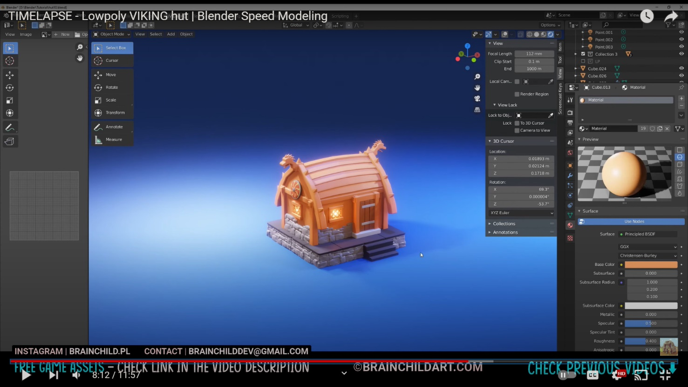

Figure Low poly Viking hut

In Blender, materials are the objects that are generated with color, pattern and texture. Shader Editor can be accessed through the Shading tab. The preview is shown on the top screen, while the Shader Editor is shown at the bottom.

The material can be added in edit mode. These switches inform Blender where this material belongs into the Render Pipeline, and which aspects of it should be rendered. There are different materials in which we can render the objects. (brainchildpl, 2020)

Surface materials allows us to render object as a surface. Wire material allows us to render the edges of faces as wires. Volume allows us to render objects as a volume. Halo render halo particles.

# 

Figure Principal BDSF shader

If after selecting an object if nothing appears, then then the object lacks material. After clicking the new “+” button at the bottom of screen, a Material is created and a node is automatically created.

The note must be attached is the Material Output node. This node’s connection will be reflected. The default shader is Principal BDSF. The default shader should be disconnected, and after creating another node, drag a line from “BDSF” on the right side of the required node to the material output. (STYLY MAGAZINE, 2020)

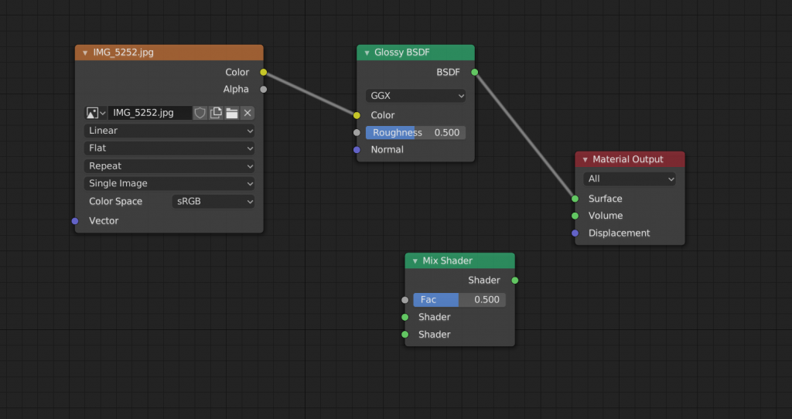

In Node editors it is also possible to combine multiple Shaders.

To do so type [Shift]+[A], then Shader, then Mix Shader. This is the node that will serve as a Shade converter.

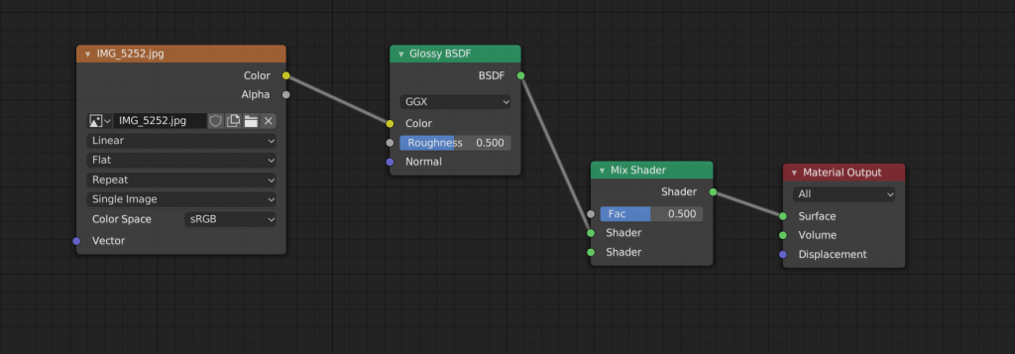

Figure Node Editor

Drag the mix shader node between Glossy BDSF and Material Output.

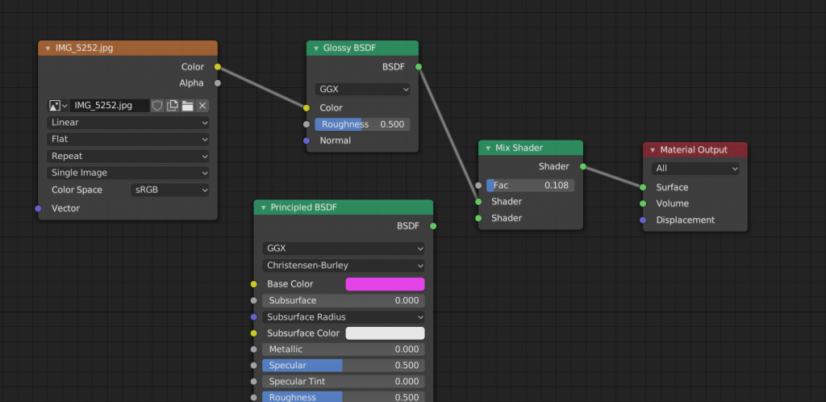

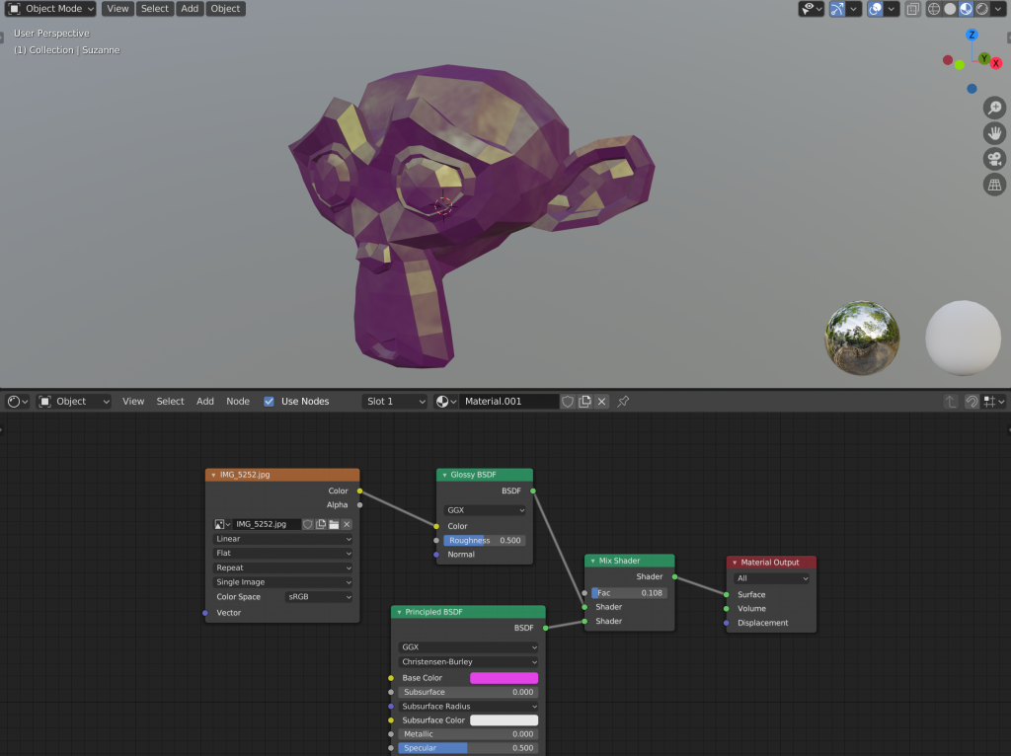

Figure Applying nodes to the object

Then another shader is added to the mix. Link the NDSF on the Principle BDSF right side to the shader on the Mix Shader’s left side, leaving two nodes connected to the Shader on the Mix Shader’s left side.

## 4.2 Lighting Techniques

Lighting is one of the most important aspect of 3D modelling to make your scene look more presentable to the audience. It plays a very vital role in pointing out the details and sudden changes in the mood of the scenes to your audiences.

In the world of 3D modelling, 3-point lighting is one of the foremost used technique to make your scene look good.

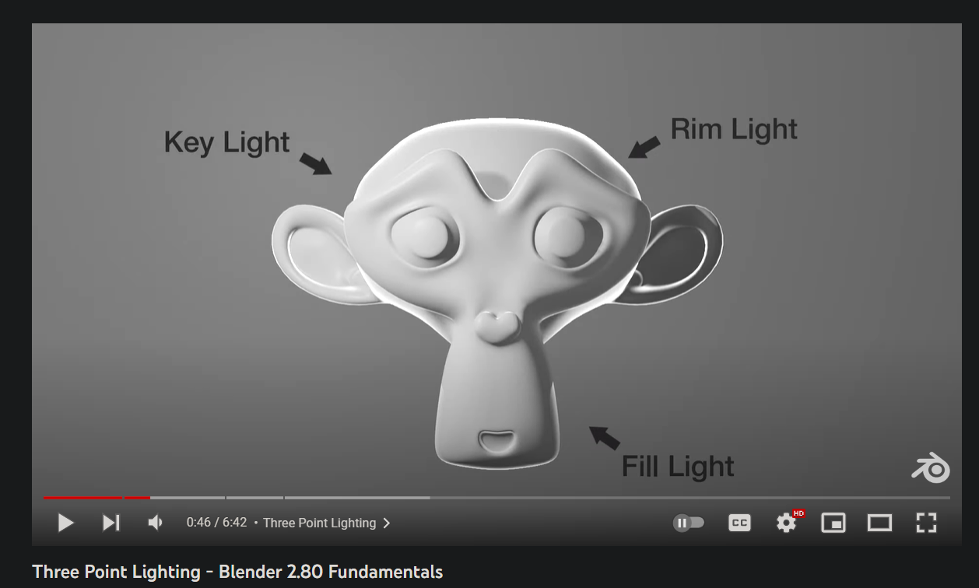

Figure 3-point lighting

Among the three-light source, the key is light is the primary source of light. It is the primary light source which defines the scene. The fill light softens the shadow that the key light casts upon the mesh. It is the least bright light source amongst the three. It is important because it prevents the shadow from being too dark on the subject. Rim light also known as the back light is cast on the backside of the subject. It is the brightest light amongst the three. It usually just gives a slight touch of brightness on the edge of the subject. This helps the subject stand out from the background. (Blender, 2019)

### 4.2.1 Key light

It is the first and the most important light source. It is critical for establishing overall lighting for the scene. It should be the most intense light of the three, and should focus on the subject’s form and its depth.

It is normally set up at a 45 – degree angle to right of the camera. While this setting may work for most of the time, it is very dependent on the scene and varies from every 3d artist.

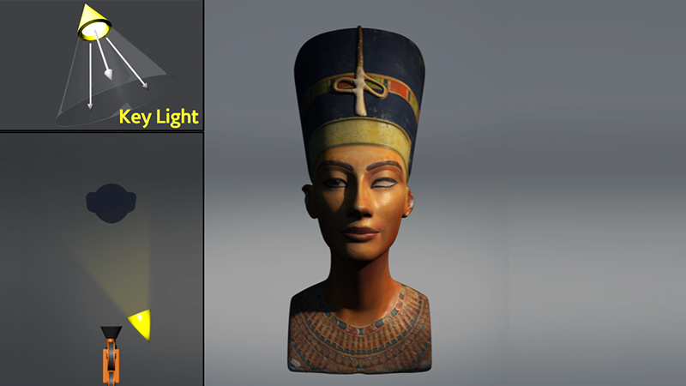

Figure Key lighting

### 4.2.2 Fill light

The goal of the Fill light is to fill in the deep shadows which is cast upon the subject by the key light. It is often placed on the opposite to the primary light and has lower intensity. Having the fill light’s intensity set too high might cause the scene to be blown out. Setting the fill light just to be bright enough to illuminate the areas where the key light cannot reach is very essential. This helps the detail to be more visible, and gives the shadow a depth

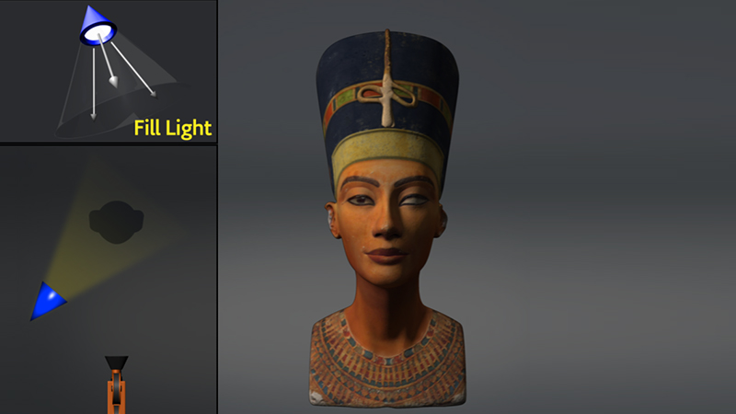

Figure Fill light

### 4.2.3 Rim Light

Make sure the rim light does not cast any direct light on the subject. If you hide the key and fill lights, you'll notice that the subject is darkened all around save for a little glow around the margins.

The rim light also known the back light is the final spot light. It is often placed behind the subject. It mainly faces the camera which provides the least amount of illumination effects. While changing the angles of the camera may help to create the desired effect for the scene. Its main purpose is to create a very subtle glow to the back of the subject. Making sure the rim light does not cast any direct light on the subject is very important. This allows the subject to gives a pinch of brightness to glow up the scene.

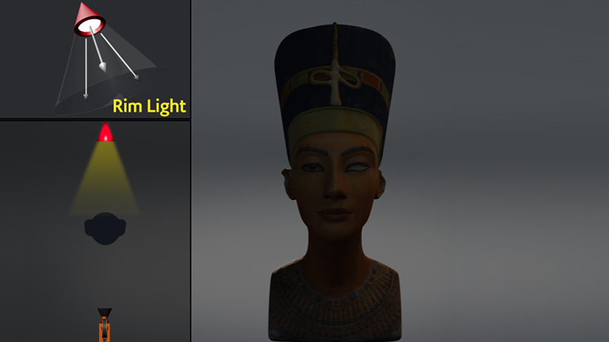

Figure Rim light

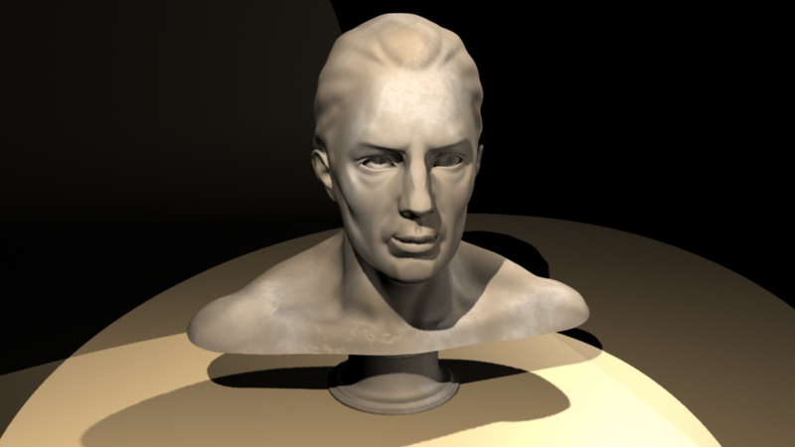

Figure All 3 lights used properly

The approach to the 3-point lightning has taken the world of 3D. It has been seen in a numerous of contexts, including product visualizations, character t-pose, etc. Due to the unique lightning results which can be achieved relatively rapidly, it has quickly become more and more the go-to lighting techniques for many 3d projects. In addition, while creating a still image or spotlighting a single product or mesh, 3-point lighting is very ideal which helps to achieve a studio- like lighting aesthetic.

It depends on the subject which is being illustrated (or the absence of a background), altering the settings in contrast to the subject rather than the background proves to be much more convenient. This is due to the lights may have bad results on the background. (Pluralsight, 2014)

## 4.3 Render Engines

There are two render engines in Blender, Eevee and Cycle. For my project I have decided to use Eevee. It is a Realtime render engine developed with OpenGL which focuses on the speed and interactivity while rendering PBR materials. It is used interactively in the 3D Viewport, but can also generate high – quality final outputs.

It is not a raytrace render engine. Instead of processing each ray of light, Eevee uses a technique which is known as rasterization. Many techniques are utilized in rasterization which approximates how light interacts with the objects and materials. While Eevee is intended to follow the PBR concepts, it has its own shortcomings. (Blender, n.d.)

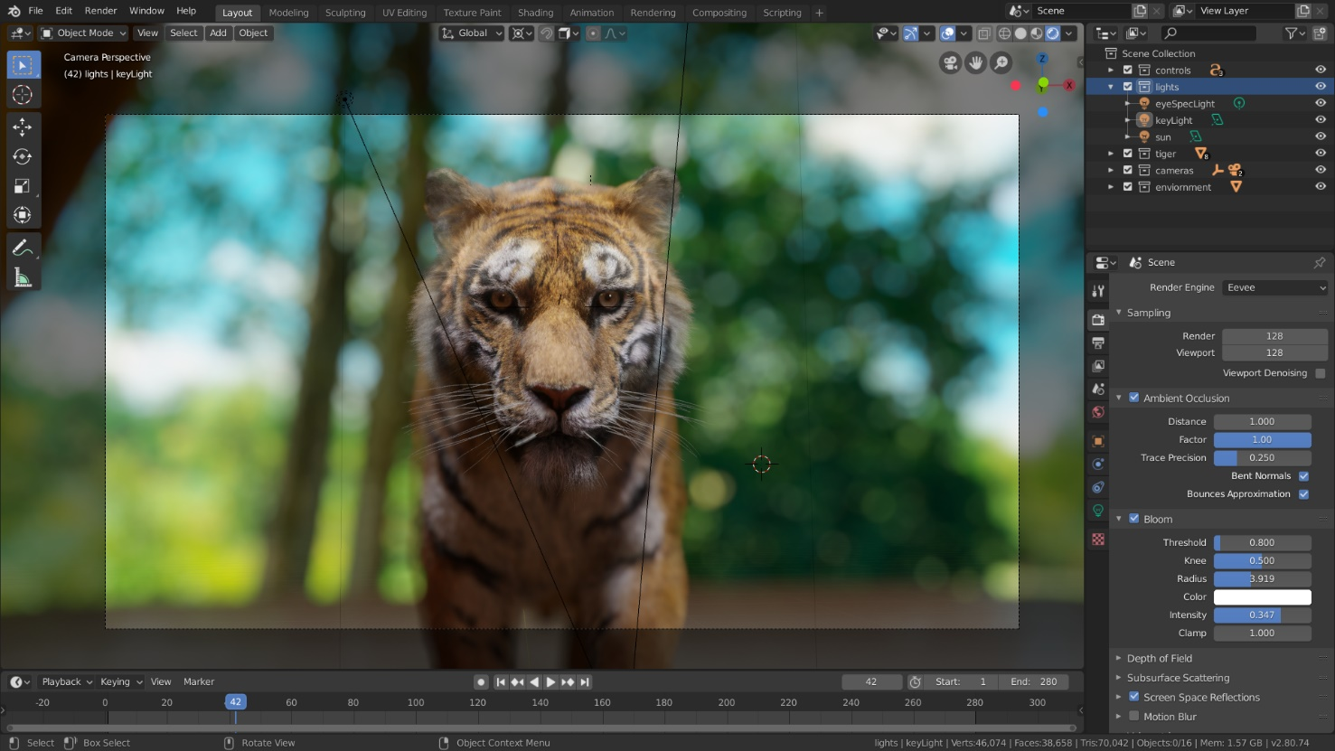

Figure Eevee render engine

In Eevee render engine, GTAO is used in order to calculate the ambient occlusion, which is then used to indirect lighting. In the render layers tab, we can render ambient occlusion as a distinct pass.

There are many settings that need to be played with while using ambient occlusion panel. This effect must be used in order for the Ambient Occlusion node to work.

Distance: It calculates the distance between the object and the ambient occlusion effect.

Factor: Determines the blending factor for the ambient occlusion effect.

Precision Trace: This increases the effect precision but also intrudes new additional noise which reduces the maximum trace distance. It increases the precision rate alongside the cost of performance. The lower precision may also result in occludes being missed and may cause under shadowing.

Blending Normals: It determines the least obstructed direction.

Bounce Approximation: It is an approximation for simulating the light bounces, which then results in less brightness or occlusion of objects. It just considers the surface hue and not it’s surroundings. The ambient occlusion pass does not get affected by this.

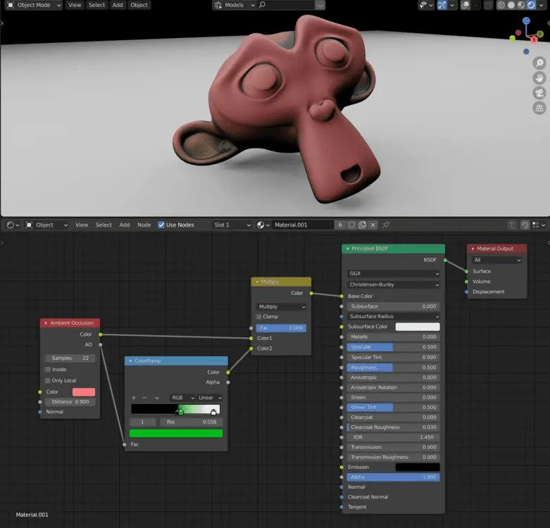

Bloom is a post- processing effect which softens extremely bright pixels. This simulates the lens artifacts which is seen in real life cameras. This allows a proper knowledge of the true intensities of the pixels.

While using Bloom Rendering Panel these are the effects that should be handled.

Threshold: this filter removes pixels which are way too dark.

Knee: This allows for a more gradual shift from beneath to over the barrier. This measures the spread distance of the radius Bloom.

Color: It is the color used in the bloom effect.

Intensity: It calculates the intensity of Blend Factor.

Clamp: It calculates a bloom pixel’s maximum intensity.

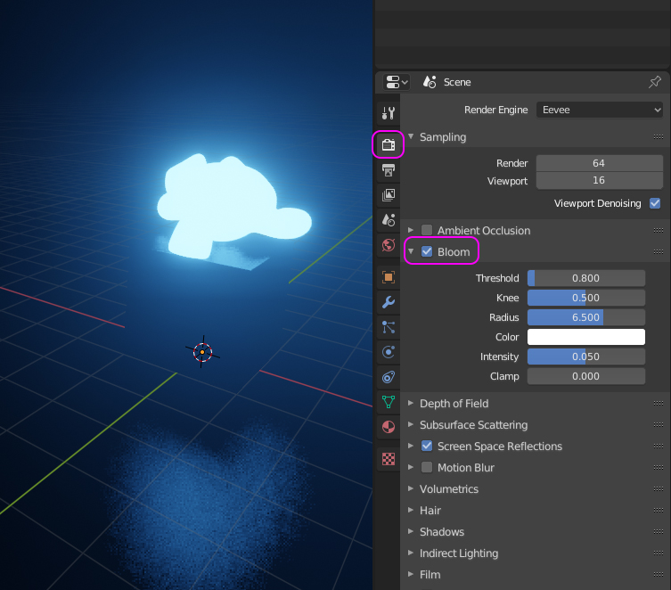

Figure Bloom

We can distort the diffuse lighting in screen space, to stimulate genuine subsurface scattering. A number of effects can be used in order to render with Subsurface Scattering.

Samples: It is the number of samples that are required to compute the scattering effect.

Jitter Threshold: The jitter threshold when increased causes the samples below the radius percentage to rotate in random manner, which masks the visible pattern. For the effect to be utilized, the samples must be united rather than random. If the scattering radius is big, this will have an effect on the performance.

The Subsurface Translucency must be enabled in order for the light to pass through such items. For example: replicating a human ear light from its behind. This option can only work with darkened lights and does not function with brighter lights.

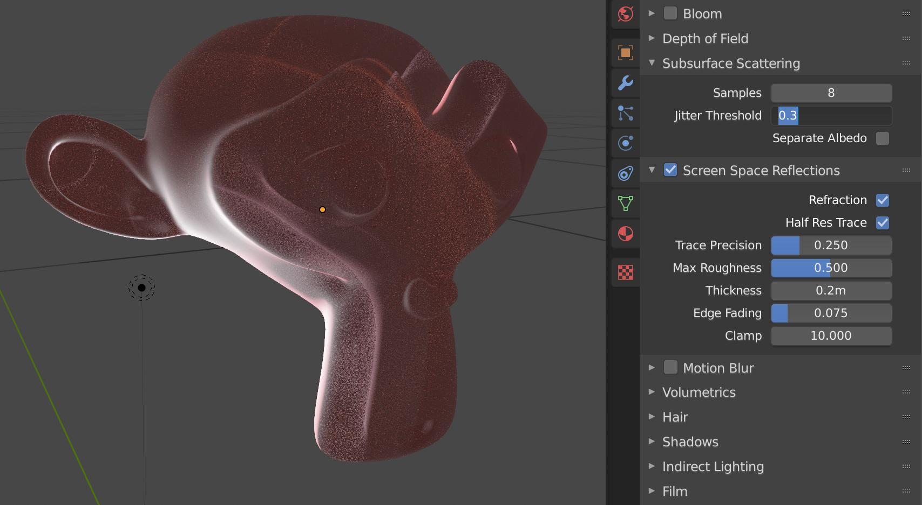

Figure Screen Space reflections

## 4.4 Similar Product reviews

One of the products that I researched for my project was a stylized forest asset pack by Synty studios.

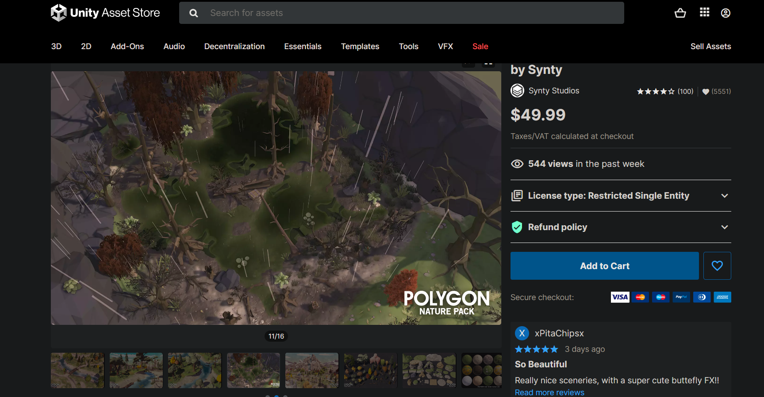

• Supported Platforms: Windows and MacOS

• Supported Unity Versions: 2019.4.28 or higher

• Download Type: Asset Pack

* Review: The asset packs include low poly trees, plains, terrain, rocks, and so on. It fits a variety of aesthetics and spans the gap between polygonal and more traditional styled components. It is a complex landscape texture with clean tiling normal maps that may be dynamically lighted which is also included in the collection. The asset pack also includes animated plants and trees. Unity makes it simple to customize. It also provides the user with a customizable stylized water shader of their choice. The pack also includes fantastic particle effects such as grass blowing, butterflies, fireflies, and so on. The overview map is helpful since it depicts numerous environmental variations such as rain, sunny mornings, and windy days.

Stylized Sci-Fi Asset

The second asset that was researched was the Stylized Sci-fi Asset pack by Synty Studios.

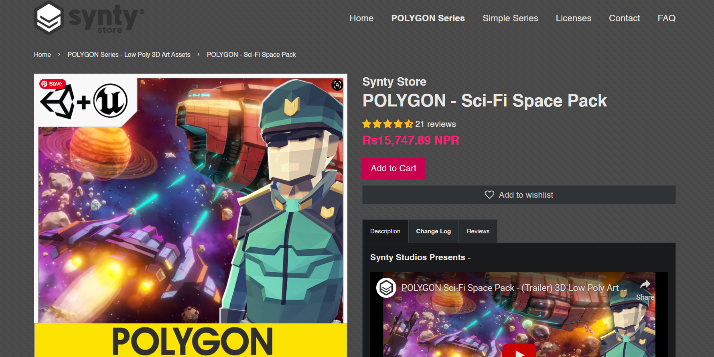

• Supported Platforms: Windows and MacOS

• Supported Unity/ Unreal Versions: 2019.4.28 or higher / 4.26 – 4.27, 5.0

• Download Type: Asset Pack

* Review: It is a low poly asset pack including sci-fi props, weapons, and settings form outer space. The modular section is simple to assemble in a range of ways. It includes detailed props such as drones, escape pods, a space station, and so on. It allows the player to interact with the outside cosmos. The atmosphere appears stylized and gives off a really cosmic vibe that mixes in with the surroundings. The effects, such as the beacon, black hole, and debris, make it incredibly interactive, proving it to be a sci-fi action- packed asset.

Stylized Dungeon Asset

The third and the final asset that was researched was the Stylized Dungeon Asset pack by Synty Studios.

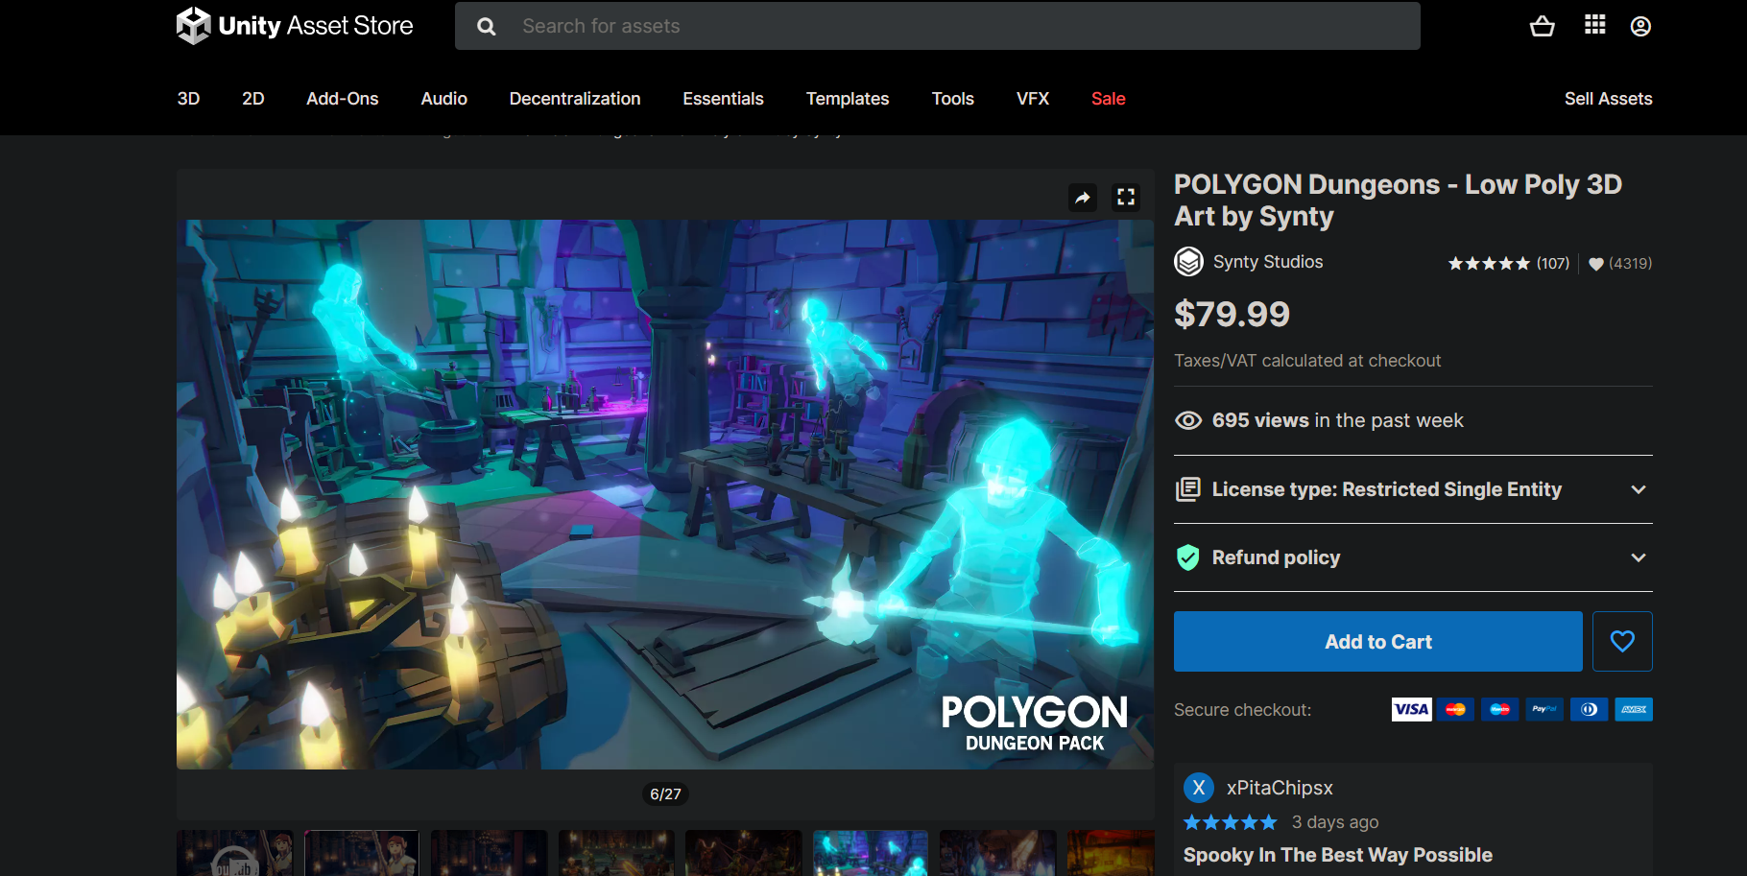

• Supported Platforms: Windows and MacOS

• Supported Unity/ Unreal Versions: 2019.4.28 or higher / 4.26 – 4.27, 5.0

• Download Type: Asset Pack

Review: It is a low poly asset bundle including dungeons which has pack of characters, props, weapons and environment which can be used by the developer to create an epic realm of fantasy low polygonal art game. The asset pack includes modular interior castle set, dungeon entrances, witches brew, weapons, modular goblin camp and to name some few. The atmosphere with the stylized interior brings out the magical realm of fantasy that dives people in it. Low poly weapons design such as hammers, maces, shield provides an additional element to the character.

# 5. Technologies employed

Many types of software were utilized to finish the project. These software were used for modeling, texturing, lighting, and compositing.

Blender

Blender is a popular open- source 3D software. It was developed by Ton Roosendaal, a Dutch art director and self-taught software developer. Blender features includes 3D Modelling, animation, UV mapping and baking, texturing, raster graphics editing, rigging and skinning, fluid and smoke simulation, particle simulation, etc. One of their reason of it’s rise is as it supports the entire 3D pipeline.

Blender is the software that will be used to complete most of this coursework. This software will be sued for low poly modelling, animation, lightning, texturing, camera, rendering and so much more. Blender is one of the most unique software that has various tools that can be used to create low poly models. For animation it allows us to work on it rather than sinking time in the models. The environment will be properly lit with one point and three-point lightning. Similarly, the camera movements are going to be used with proper camera angle to match with the shading and lightning of the model. Once the modelling and animation is completed the whole scene will be rendered with proper settings.

Adobe Illustrator

Adobe Illustrator is the industry top graphic editing software, that allows us to produce and edit logos, charts, illustrations, diagrams, photos, and so on. It includes multiple tools for creating and editing vector images. It is the perfect tool for designers and artists to create and edit digital graphics in high precision.

Illustrator will be used while making the base color or gradient layer for different textures, reference images, concept art and vector designs that will be imported in Blender.

Adobe After Effects

Adobe After Effects is one of the industry leading software for graphic designing motion graphics and visual effects for films and video. It is an excellent tool for editing that allows to make animations, and various effects to moving images.

This video compiling software will be used to composite and edit the final rendered video. With different layers in after effects any changes that needs to be done after the final compositing will be done in after effects.

Adobe Premiere Pro

Adobe Premier Pro is a full- featured software that includes cutting edge editing tools, motion graphics, visual effects, animation, and other features to enhance the final video project. The software is also completely compatible with Adobe Illustrator and Adobe After Effects.

Premiere Pro will be used for editing the video and sound. It will also be used to complete the sound effects and arrange the videos. The final edited video will be color corrected and rendered in proper settings.

# 6. Project Plan

Gantt chart

After the timeline for the production of the project was decided, to create a plan to keep track of the process a Gantt chart was designed. The Gant chart also consists of the tasks that were already completed at the pre- production such as concept finalization and storyboard. To show the production of my project plan the Gantt chart displays the overall workflow of the project. All the steps, including modeling, texturing, compositing is further clarified.

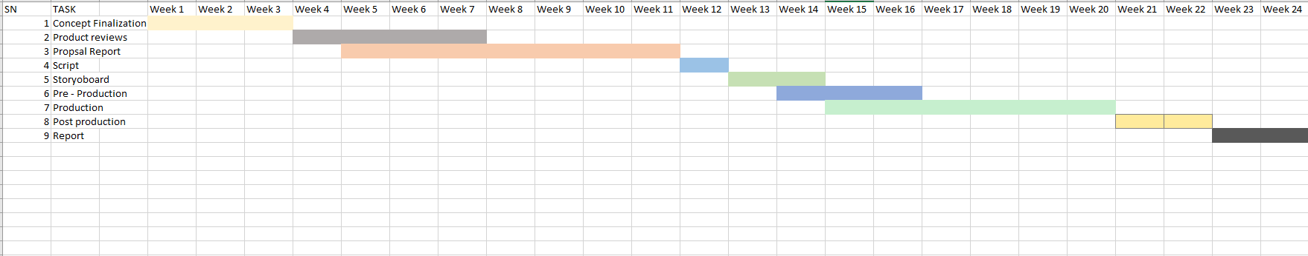

Figure Previous timeline chart

In the timeline and scheduling of the previous coursework, there were lots of process missing and unassigned. This was mainly because at that time the GDLC model process was not followed. However, the work was divided to standard project planning i.e., Preproduction, production, and post-production. The production process was mentioned to start from November of 2021 to May of 2022. Thus, in the second semester this process was reset and started from beginning as more contents and steps were added to the production as per the guidelines of GDLC model.

For the previous timeline of the project, lots of production processes were not properly followed. It was due to lack of a proper model process being not assigned to the project. However, the tasks for the project were divided into standard project planning, Pre-production. Production and Post- production. The production process was mentioned to start from week 15 to week 20. Thus, due to the project not being updated with the previous timeline the initial plan that was done for the DMP was updated with the new Gantt chart.

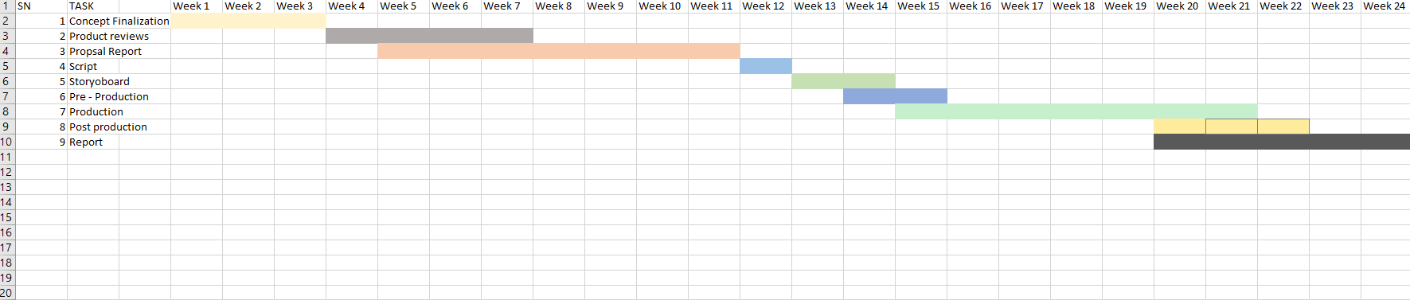

Figure New Timeline chart

In the early stages, the project was going smoothly. But, with the encounter with some software bugs the project was halted for a while. So, with the new timeline the pre- production process remained same with some changes in the production phase. Following the changes in the model of the production, the contents and scheduling of its processes were matched with the changes. The project contained modelling and animation loops, and I decided to add some particle effects to make it more appealing. So, due to some technical problems and understanding new topics made it time consuming. Thus, the contents and scheduling for the production and prost- production process were updated to match the changes. The production phase duration has increased giving more time to create models with proper shaders and lightning. Post-Production has been moved forward as to render the materials as quickly as possible.

# 7. Resources

A Number of resources were required in order to finish the project. Here, is a list of various resources that was collected and used for the production of the project. The follow resources have been mentioned as follows:

Hardware and Devices

* Acer Predator Helios 300
* NVIDIA GTX 1650TI GPU
* Intel Core7 9th Gen

Software

A total of 4 different software was used in the production of this project. All of this software was used for modeling, texturing, lighting, and compositing.

* Adobe Premiere Pro 2020
* Adobe Illustrator 2021
* Blender 3.4
* Adobe After Effects 2021

Distribution Platform

We were required to upload our project files to GitHub and provide a link to Google Drive. The finished video has been uploaded on YouTube.

* YouTube
* Google Drive
* GitHub

Survey and Testing Tools

When the final product is released online it is ready to be tested just like any other product. With the use of these survey and testing tools, I will be able to better understand and approach the reviews of my product.

* Google forums for survey
* YouTube used to test the playback for modelling and animation

# 8. Production Phases

## Game development Life Cycle

Game Development Life Cycle also known as GDLC is a life cycle of software development with the aim to help the developers follow specific plans to achieve their desired products. Comparing to Software Development Life Cycle (SDLC), developers may face many obstacles while developing games, hence they follow a specific set of planning for developing games.

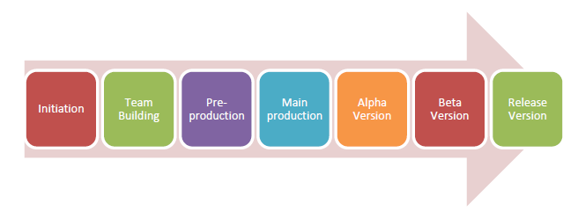

Figure GDLC

When the game is being released to the general public, GDLC goes through seven different stages, as shown in the above image. The stages are as follows: Firstly, planning what game to produce, deciding on the genre of the game, pre-production: which includes building the games prototype. The main production includes the games latest version. The alpha version is the unfinished but playable game which is used for alpha testing and fixing bugs and errors. The Beta version is when the game is being tested out by beta tester and released once the bugs are found by the testers and errors have been fixed.

## 8.1 Pre- Production

As I mentioned above in the GDLC the first step of the project is pre- production. This stage includes planning for the project. It includes the title of my project, the genre for the game, it’s targeted audience and the design and aesthetic for the game. During the pre- production stage I researched and look for reference to start my project. After deciding on the models and animations for my project I finally started working on the concept.

The first stage of game design is where the developer decides on the genre of the game, it’s targeted audience and the overall aesthetic and build. The main objective of my asset pack is to provide a wide range of models to the gaming community which can be used in different settings of games. So, in order to make different models with their unique aesthetics and world buildings I have searched on and came up with distinct references for my project. Here, we can see all the concept art I came up with after researching on the style of these models. This stage is the basis for any game art or design. The concept design for my project had to creative, imaginative and understanding for the audience.

After finishing up on the concept arts and all the research needed for the planning of the modelling and animation, I created an outline for my limitations and the software I planned to use to complete the project. All the further planning included for the overview of my modelling, shading, lighting and rendering. For the completion of my project I chose the most compatible and best software which can be used to totally utilize my assets as much as possible.

## 8.1.1 Concept Art and rough sketches

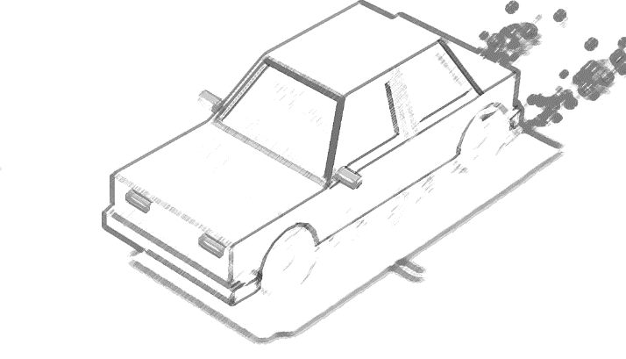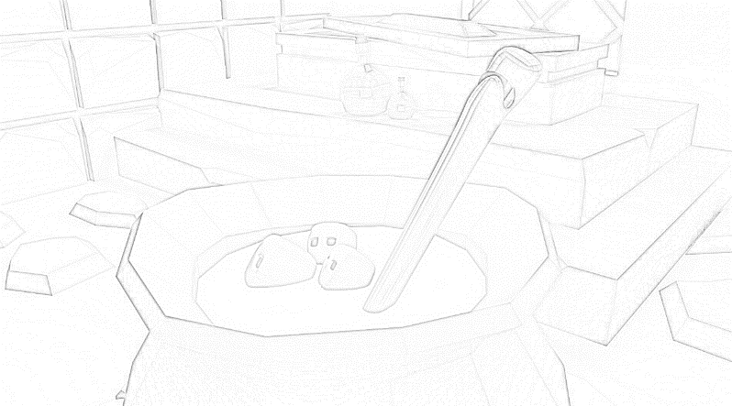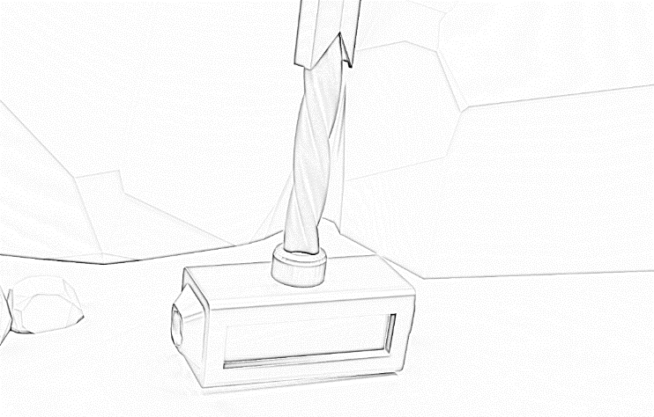

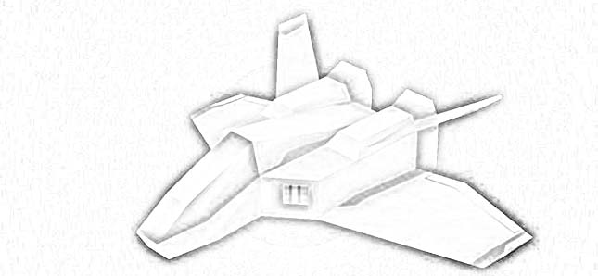

Figure Concept art

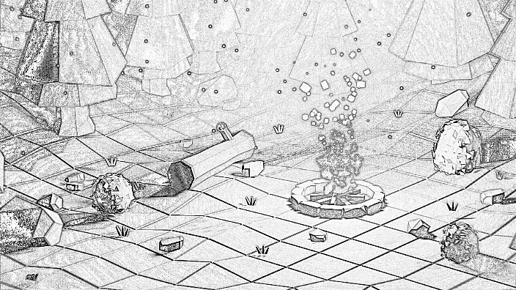

## 

## 8.2 Production

After finalizing my designs from the concept art and the approval from my supervisors, the pre- production phase ended. Following, I moved on to the production phase of my project. This phase included where the game assets were starting to get modelled per the concept art of my pre- production stage. In this stage all the aspects of the products are created and enhanced. This stage plays a very vital role for the technical creation and aesthetic visuals which is implemented in the games.

### 8.2.1 Low Poly stylized Rocket

Firstly, for one of the models for the project I started with a low poly jet. So, I modelled a low poly jet for the scene.

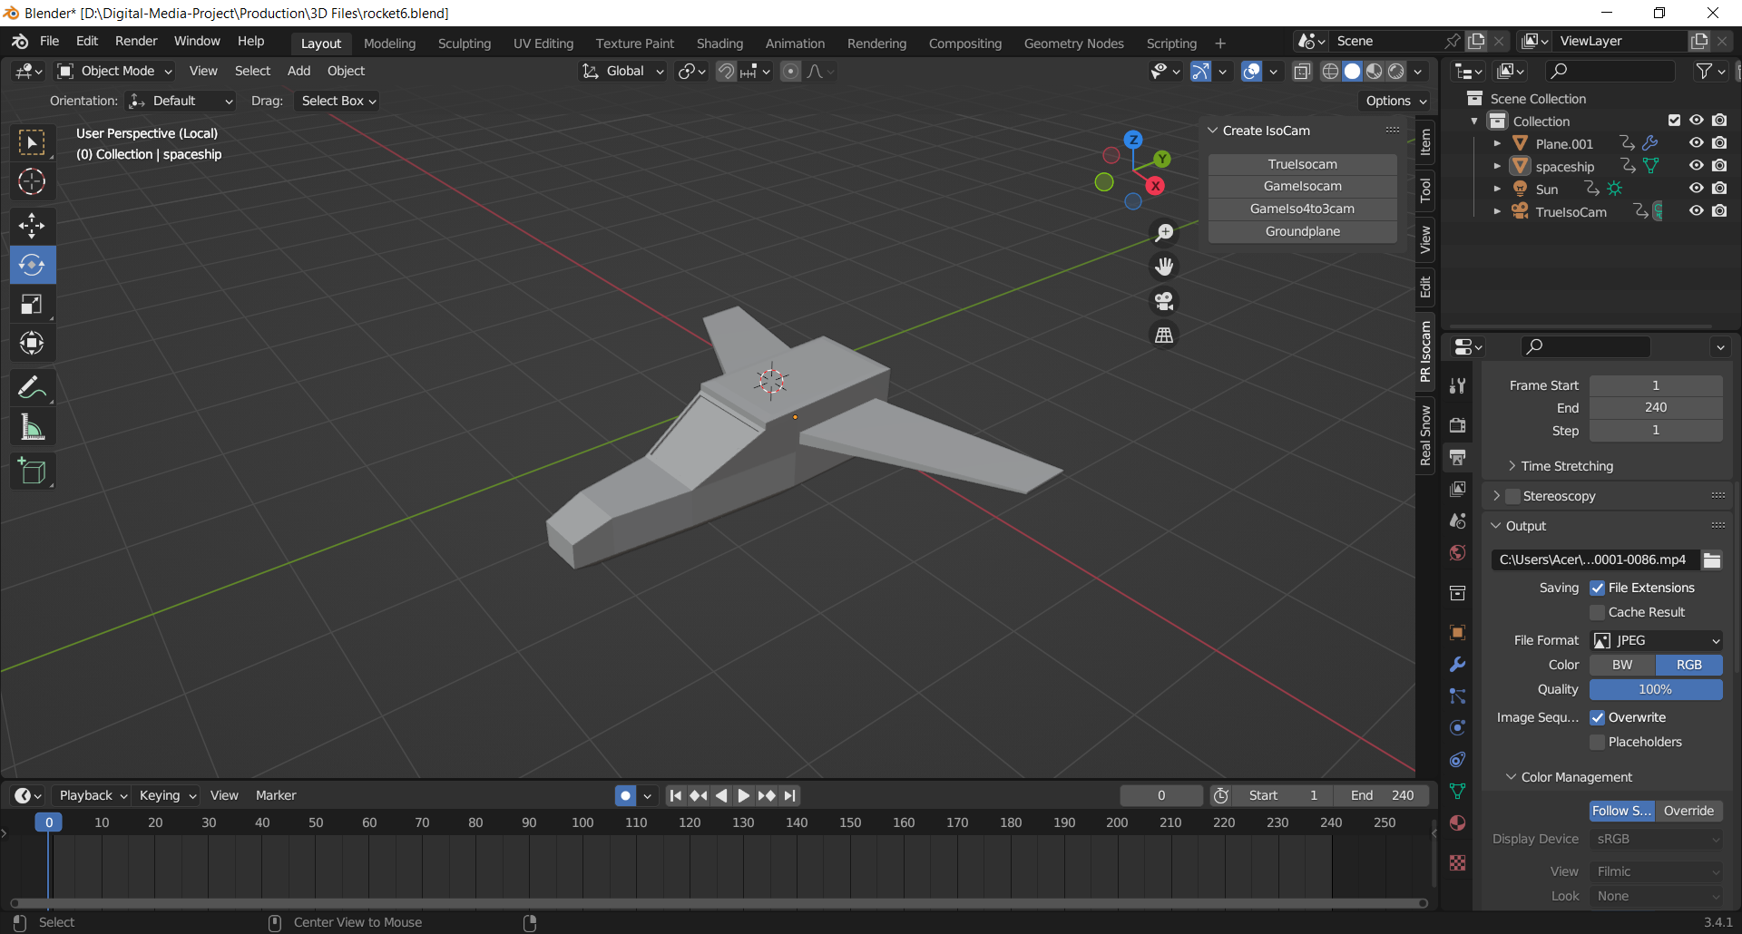

Figure Modelling of jet

Then I created a plane for my environment. Then I added details to my environment. I wanted to create a desert landscape so, I added a plane and extruded it to create stones. After that I duplicated the stones and aligned them accordingly. I adjusted their heights and created stones for the ground as well.

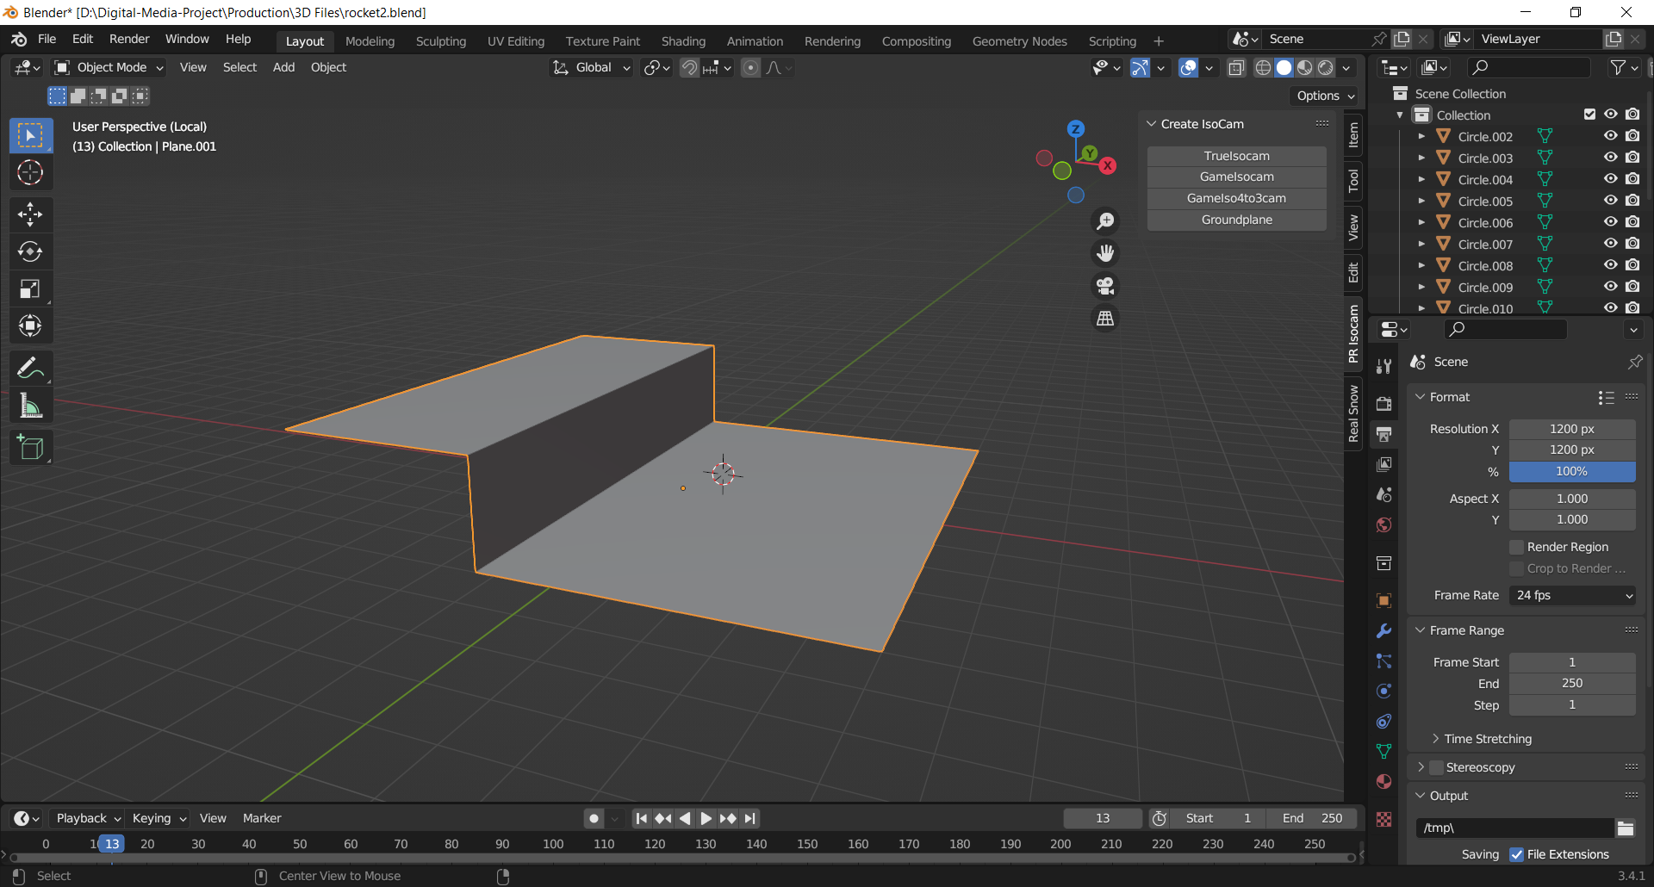

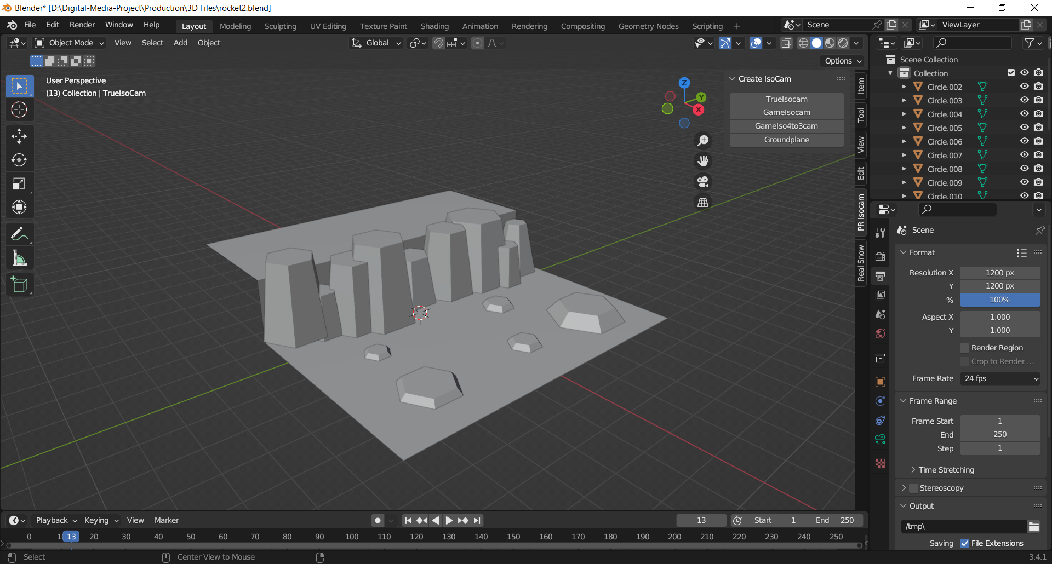

Figure creating landscape

Following the completion of the plane, to create an animation loop I duplicated the plane for 3 time and placed it in front of the other. Then I added a simple animation to the location of the plane one the y- axis.

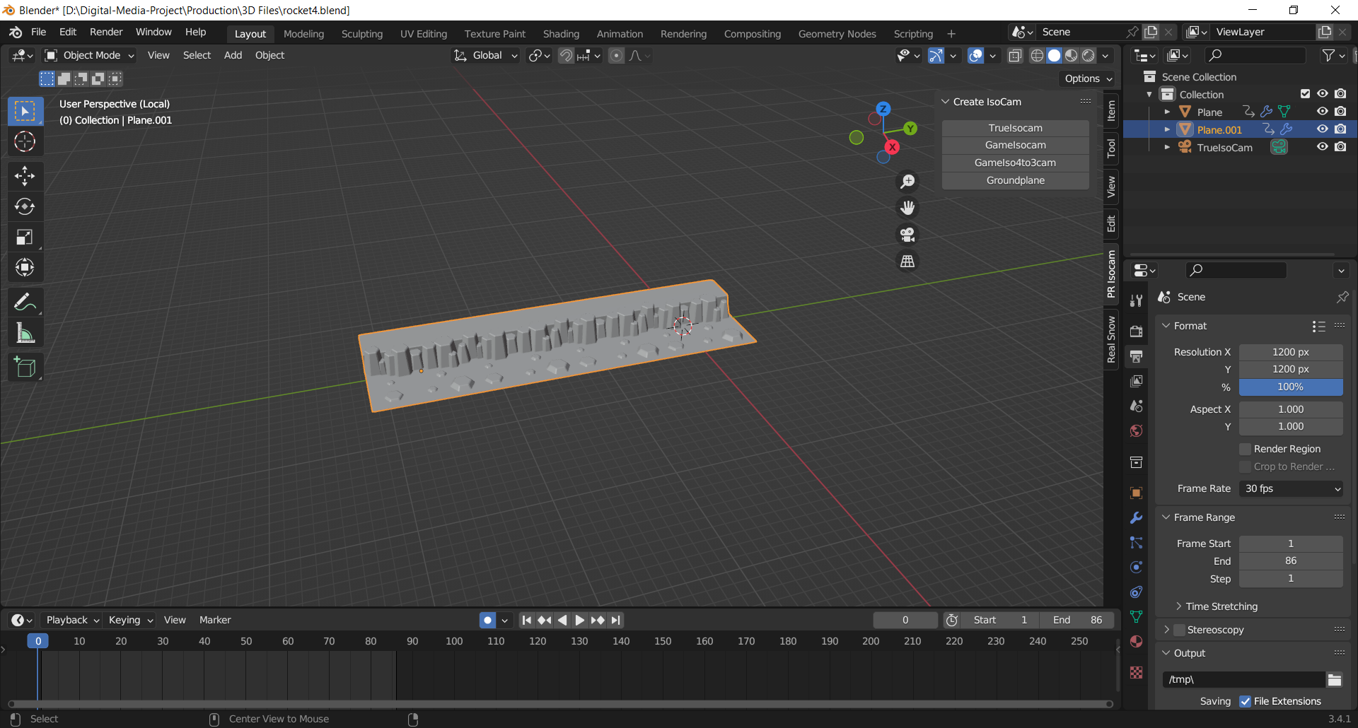

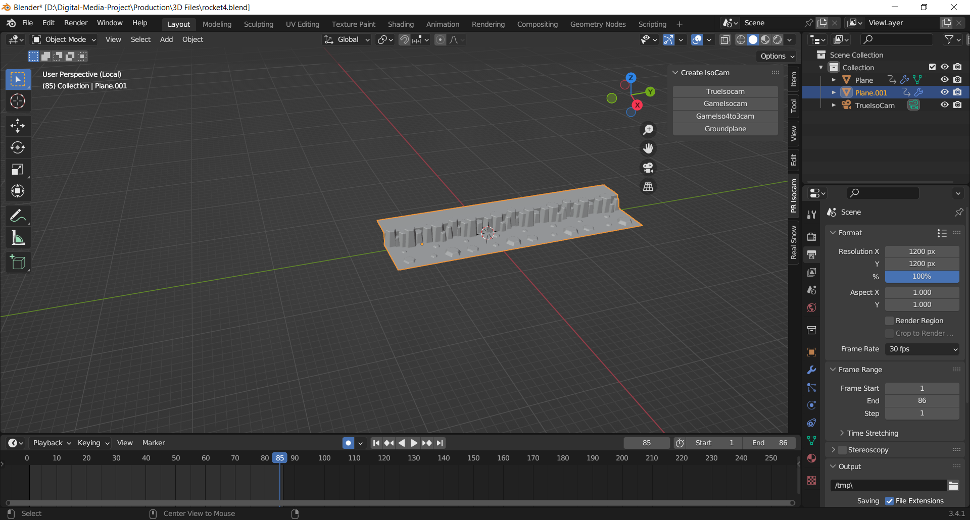

Then, I adjusted the position of the jet to the landscape and set the keyframes from 1 to 240 and the fps to 24. I placed the camera at an angle to give me a good view of the jet.

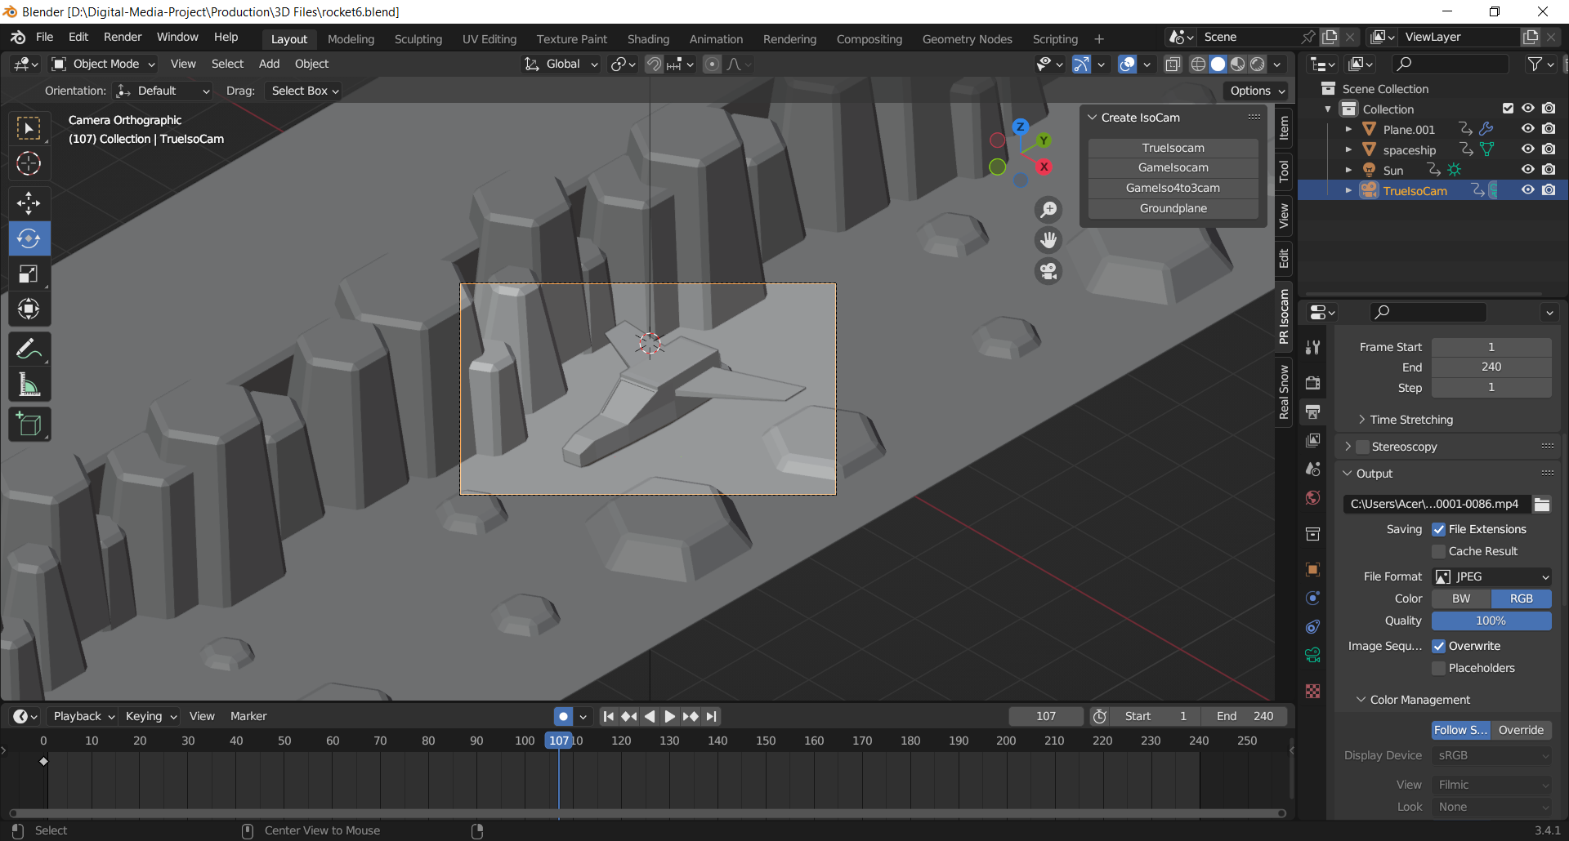

Then on the animation tab I added animation to the jet. I set the keyframes on the jet to the y- axis as well and hid all other axis.

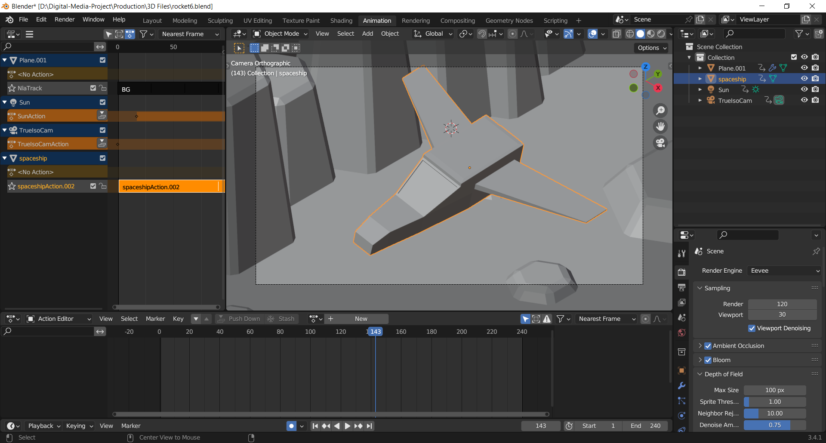

In order to loop the animation, I firstly created an action for both the jet and the ground then pushed it down. Then in the non- linear animation viewport I went to the strip option and on the action clip I set the repeat to as much as I needed.

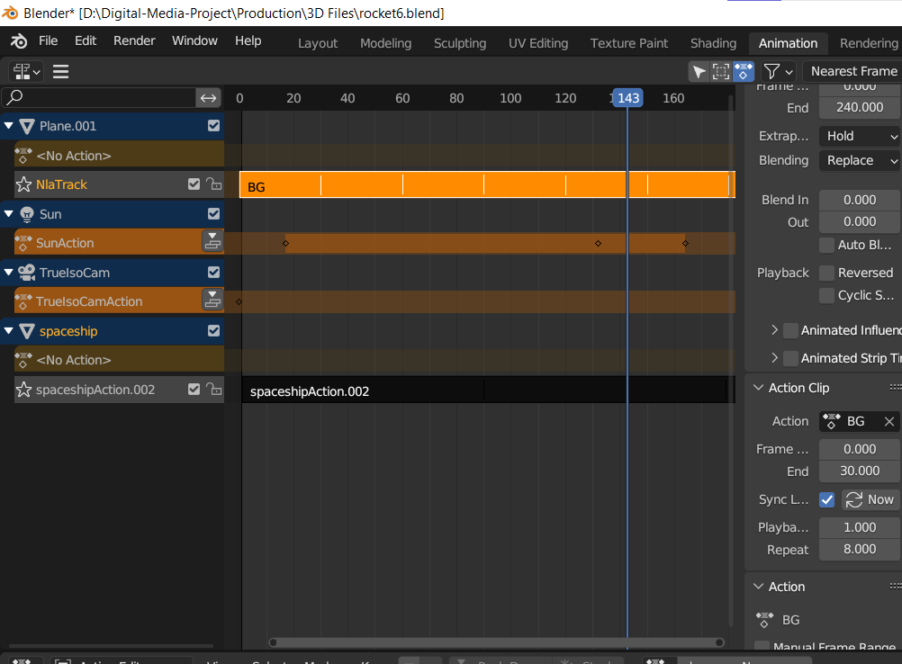

Figure editing animation loop

After the animation for both the landscape and the jet was done I moved onto the shading of the models. For the jet I used all Principal based BDSF materials. For the tip of the jet I added a black color and increased it’s metallic and decreased its roughness. I added a pattern of orange to both side of the wings. I also added a metallic PBR shader to the glass of the jet. I then proceeded to create the same orange pattern for the body of the jet.

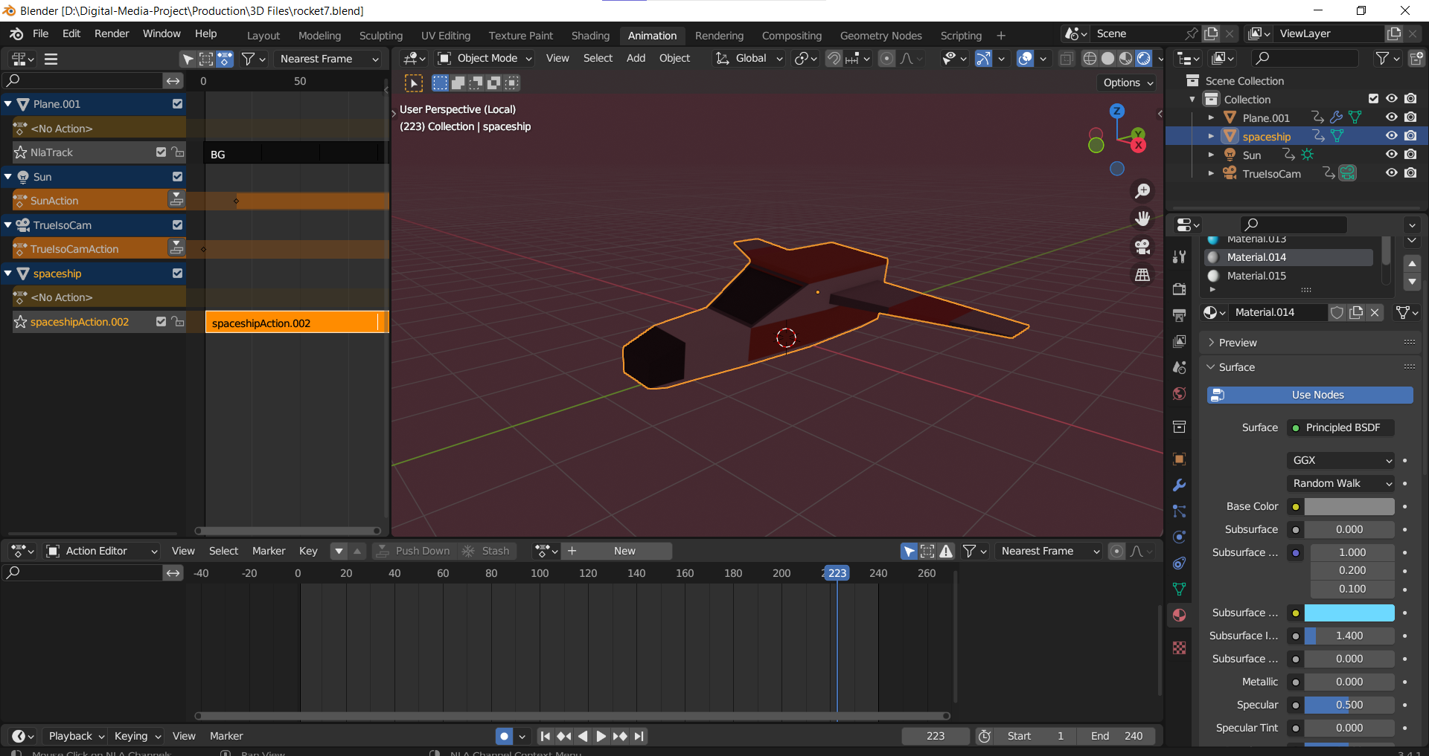

I also used a Principal BDSF shader for the terrain. To give it a darker night desert vibe I gave it a little light and shallow shade of brown. I also decreased its metallic properties and bumped up the roughness.

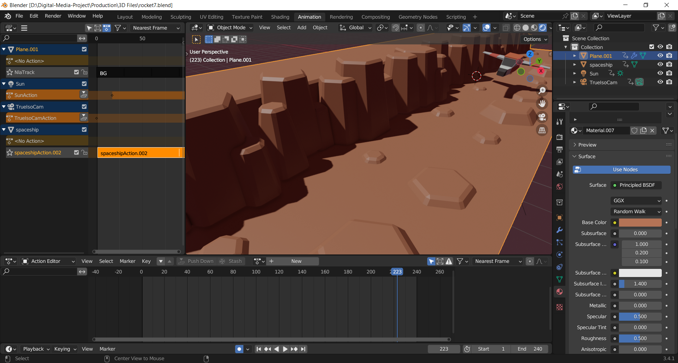

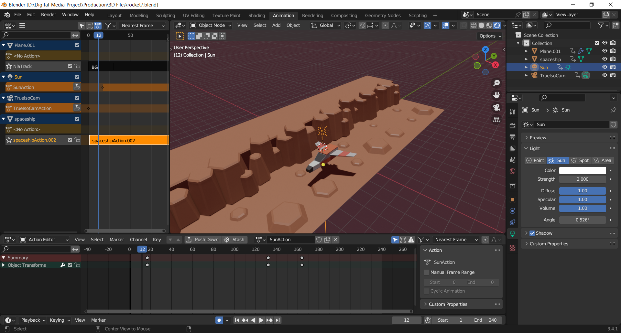

I also animated the position of the light source. I only used the sun light as my main light source. At the beginning of the animation the light stays in contrast to the jet, and after sometimes it moves up to 45 degrees left to the jet which creates a night like mood to the scene.

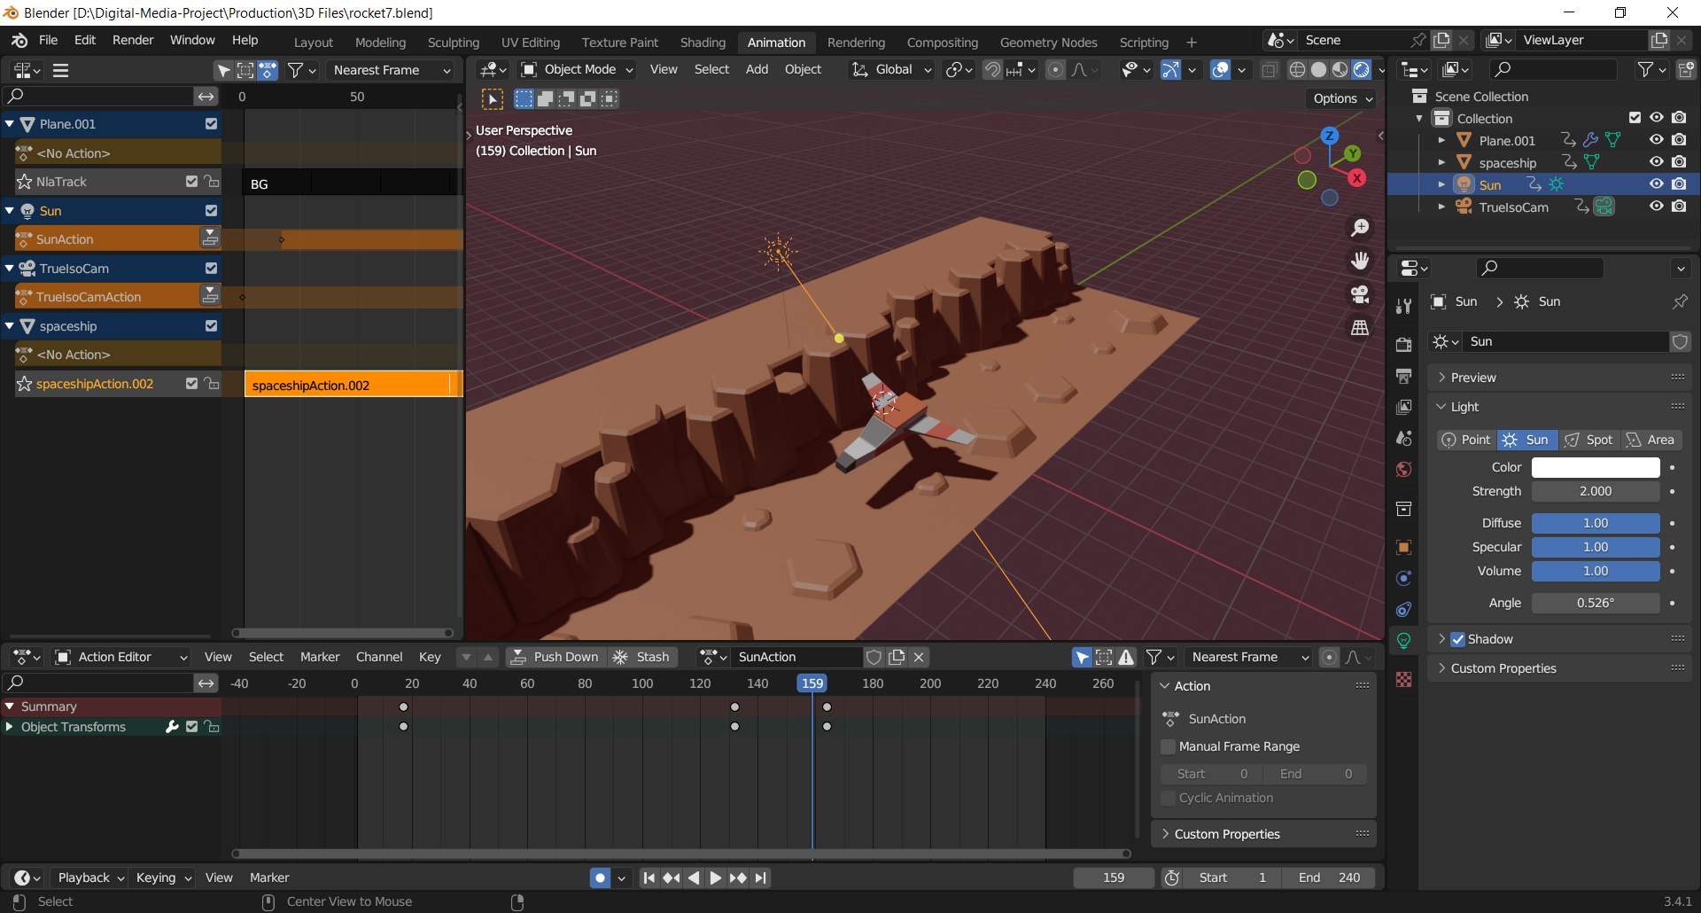

Figure adjusting the light

After the animation and lighting were completed I set the background of the overall scene, to make it look more purple tint which blended well with the light. Then I moved onto render settings for the animation. I set the render and viewport values to 180 to calculate more pixels for rendering. I also used Ambient Occlusion, bloom and Screen space reflections for more details to be rendered.

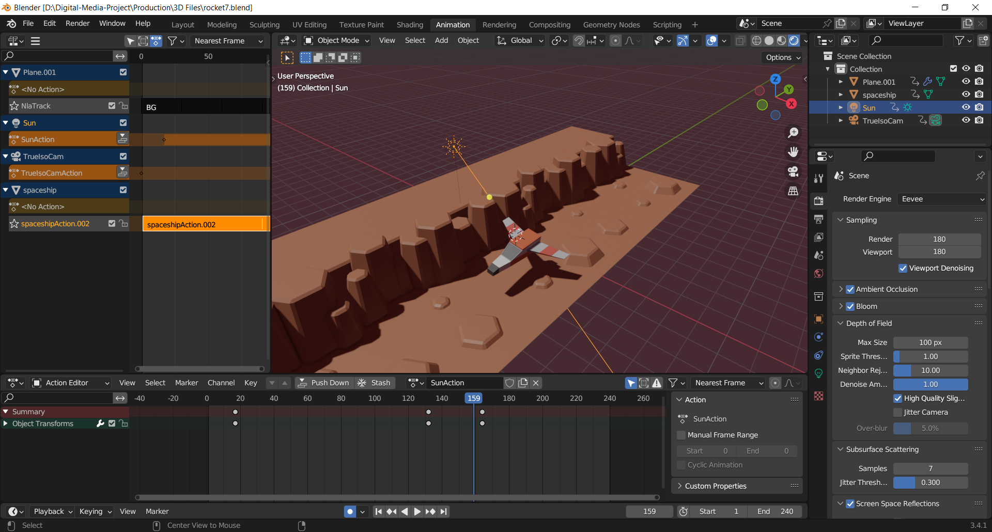

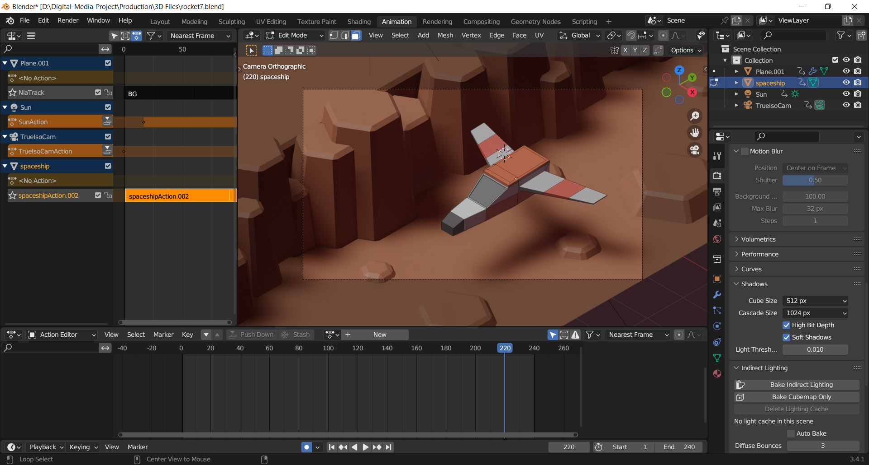

### 8.2.2 Low poly stylized house

The second asset I modelled for my project is a house. I used simple loop cuts and bevel the model to make it a simple and proper house.

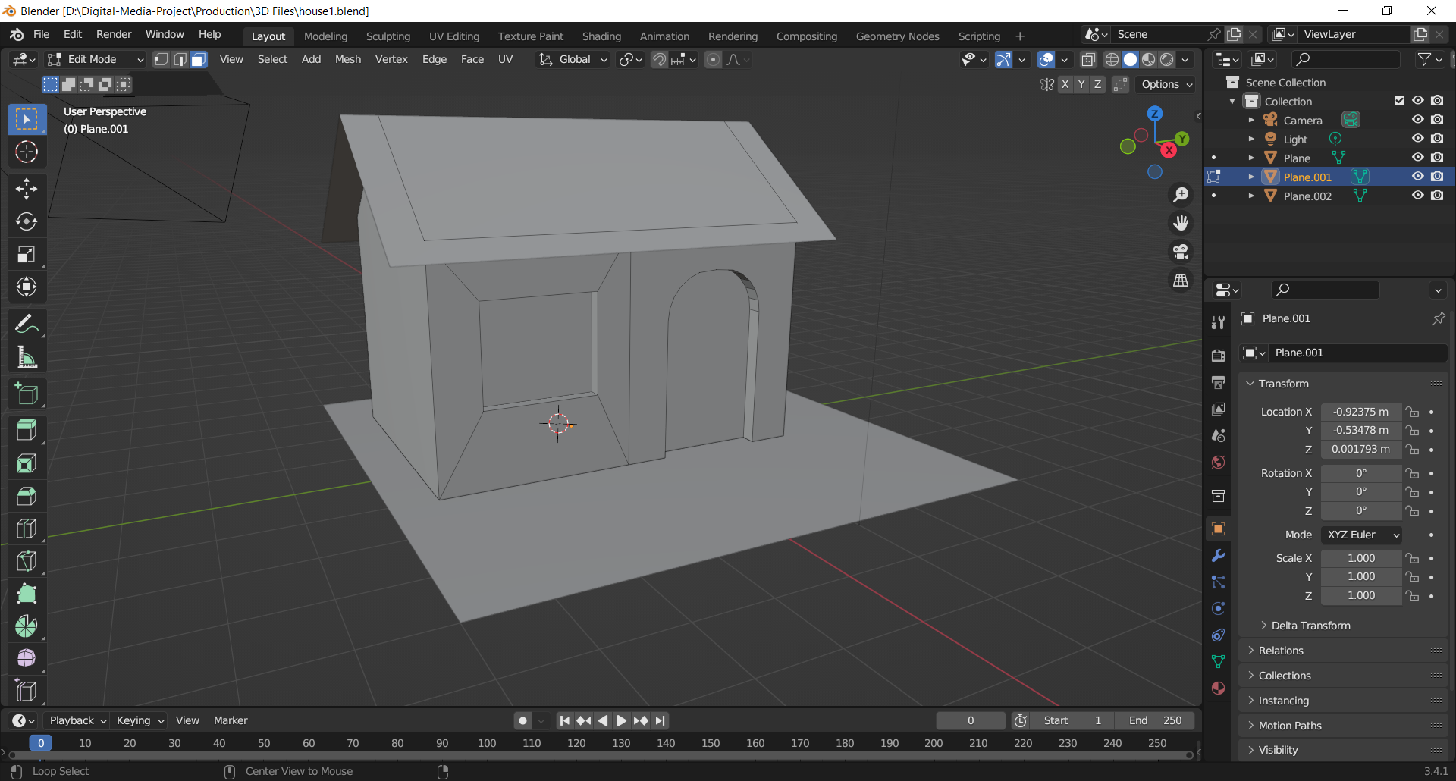

Figure modelling house

Then I modelled a chimney for the house and added additional details to it like bricks on the roof, windows and door.

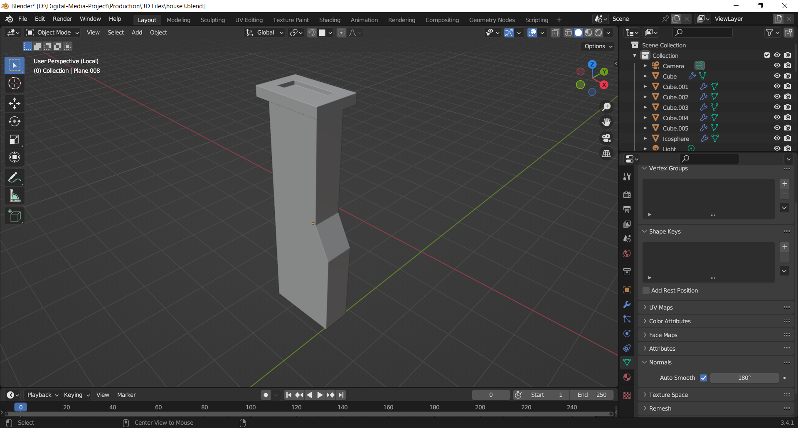

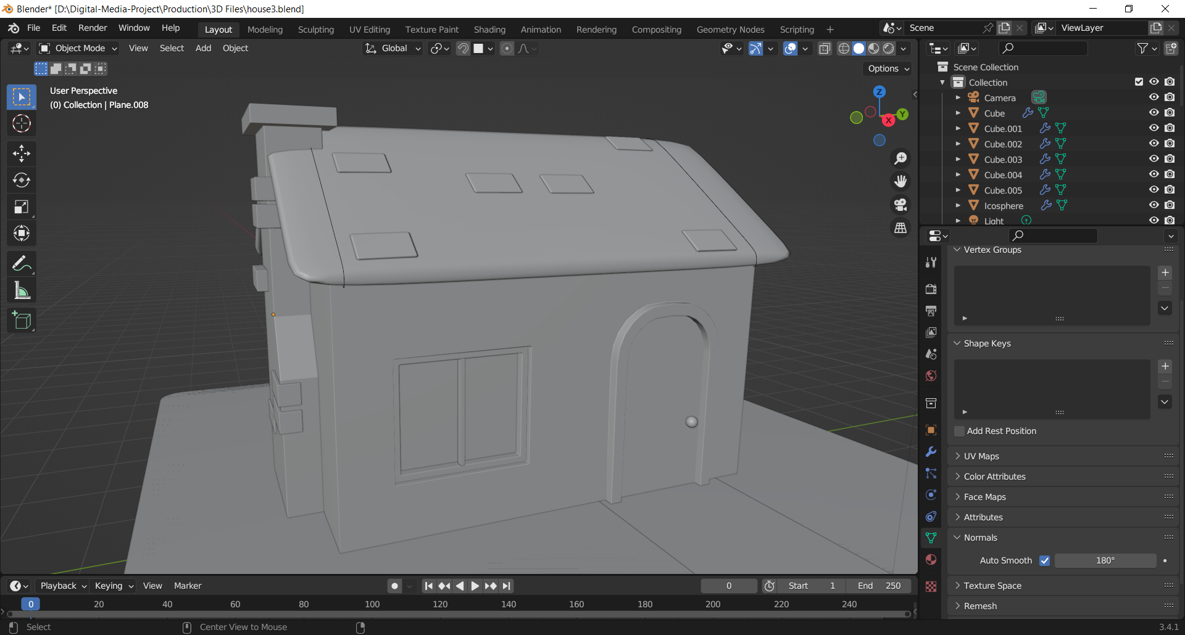

Then I added a meatball to make a bush for the surroundings. After creating one meatball I was able to duplicate them and create a whole bush. After that I duplicated the whole mesh, scaled them and positioned them on the ground.

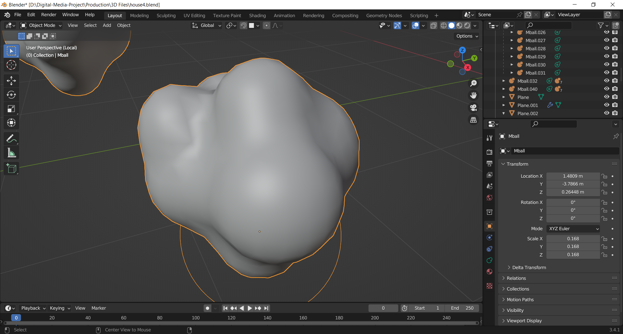

After the modelling was completed I decided to add snow to the scenery. To do so, I wanted to sue the Real snow plug-in of Blender. To use it I selected the objects and then adjusted the value to my liking.

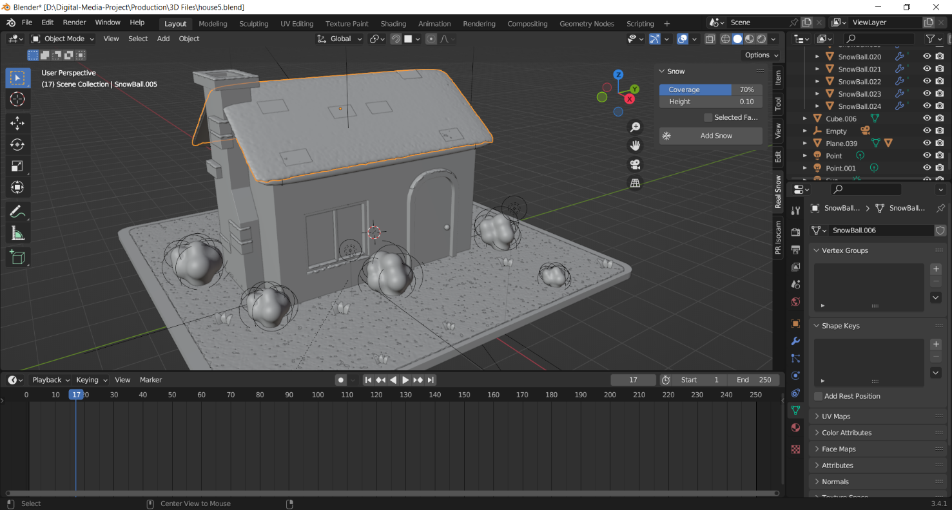

To create a night scene, I used a sun light and set its strength to 1.28 to which made the light very dim and gave it a shader of blue.

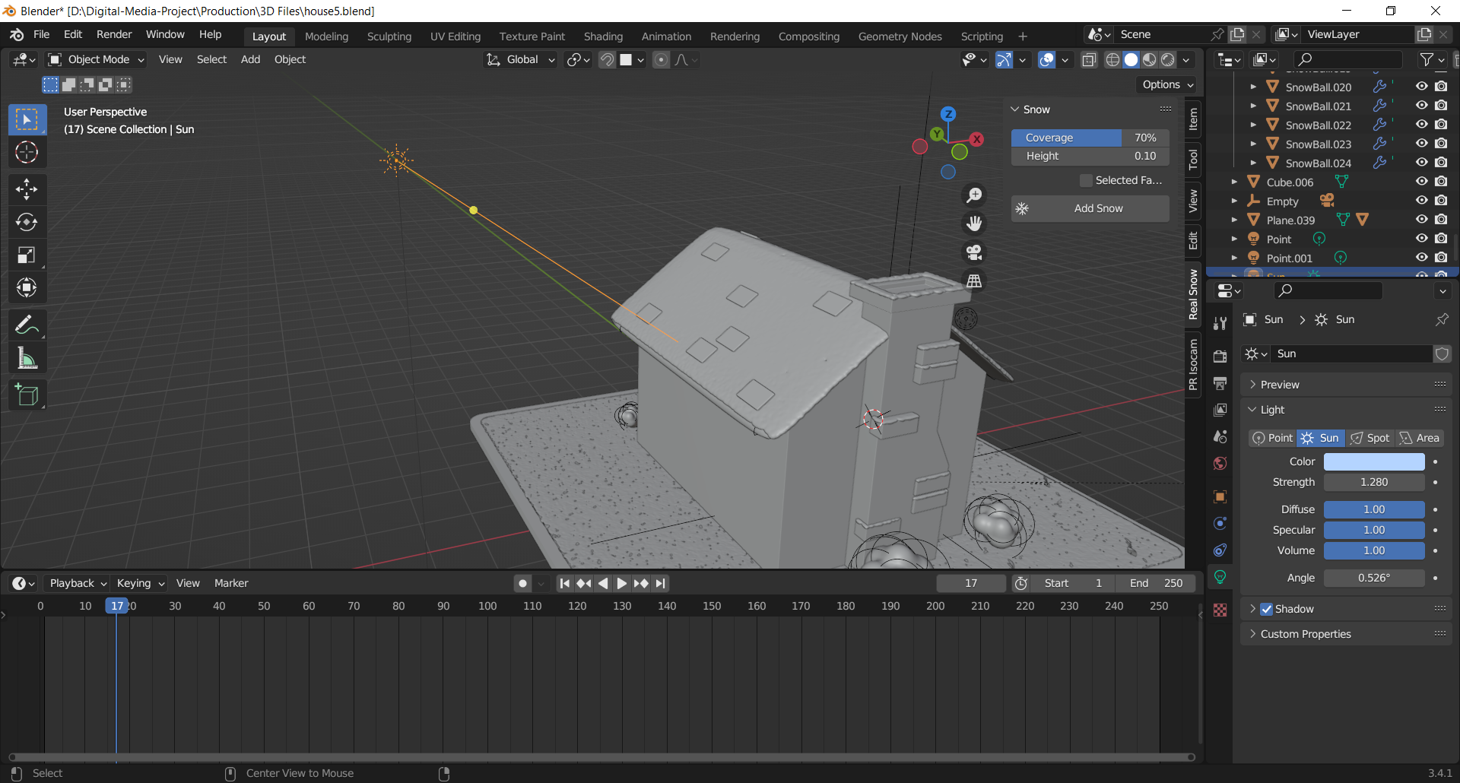

Figure adjusting the light

Then shortly, I added a cube and made it bigger then my scene, and in its material preview I disconnected the shader, and in its properties in viewport display I checked on it as a box which made it transparent. Then I set the volume to volume scatter which allows the light to pass through it.

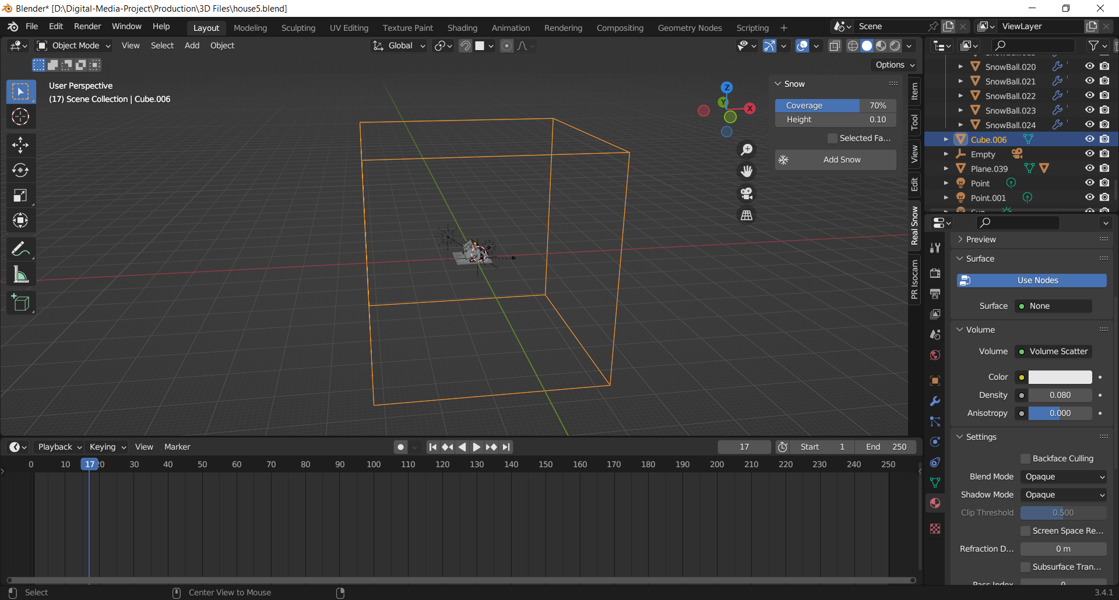

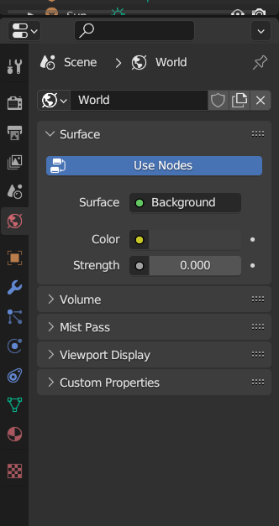After that I changed the overall background color of the scene to the color of my light to give more contrast.

Thus, I set the density of the cube lower to create a fog for my scene. I positioned the main light source at the back of the object to create shadow for the house and give it a natural night setting. I also positioned a point light in front of the window and turned on the bloom and emission to make it look brighter.

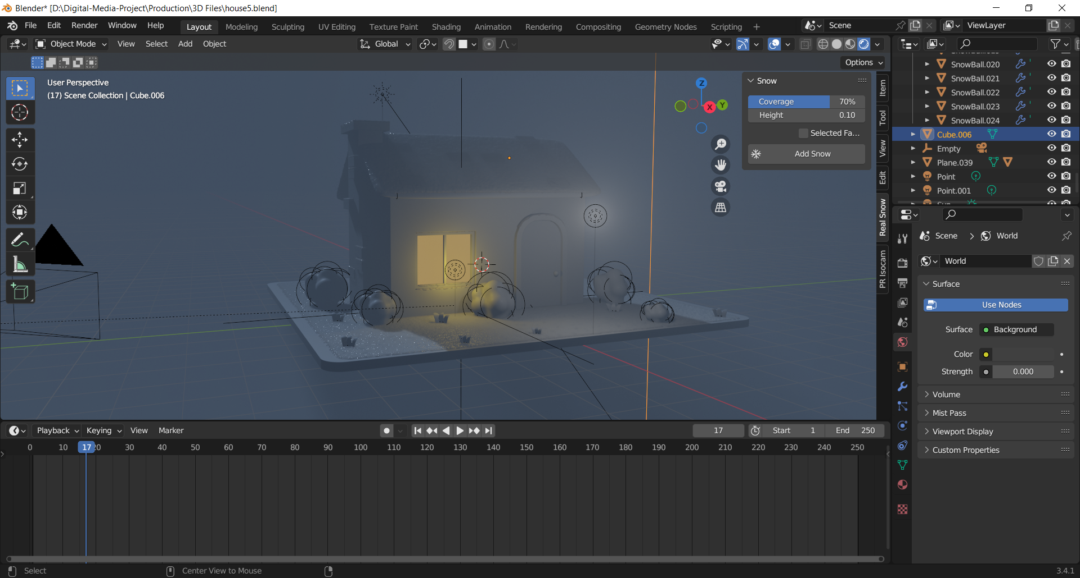

Figure editing the background

### 

### 8.2.3 Low poly stylized car

The next model and animation for my asset pack is a low poly car animation loop. After researching for the design of the car, I decided to go on with the most common designs used in games.

After achieving the initial design for the car, I added a wheel to the car. To add it to the car, I used a cube with the wheel model inside, which I then differentiated with the car’s model.

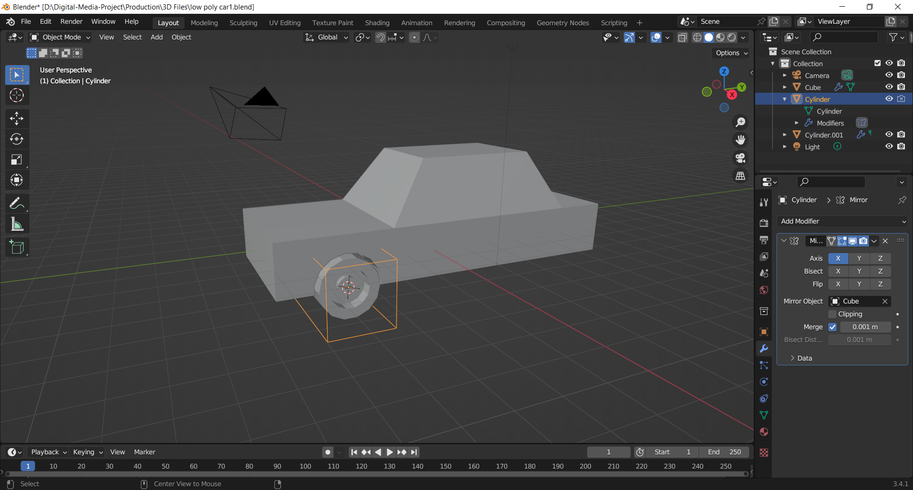

Figure modelling the car

Then after the design of the car was completed, I instanced a particle for my scene to create dust blowing off when the car came in contact with the ground.

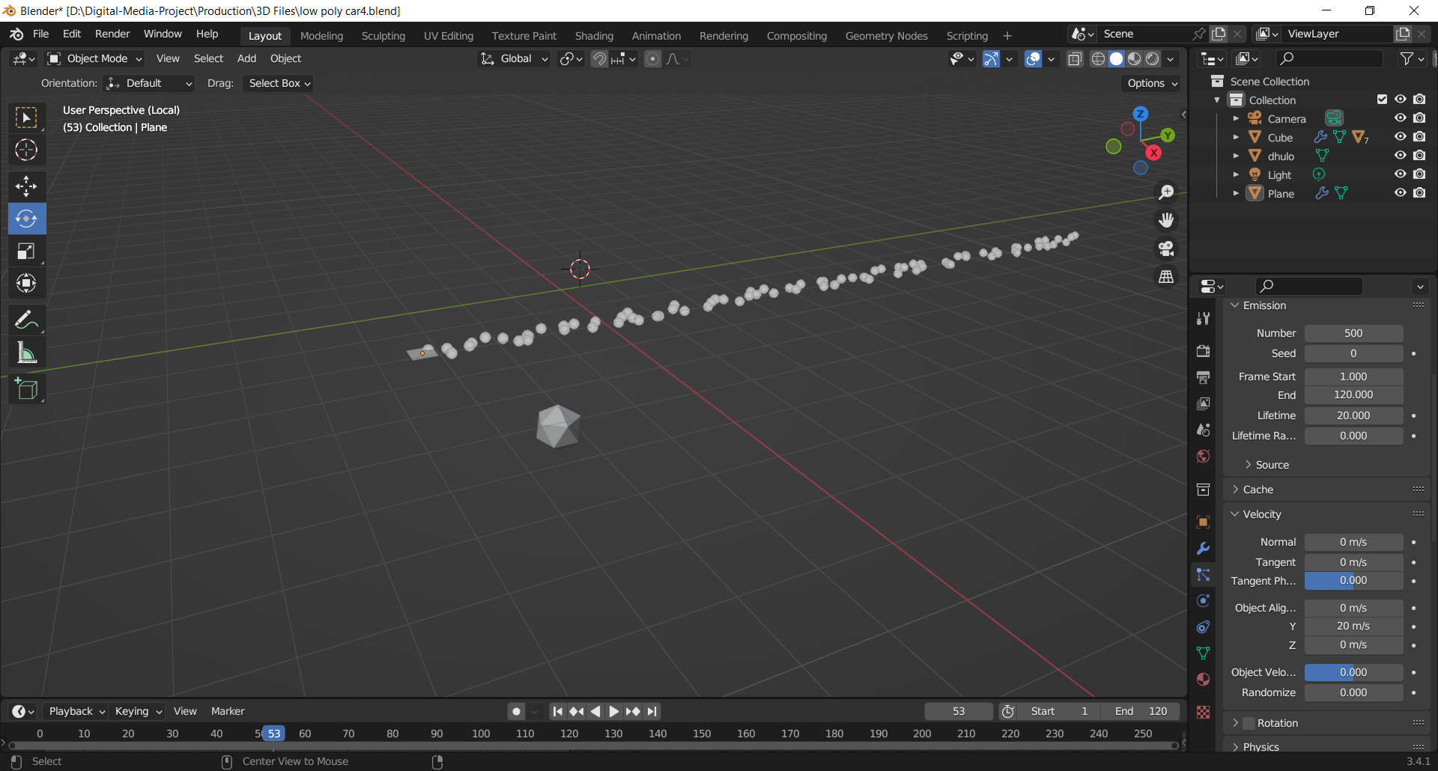

I then set the number of seeds for the particle, adjusted the velocity and decreased its gravity. I set the emitter to non-render as well. Afterwards, I duplicated the particle to the other side of the car.

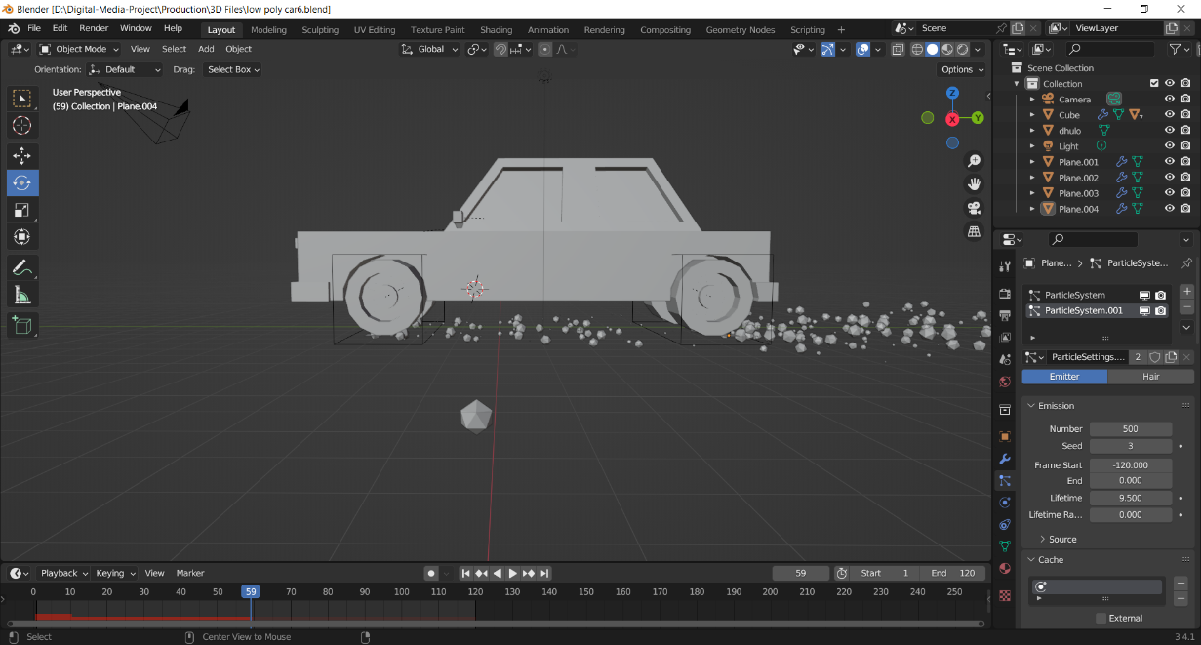

Figure adjusting particle effect

After that, I created a plane which served as a ground for the car Since, I wanted to create bumpy roads for the scene, I used proportional editing and went to the edit mode, selected the faces at random and adjusted them to fit my scene.

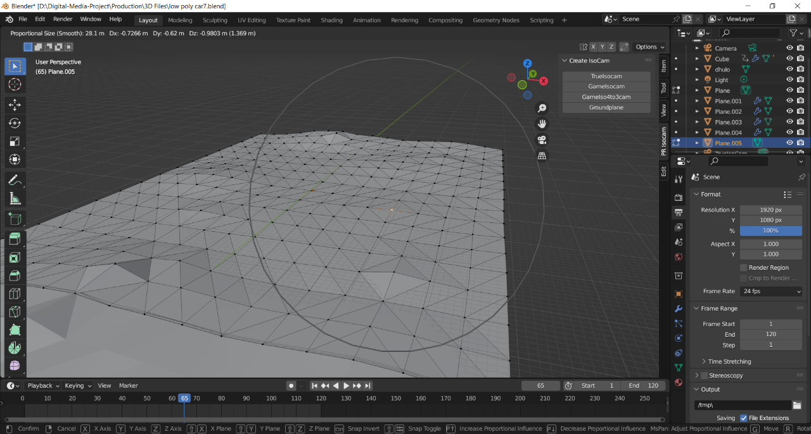

Then, I duplicated the plane and made 3 more planes and positioned them accordingly. Then shortly, I animated the plane and cars location on the plane of y- axis. To loop them, I pushed their action down on the non- linear viewport where I repeated the action clip a few more times.

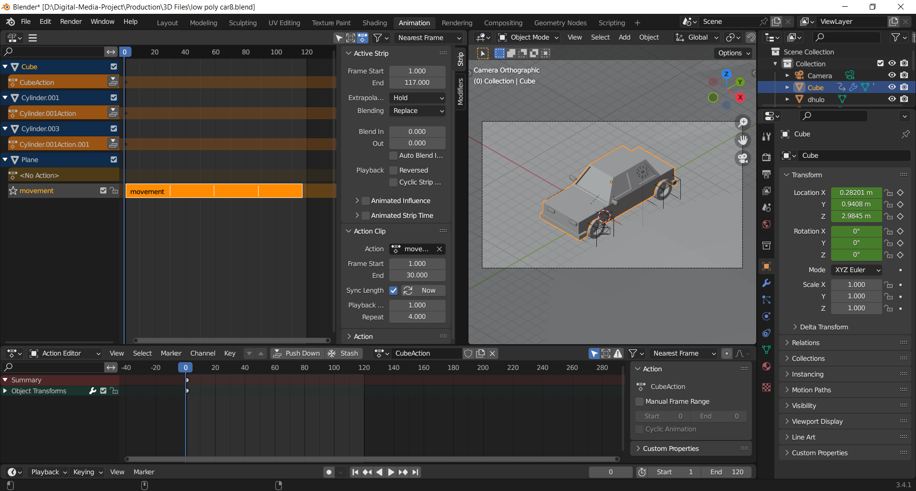

Figure editing animation loop

After setting the camera to the top view for a perspective view, I added a sun light to the scene. I positioned the light source to a 45-degree angle to its left side. I adjusted the strength of the light to 1 to give it a dimmer and darker vibe.

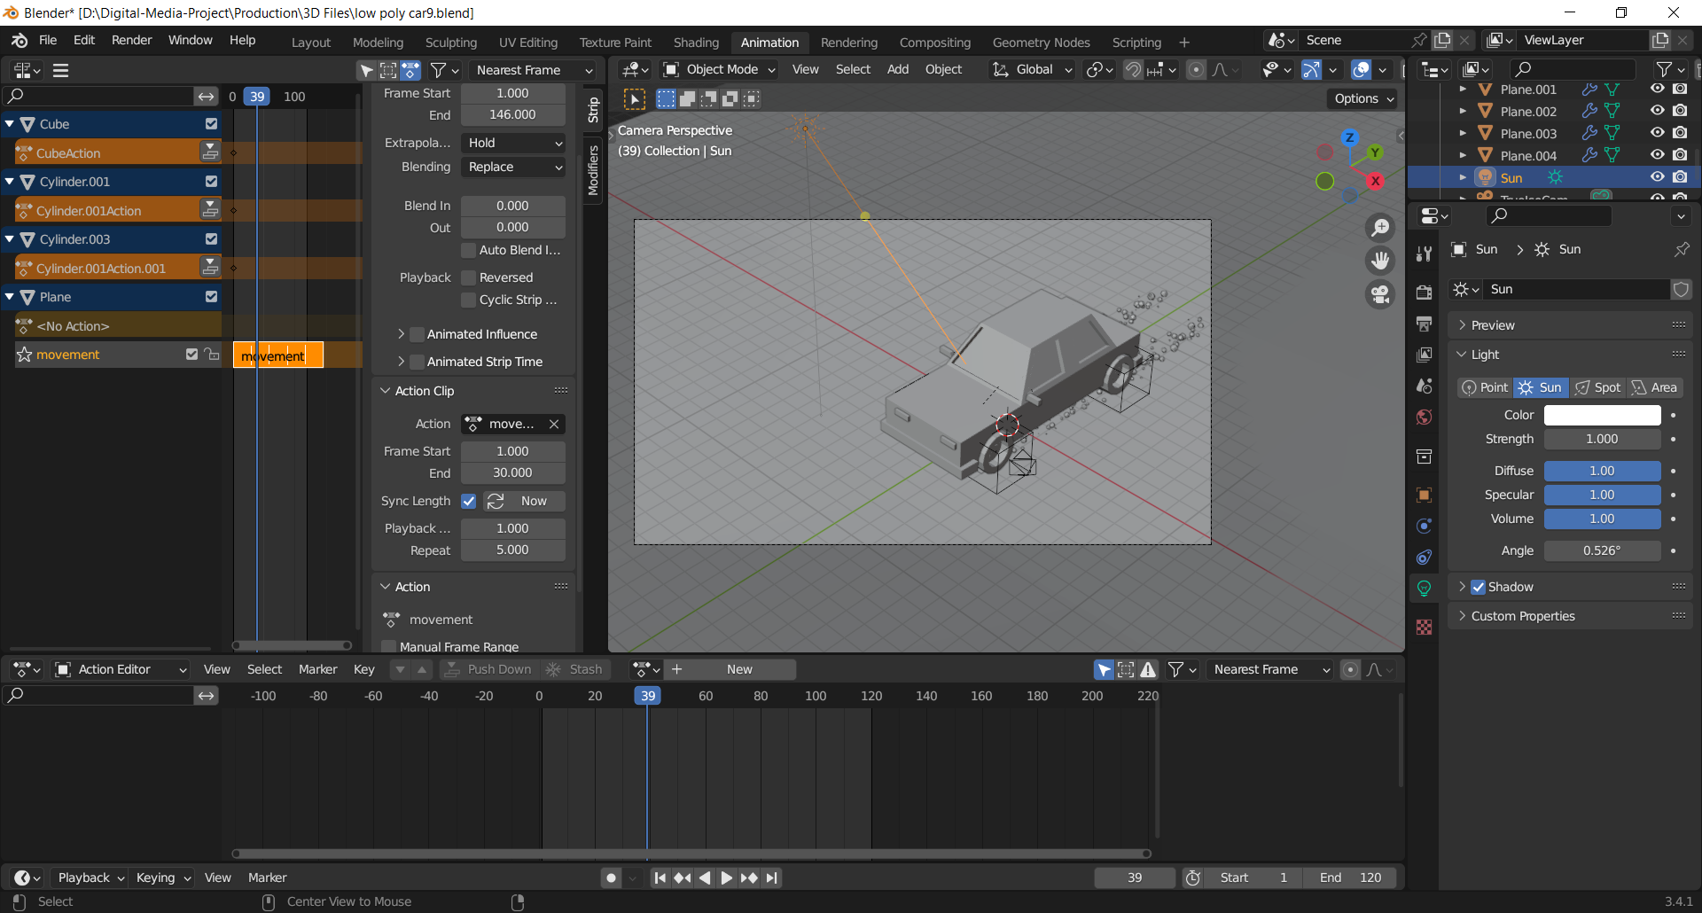

After that I started shading on my model. I used a PBR shader for the car. I bumped up the metallic properties for the car. For the ground, I used a shallow and light brown shader and bumped up its roughness. I assigned the same shader to the particles as well. To make the scene look a more of a night scene I tainted the background as white which blended well with my light source.

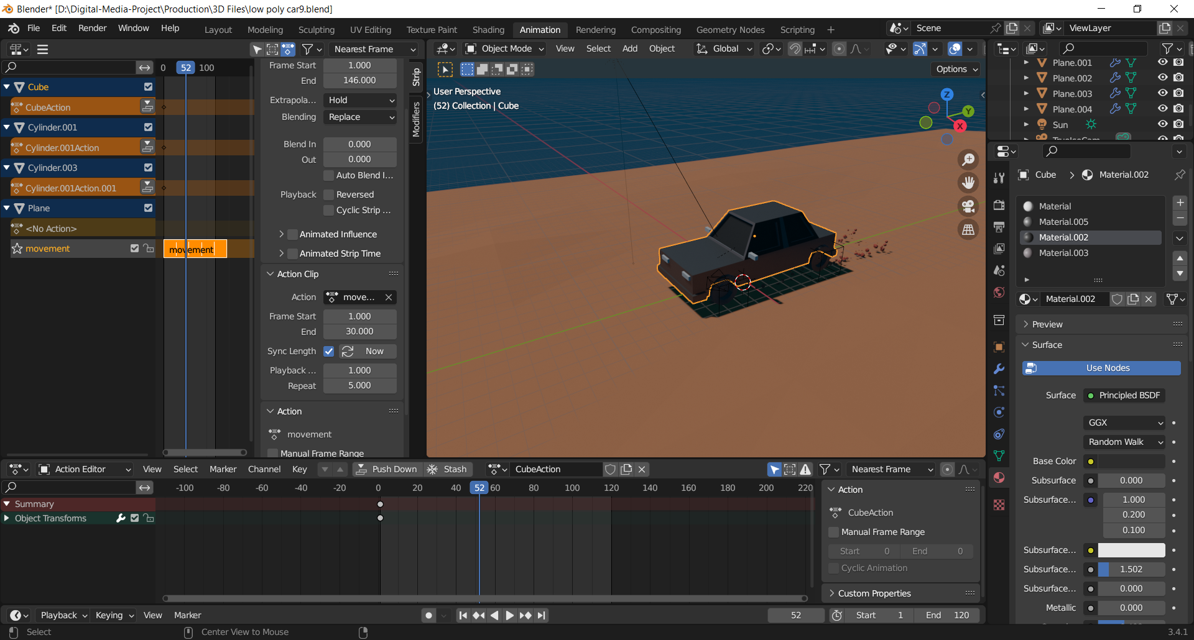

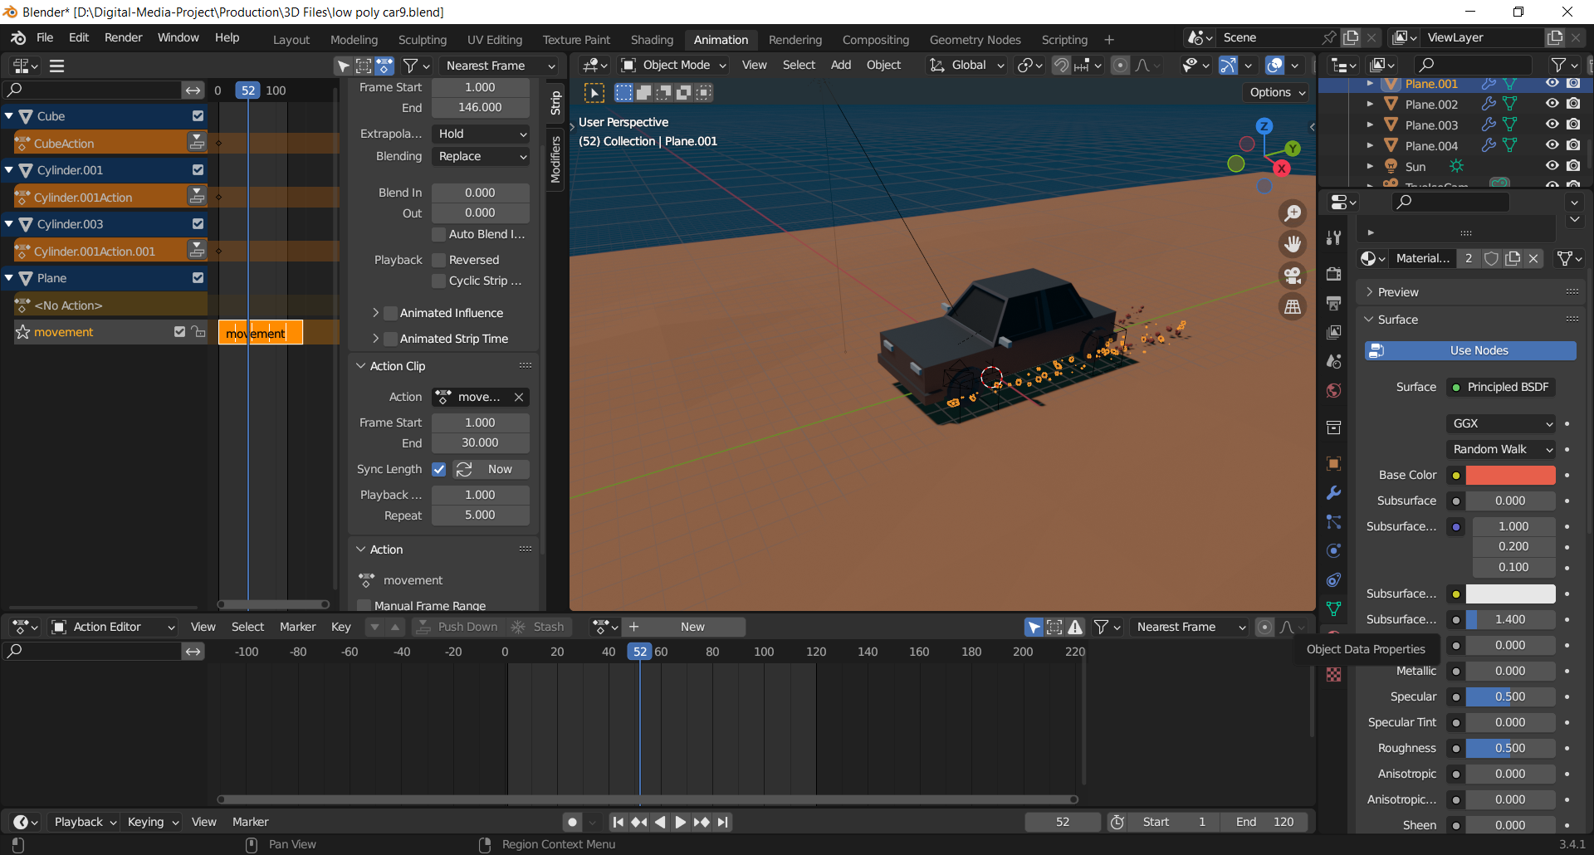

For its render setting I set the render and viewport to sample 120 pixels for rendering which will give me a clearer and less noise render output.

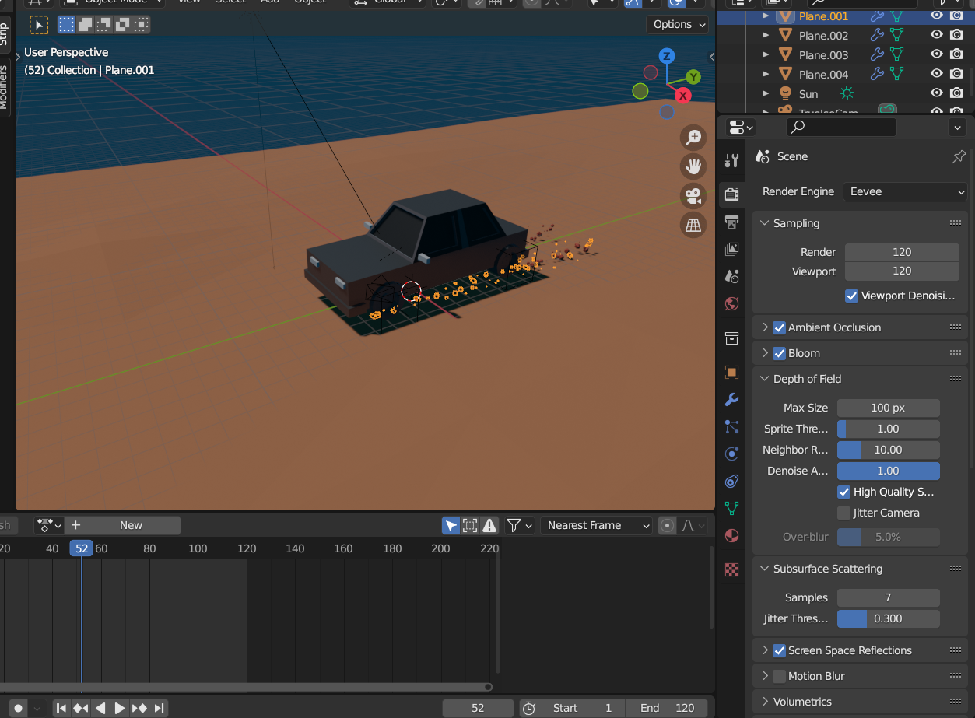

Figure adjusting light source

### 8.2.4 Low poly stylized witch room

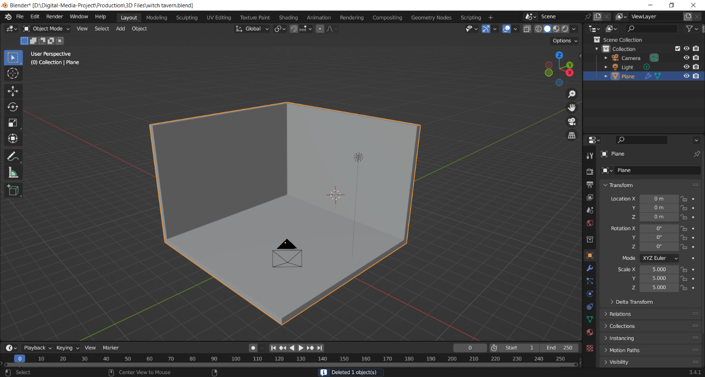The fourth model for my asset pack is a witch’s room. To create this model, I decided to model it in an isometric view. Firstly, I modeled a plane and then extruded it along the z- axis. Then I extruded the faces along the normal.

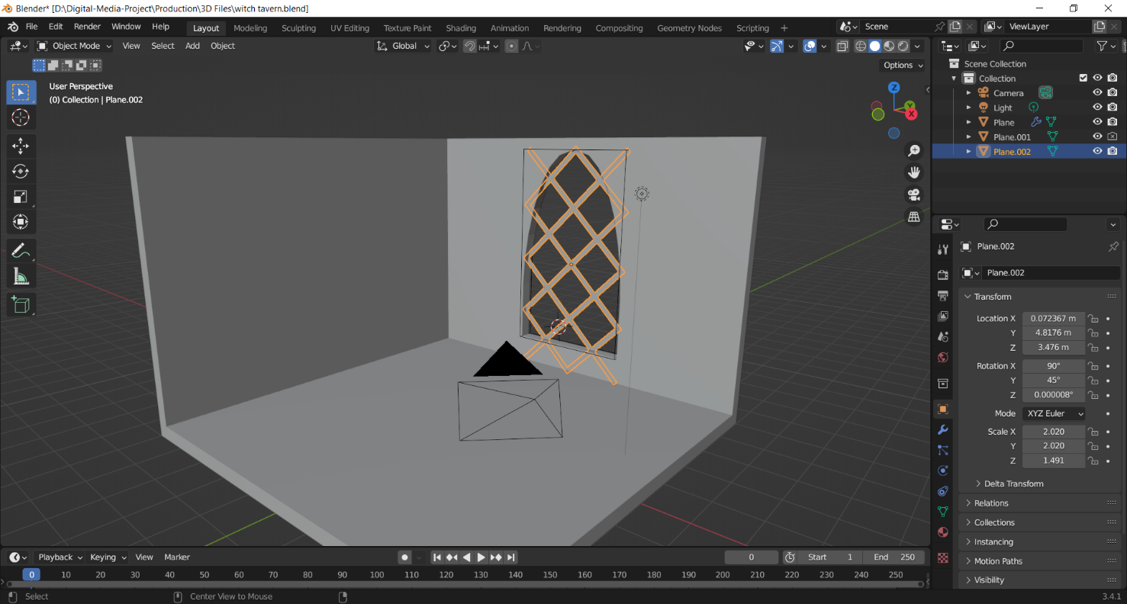Then to add a window to the room, I modeled a steel bar and used a cylindrical shape and differentiated it with the cube.

Figure modelling room's window

Then to design low poly brick walls, I at first modelled 5 different low poly design for the brick walls and used the array modifier to add others on the z- axis. After that I positioned them accordingly to the room.

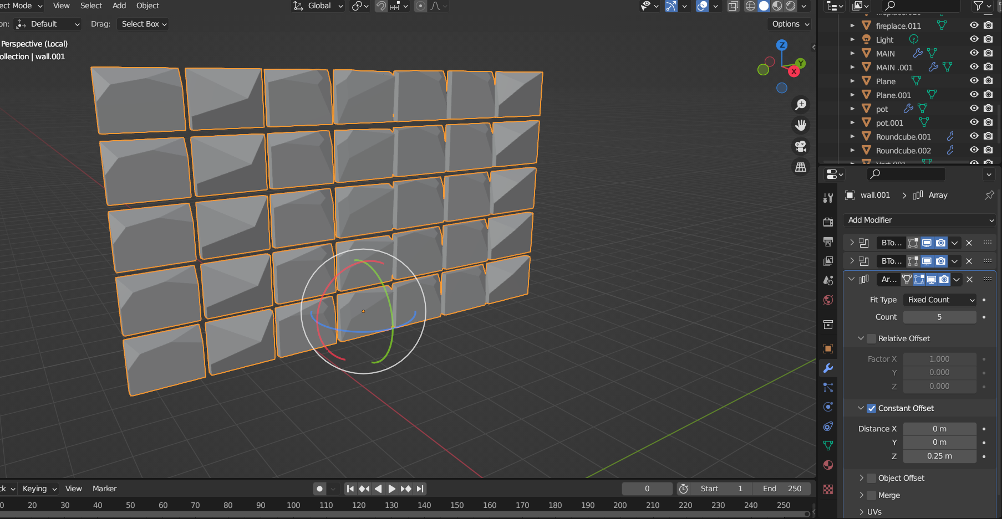

I used the same models for stones for the pavement f the room and placed them accordingly.

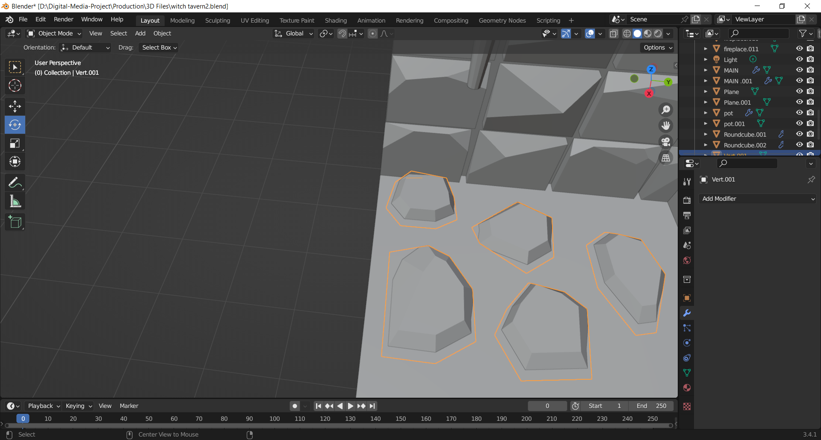

Figure modelling low poly stones

Then afterwards to give more details and to make it look like a witch’s room I modelled a stone pavement for a coffin to be kept alongside a skull. I gave it cuts on the edges to make it look more natural and wearier. On top of it I modelled a metallic coffin to put the skull on top of it.

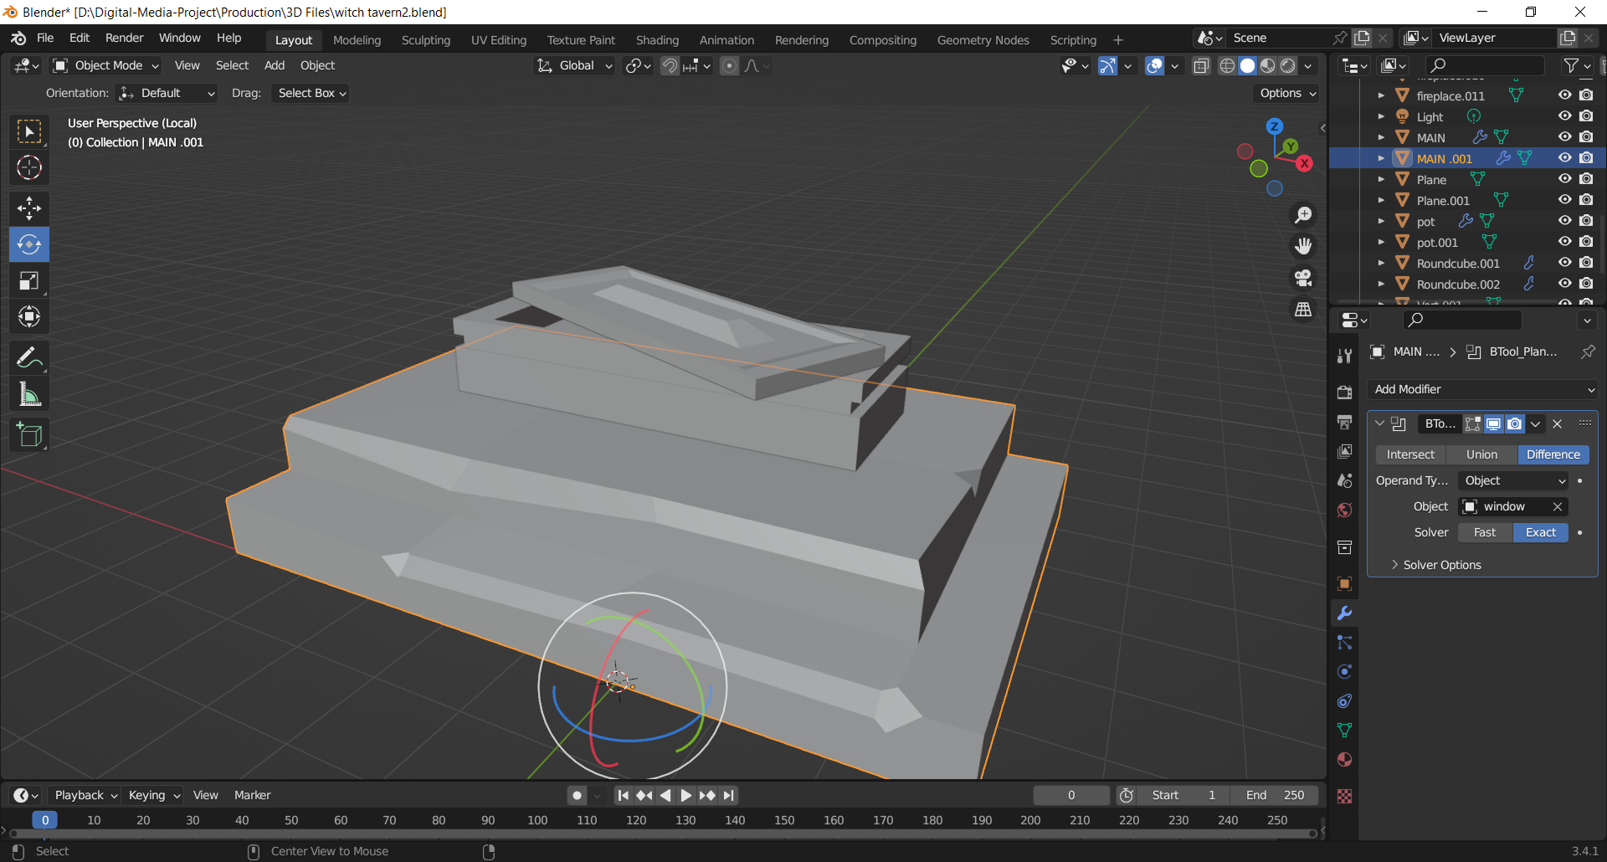

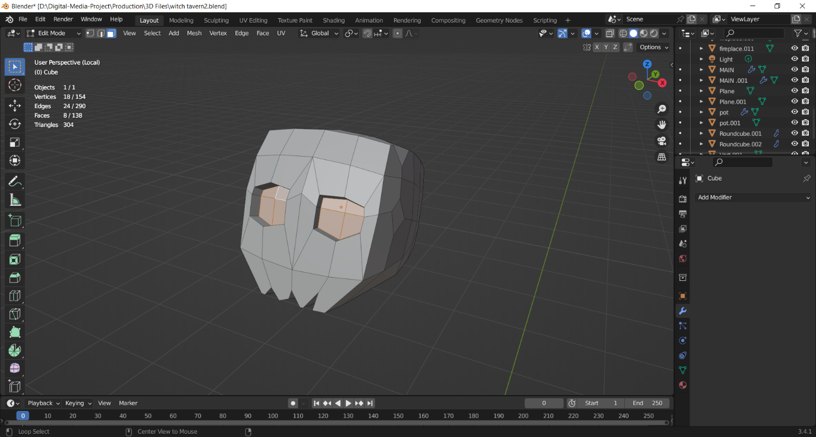I then modelled a skull for the top of the casket. I added a detail to its eyes by extruding them inside. I also gave a cut on its chin to make it look spookier.

Shortly after that I modelled a brew for the witch’s room. I firstly modelled a low poly stone and then set the origin from the median point to 3D cursor, which allowed me to duplicate the stone and rotate it on 30 degrees. After that, I modelled logs for the brew to place the fire on. I gave some edge cuts to the log to add some nice details.

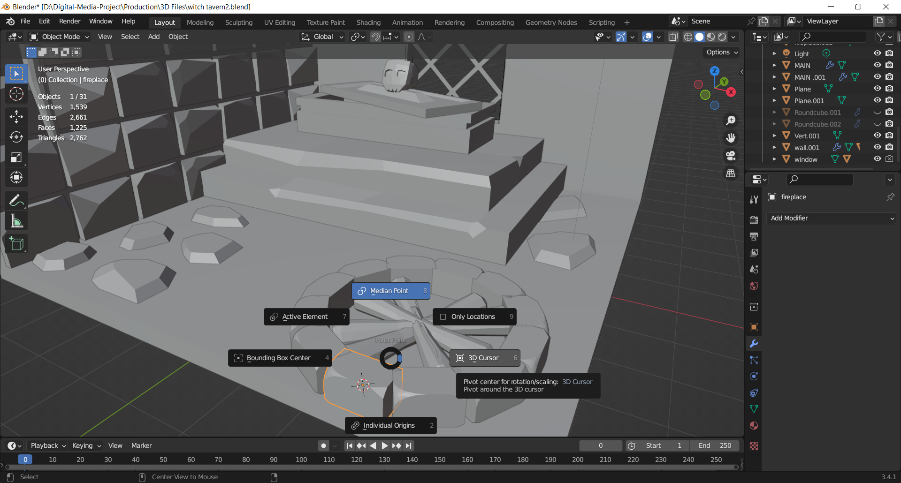

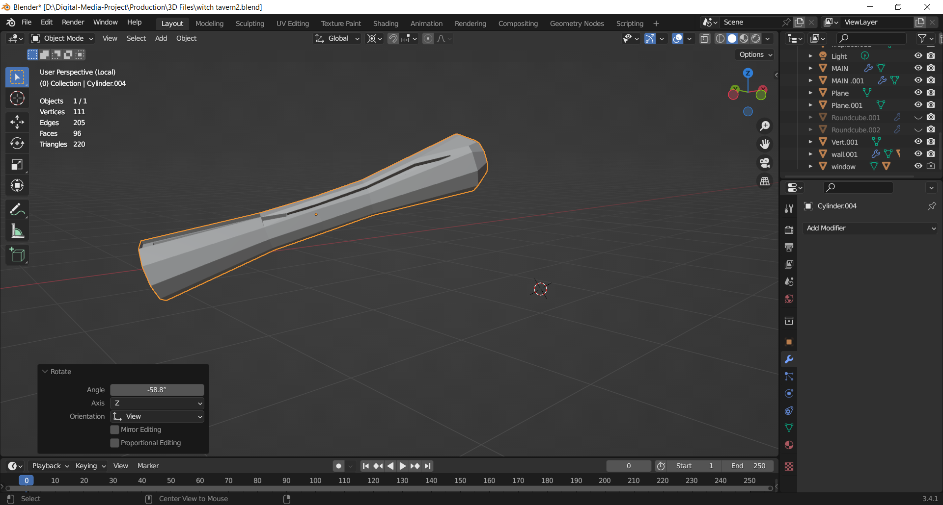

Then I modelled a stewing brew container for the witch. I added few details to the model as to make it look low poly. I then gave it an edge cut on top of it for a nice detail. I then added another place inside of it to later on to make it glow it the use of a shader.

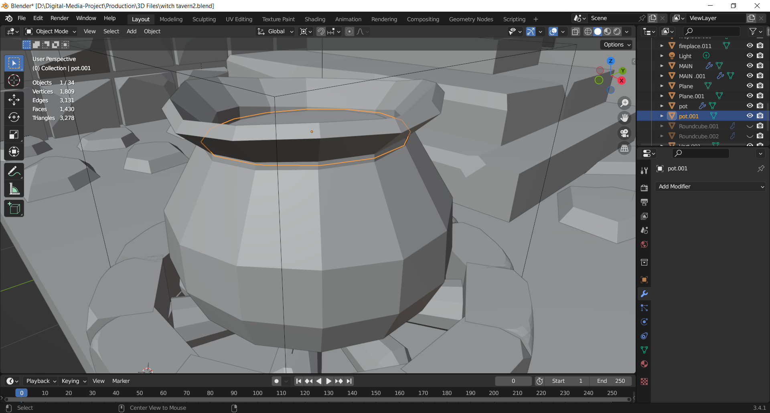

Figure modelling a brew

Then I Modelled potions for the scene. I modelled two different shapes and sizes of potions.

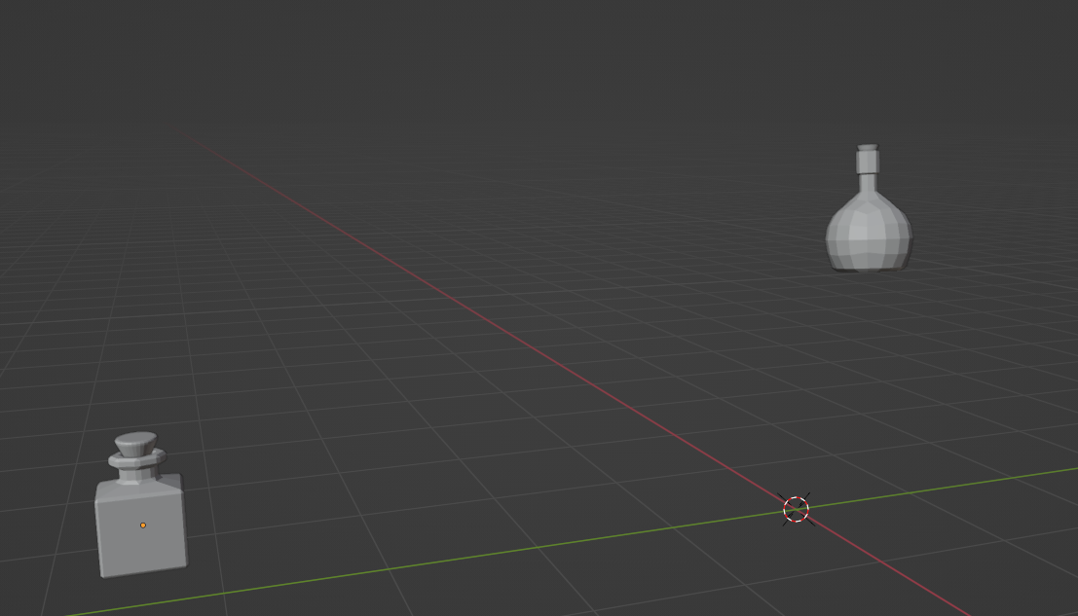

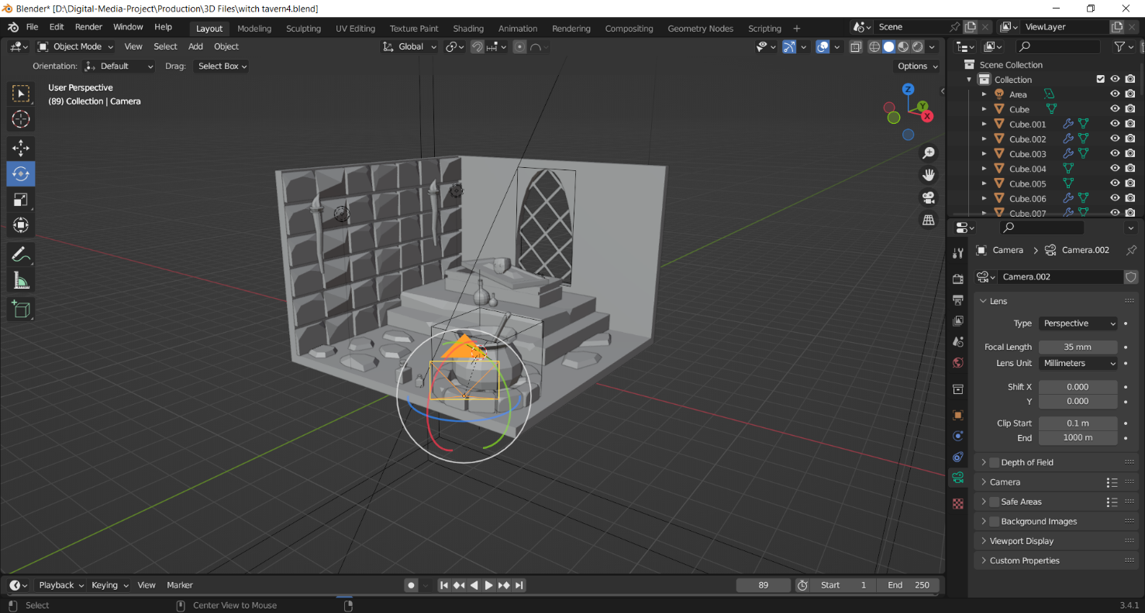After the modelling was done it was now time for the camera, lighting and shading of the materials. For the camera angle I placed cameras on various angles to zoom in and zoom out the details for the camera animation.

Figure adjusting the camera

Then to add some dark fog I added another cube and made it bigger than my objects. I removed its shader and on its volume settings I used it as a volume scatter to allow the light to pass through it as a volume. I also set the color and value of the density to match my lighting.

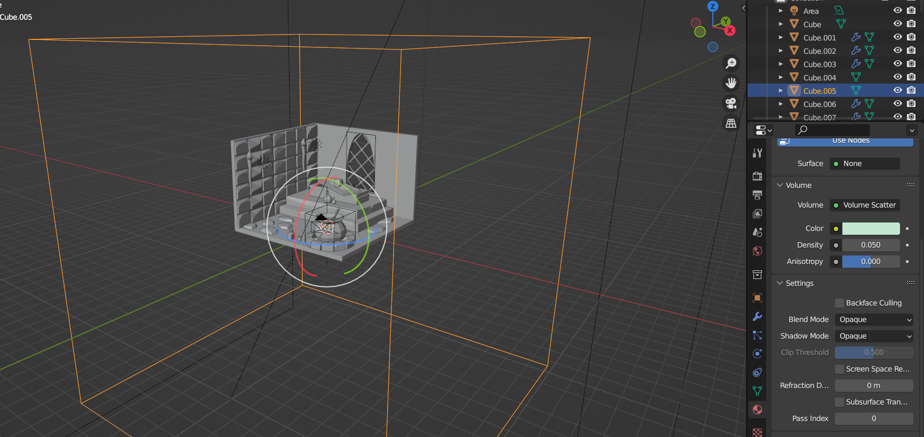

The for light, I used the sun light as my primary light which is way above from my scene to provide a sense of night with blue shader. I also placed 34 points light on the scene. One at the bottom of the brew, two in front of the fire and the last inside the coffin to give a creepy vibe.

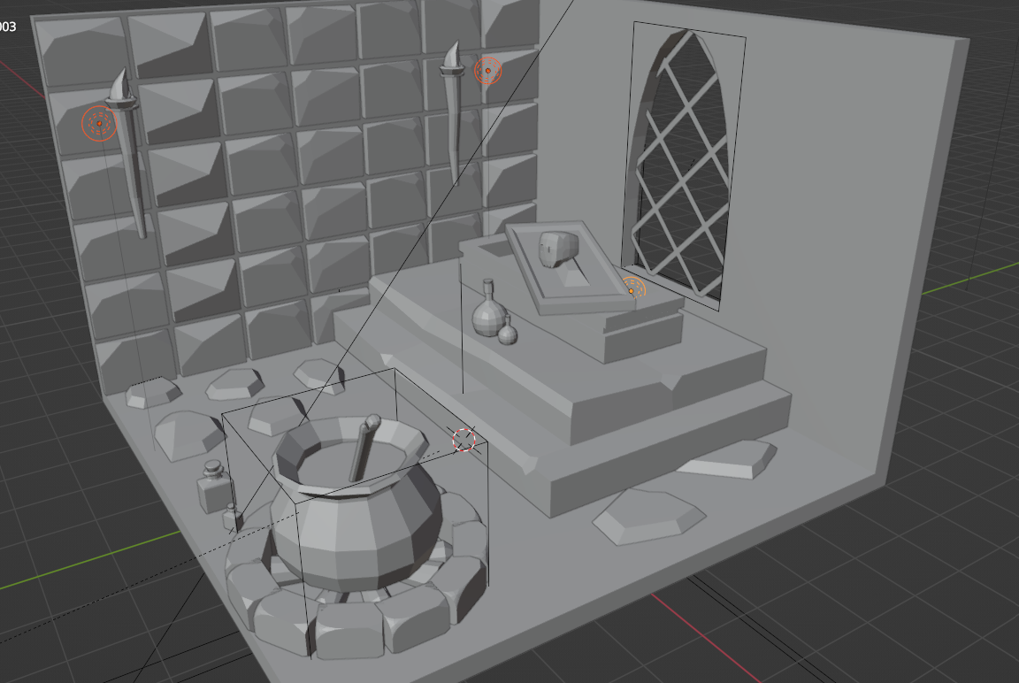

Figure adding point lights to the scene

Moving on to the shader of the materials, for the pavement of the room I used a shader closely resembling a greyish cement to fit for the scene. I used the same shader for the wall, the stairs to the coffin and stones as well, then duplicated them and altered it to my liking. For the coffin lid I set the metalness high and dropped the roughness off it.

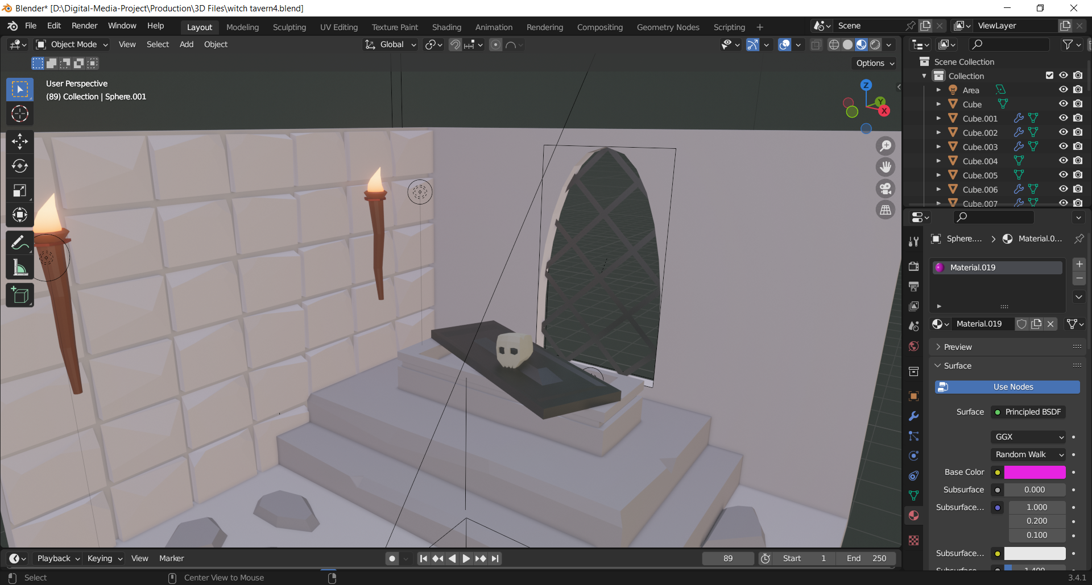

Figure reviewing on material preview

For the shader of the potions I used a PBR shader. I bummed up the roughness of the model, decreased the metalness and increased its transmission. To make it transparent I had to check on the Ambient Occlusion, bloom and screen space reflections. This helped me in the reflection of the ray and made the emission shader to light up.

After adding the shader, to create the liquid inside the shader on the shader tab I bummed up its IOR, transmission and roughness which made it more of a solid substance that more has liquid nature in it.

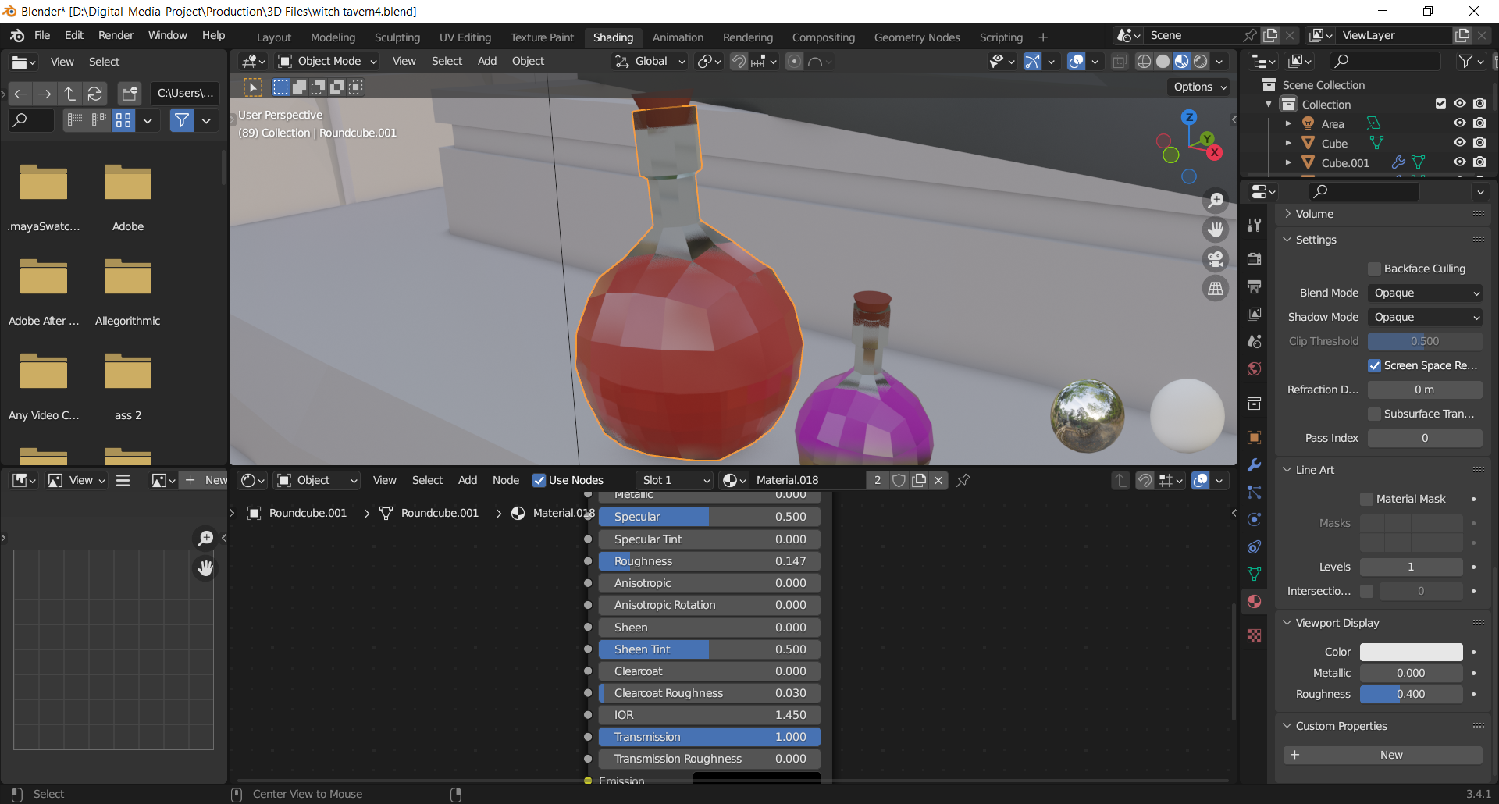

Figure adjusting transmission on node

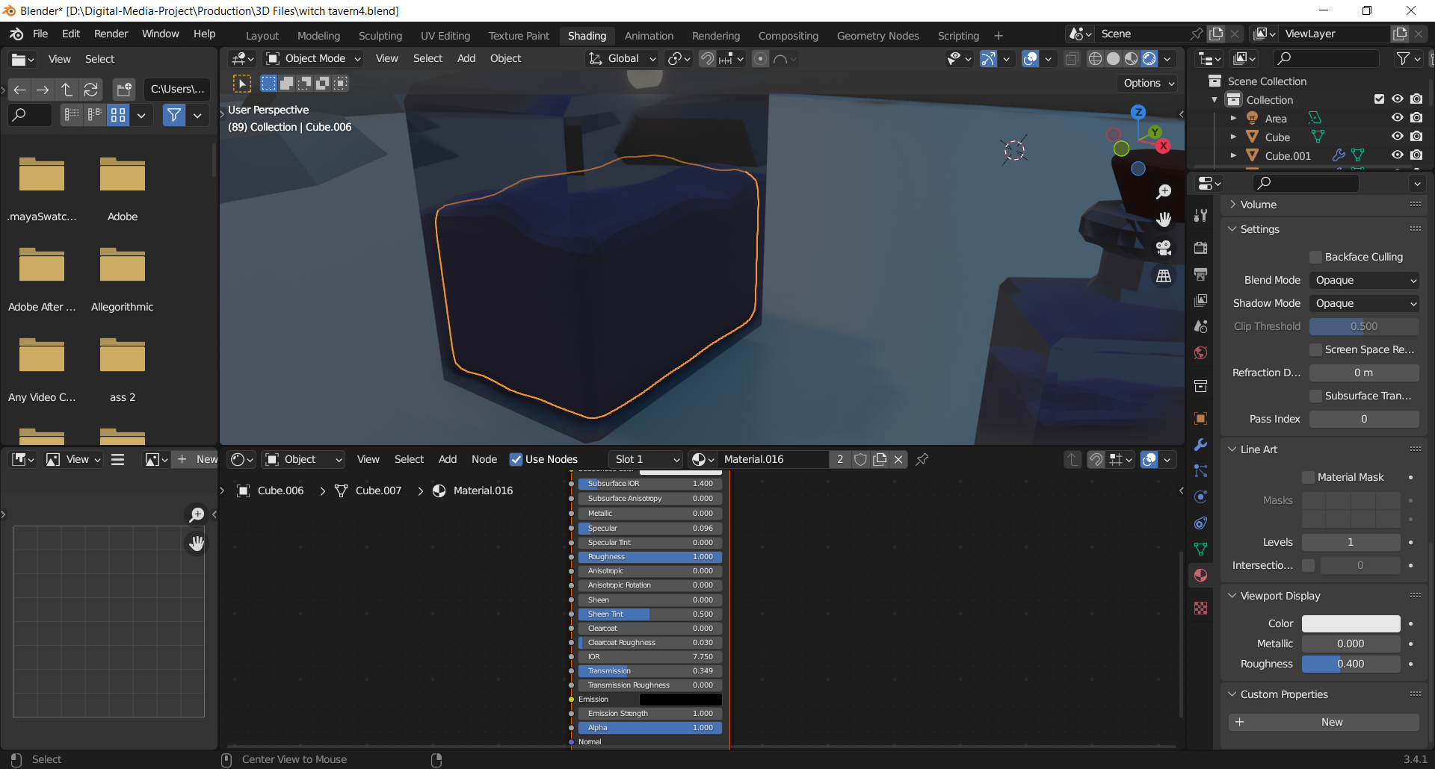

Then after everything was completed I set the render settings for the scene. I set the render and viewport to a 120 per pixel sample.

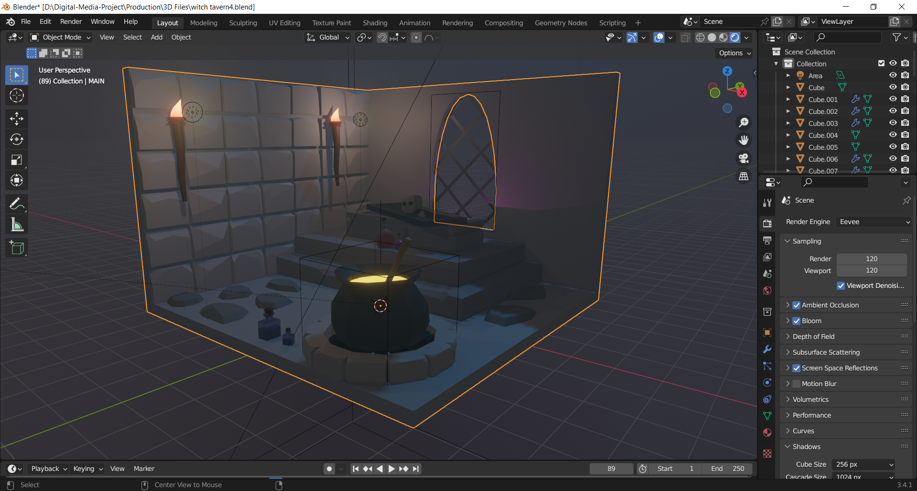

Figure final output

### 8.2.5 Low poly stylized hammer

The next model for my project was modelling of a hammer. This was a weapon asset for my pack. To model the hammer, I created a cube and then scaled it to make it to a rectangular. The, I added an edge loop to its center and deleted it.

I then added a mirror modifier to it, for it would be easy for I would not have to model in both sides of the hammer. I then created a loop cut on the center of the side of the model. I used the loop cut plug-in from Blender, which allowed me turn the square loop cut to a circular loop cut. I then added details to the model.

I applied Bevel weight to random edges on the side of the hammer. This gave it a more unique and distinct design.

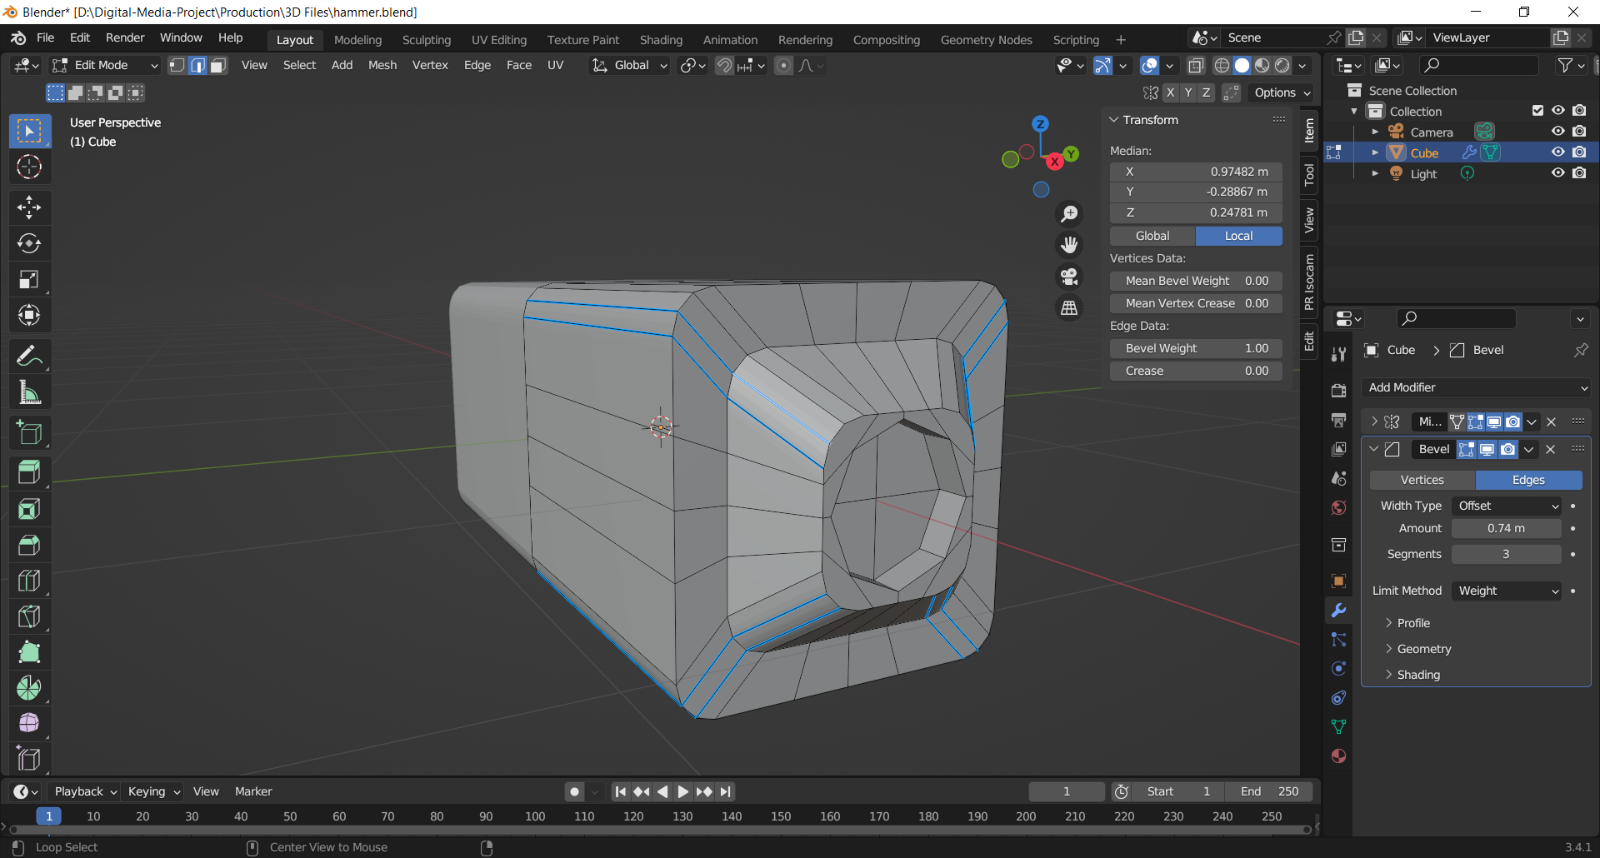

Figure adjusting the bevel weight

Then to create the sheathe for the hammer I use a cylinder and applied the Decimate Modifier and set the iteration to 2. This allowed me to reduce the vertex and face count of the object with minimal changes.

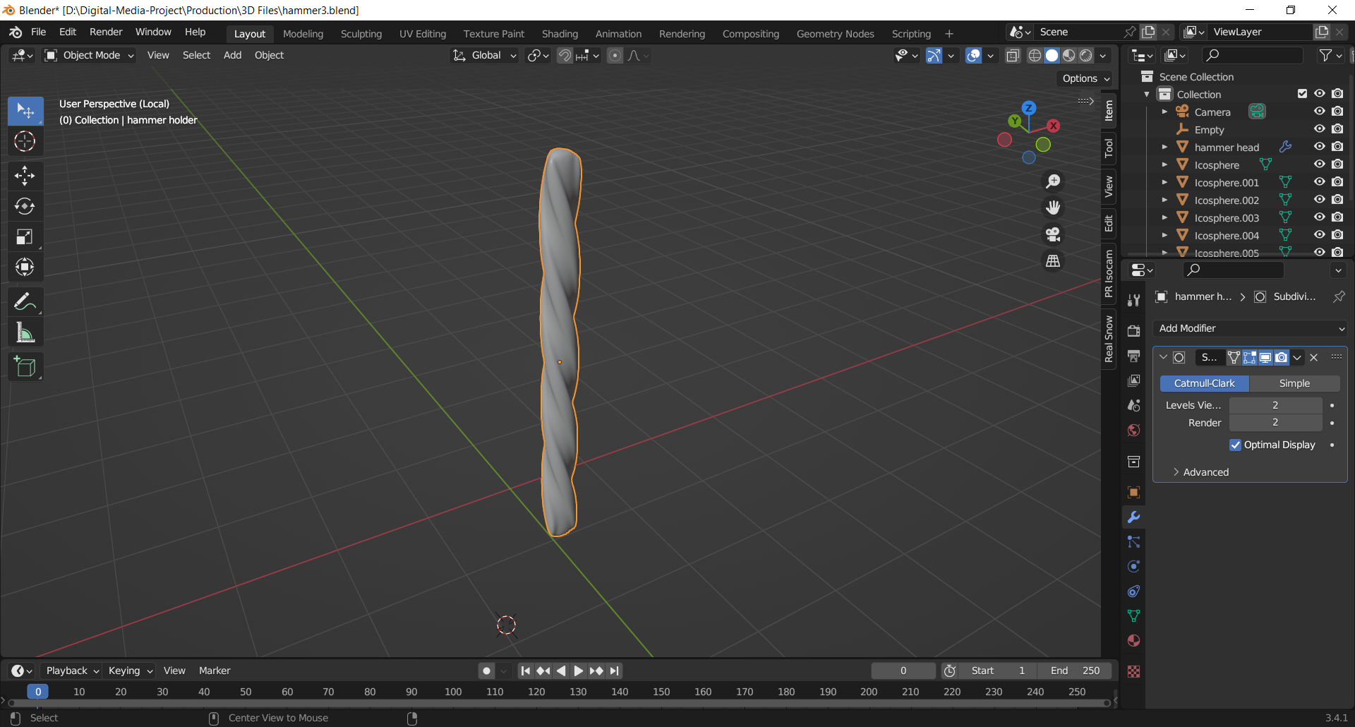

Figure using decimate modifier

To model the tip of the hammer, I used the curve tool to create it along the axis. Once it was completed I used the solidify modifier, which allowed me to increase the overall thickness of the object. I then subdivide the object by 1 to make it look lower poly.

For the cap of the sheathe, I used a cylinder and resized it tom fit it. I then used the edge cut tool to cut it and give it a more appealing design.

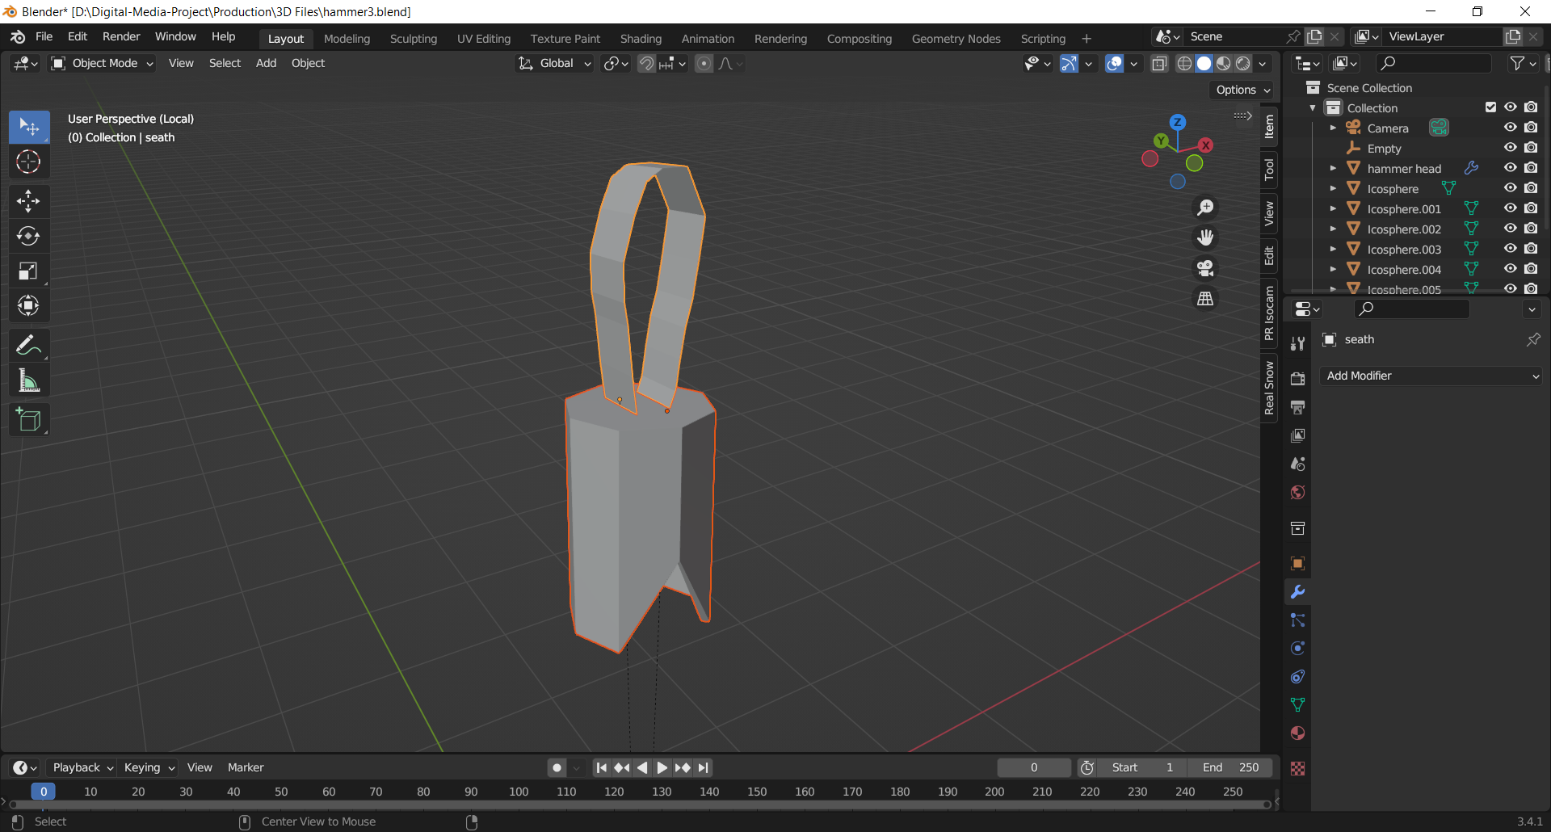

Figure handle for the hammer

After the modelling of the hammer was completed. To give the background scene a more aesthetic I started modelling low poly stones. To model them I used the bisect tool. This give me a easy and faster way to cut a mesh into two along a specific plane. I then adjusted the Clear inner and clear outer of the stones and rescaled and positioned them accordingly.

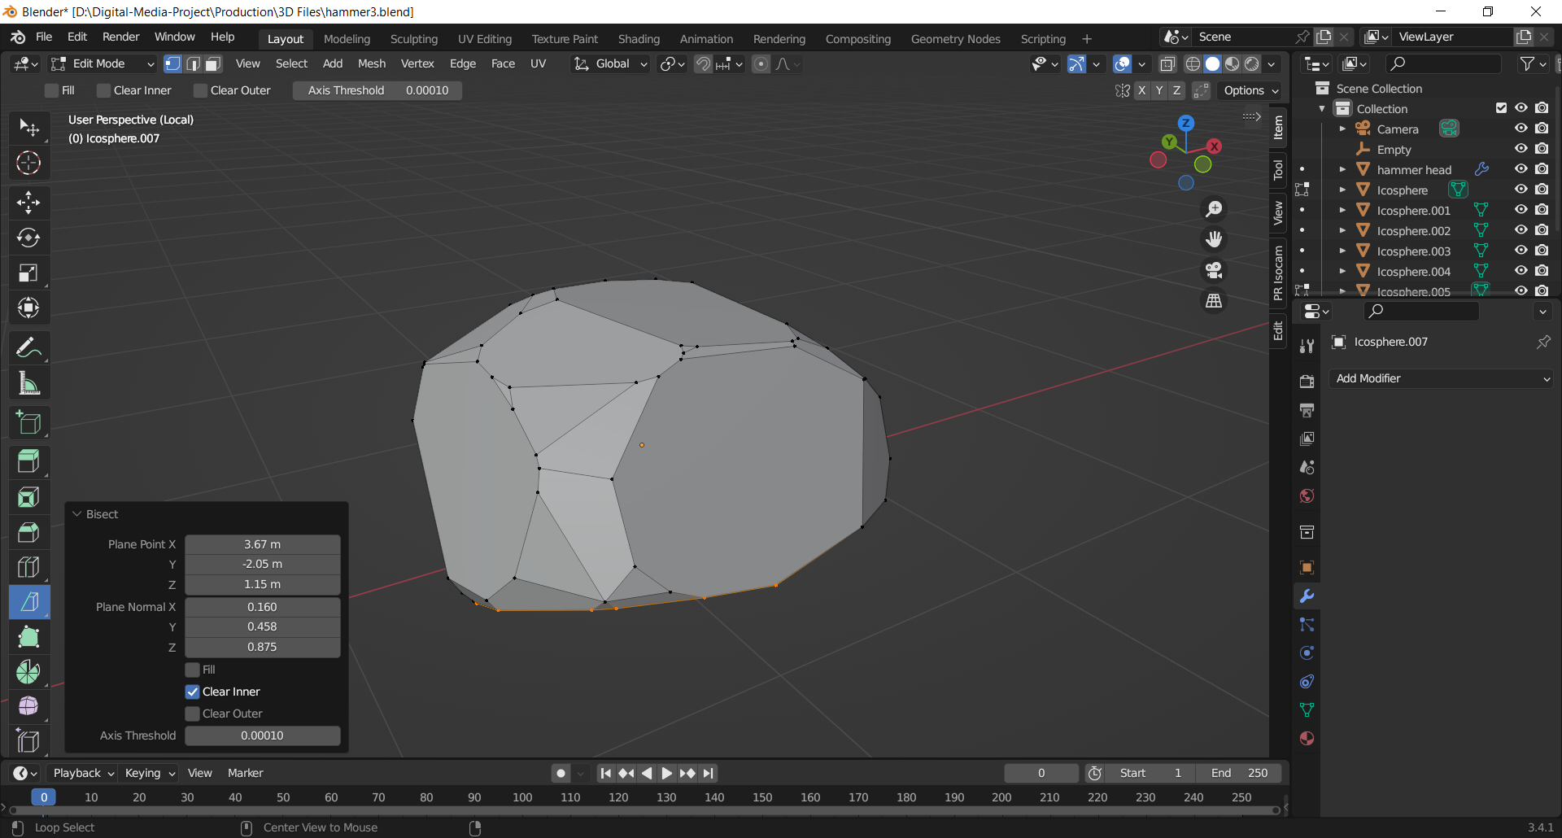

Figure using the bisect tool to model stones

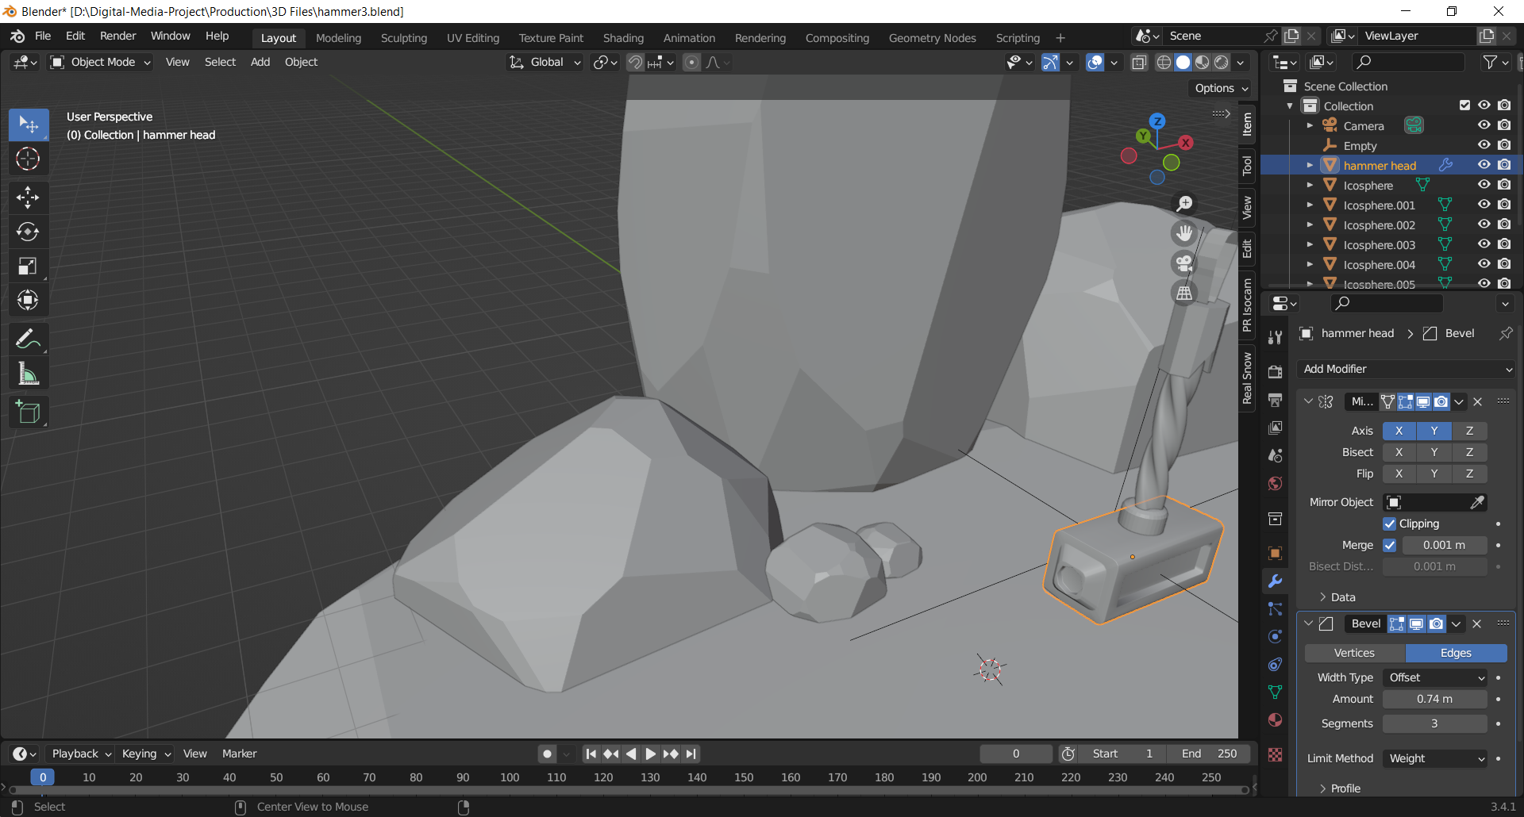

After the modelling was done I set the camera and lighting properly to fit my scene. I set the camera at a front view angle to get a medium view of my model.

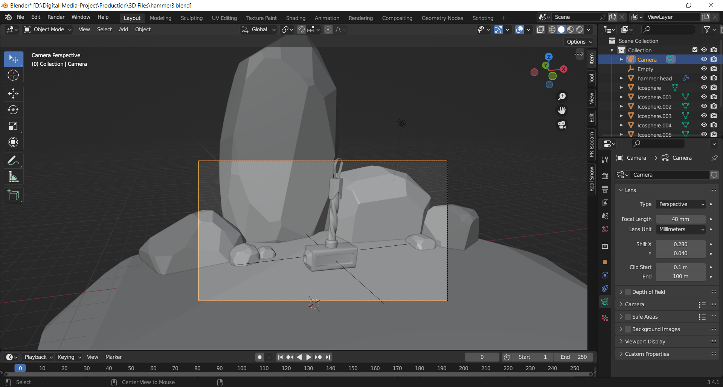

In this scene, I have used three-point lighting technique. I have placed the primary light on top of the top of the scene. The strength of the point light is around 500 watts. I have placed the back light behind the scene to provide a slight touch of light. Then, I have placed the fill light at the right side of the scene to cast the shadow.

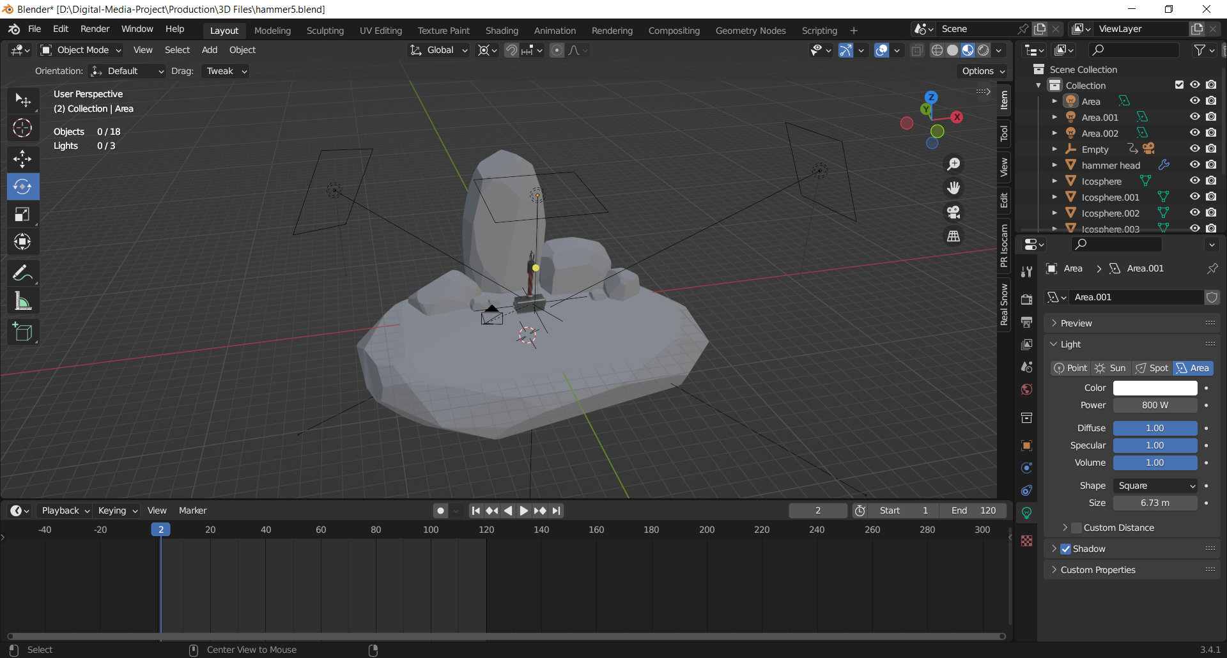

Figure adjusting the lighting

After the lighting and shading for the model was done, for the render setting I have sampled the viewport and render to 150 pixels per render.

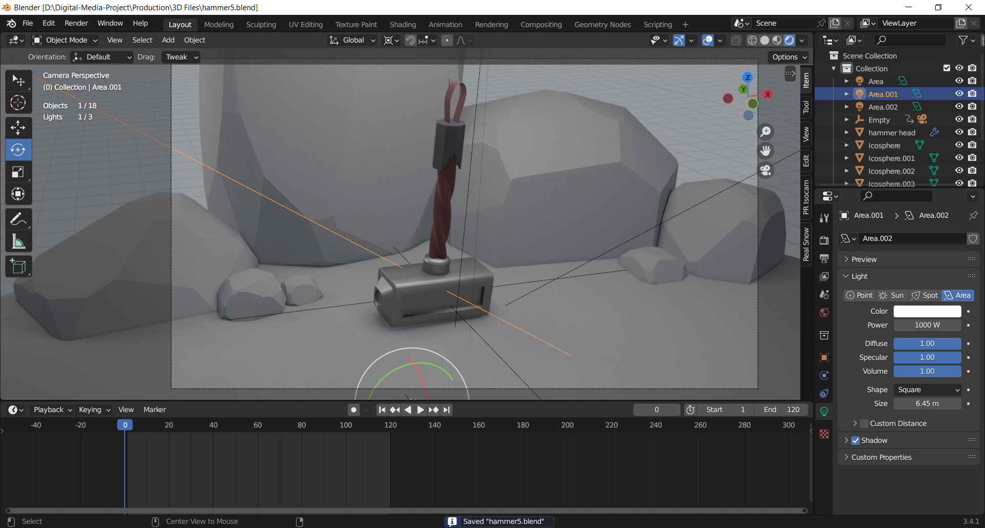

Figure final output

### 8.2.6 Low poly stylized outer space

Then the next animation loop for my asset pack was an outer spaceship animation. So, firstly I started by modelling a spaceship for my scene. For the spaceship of my scene, I used the same model from my previous asset pack, but to give it a more detail I added a tail to the spaceship for it’s fire launch. To add the tail, I used a cube and extracted the cube and pushed back the face for the fire to start. I also added a missile to my spaceship. I used a cylinder and then beveled the edges of the center to make it more circular. I then mirrored the object to my left side.

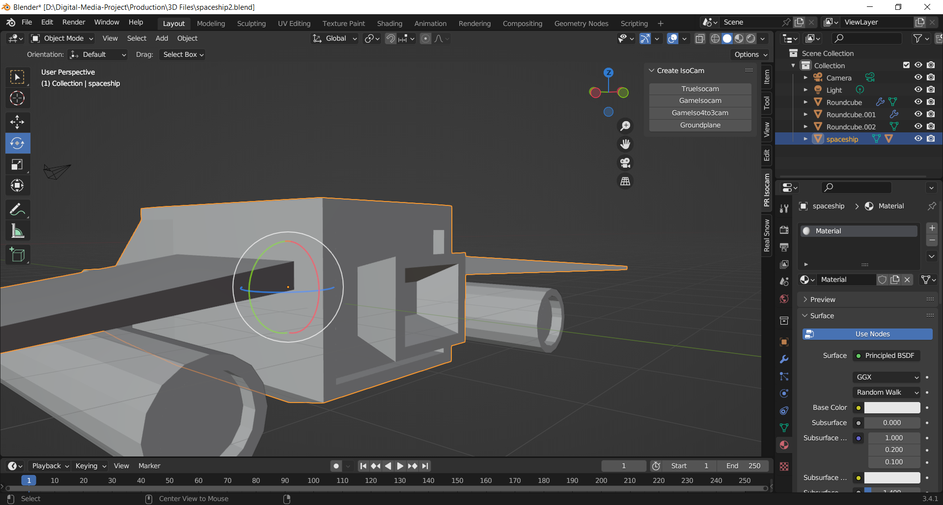

After the modelling for the spaceship was done, it was time to model the asteroids. To give them bumps I used the displace modifier this displaced the vertices in the mesh based on the intensity of my texture. So, I set the texture to Voronoi which creates cell like patterns for the model based on Worley noises. To make the asteroids with different characteristics, I also selected random faces of the asteroid and deleted them. This later on allowed me to select the faces and place a emission shader on them to lighten them up.

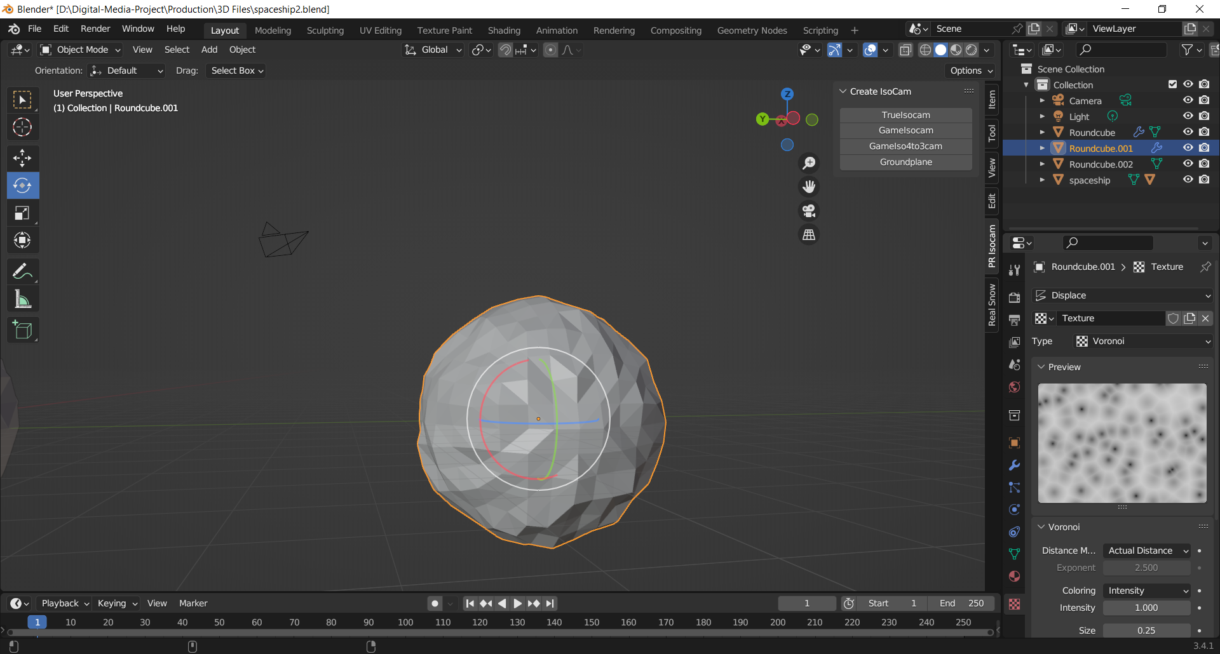

Figure using the displace texture

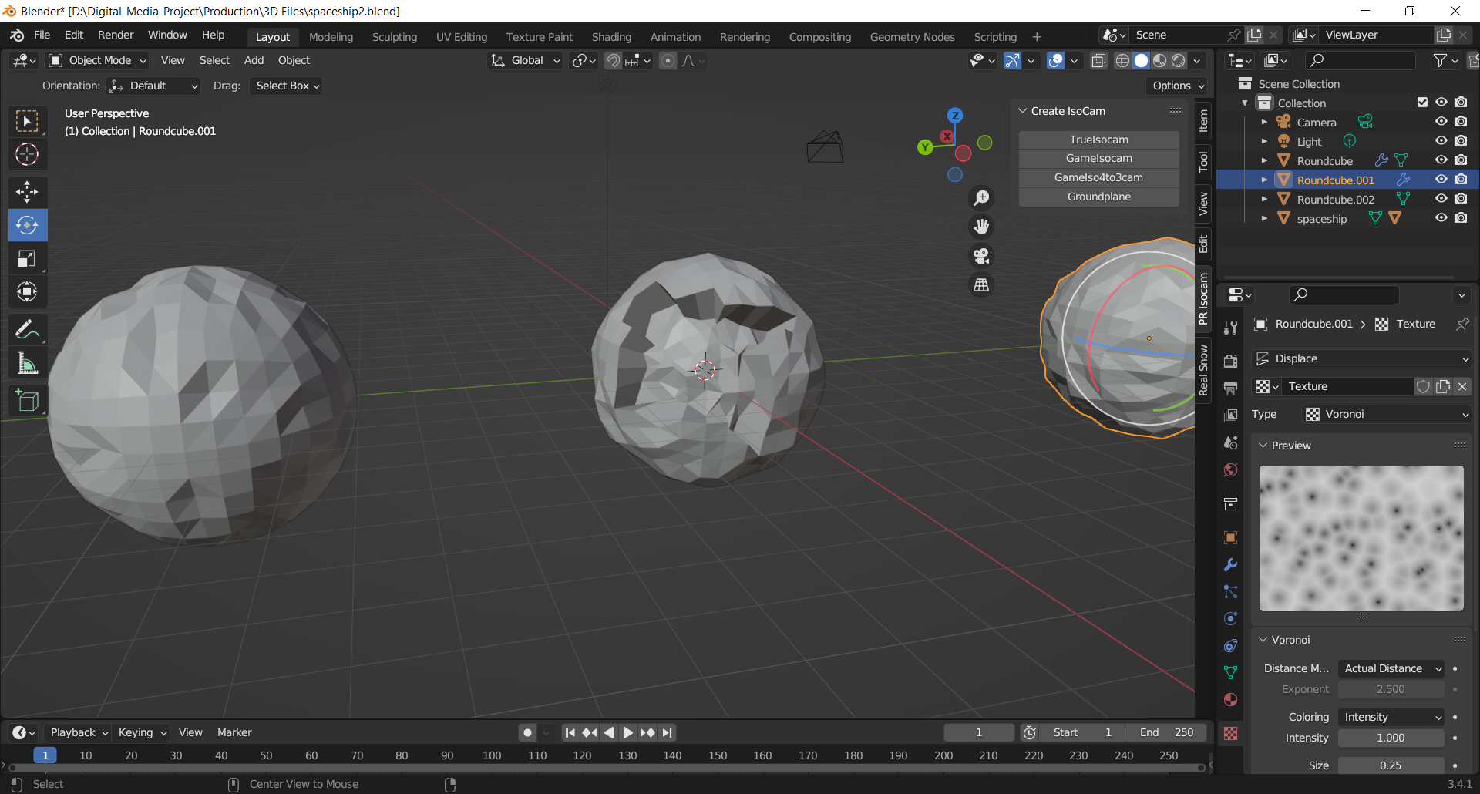

I then placed the asteroids in front of my scene. I then duplicated them and hid the original ones. In order to do so I paired them up with and empty axis which made it easier to select only one object rather than selecting three or four and moving them one at a time.

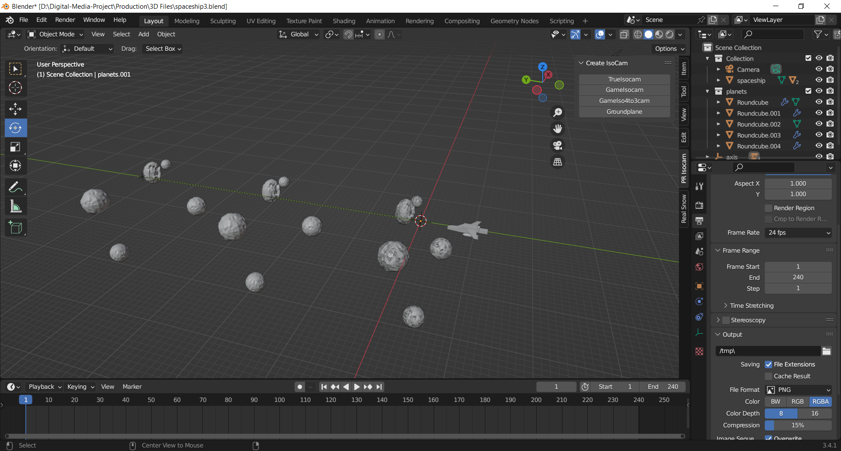

Figure duplicating the asteroids

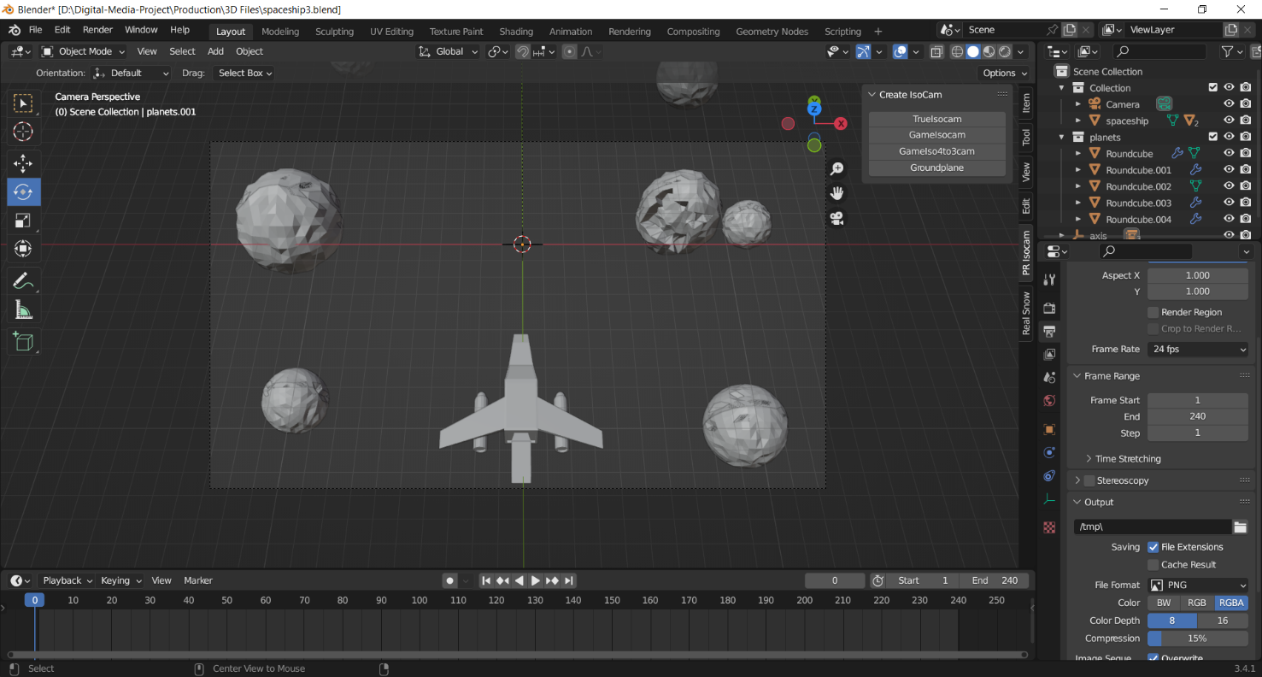Then, I placed the camera on top of the spaceship for my view. Shortly after that, I set the frame range from 1 to 240 and the fps to 24, with the resolution to 1920*1080 as it is for all of my other assets.

Figure adjusting the camera

Then after that, I animated the spaceship along the y-axis and added a fun spin animation for it.

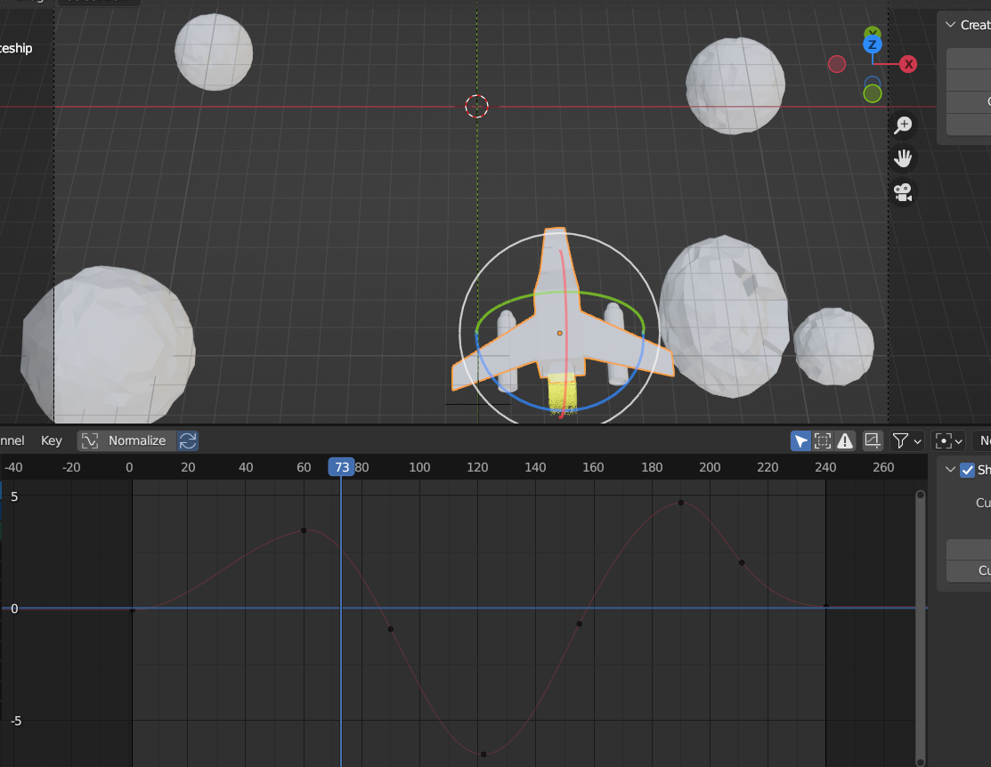

Figure adjusting the animation

Then at the shader tab, I added an emission node to the tail of the spaceship. I set the color to yellow. I also added a transparent shader to make it opaque. For this I also added a mix shader which is connected to the surface.

To make the color of the spaceship yellow I added a color ramp which was connected by a gradient ramp. I also mapped the gradient ramp, which allowed me to shift the position of the flame on the x-axis. On the color ramp I added two ramp one which I set the first one to brighter yellow and the other to none. After it was done I check on the Bloom setting on the Eevee render.

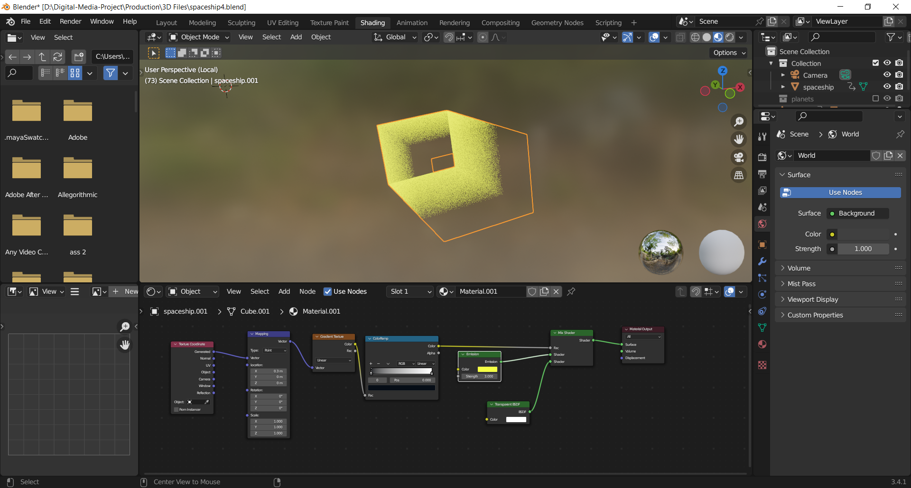

Figure adding mix shader to the tail

After this I added a cube to my scene, and made it larger than my models. I then disconnected the shader and, on its volume, I set it on to Principle volume node which combines all the volume shading components into a single and easy usable node.

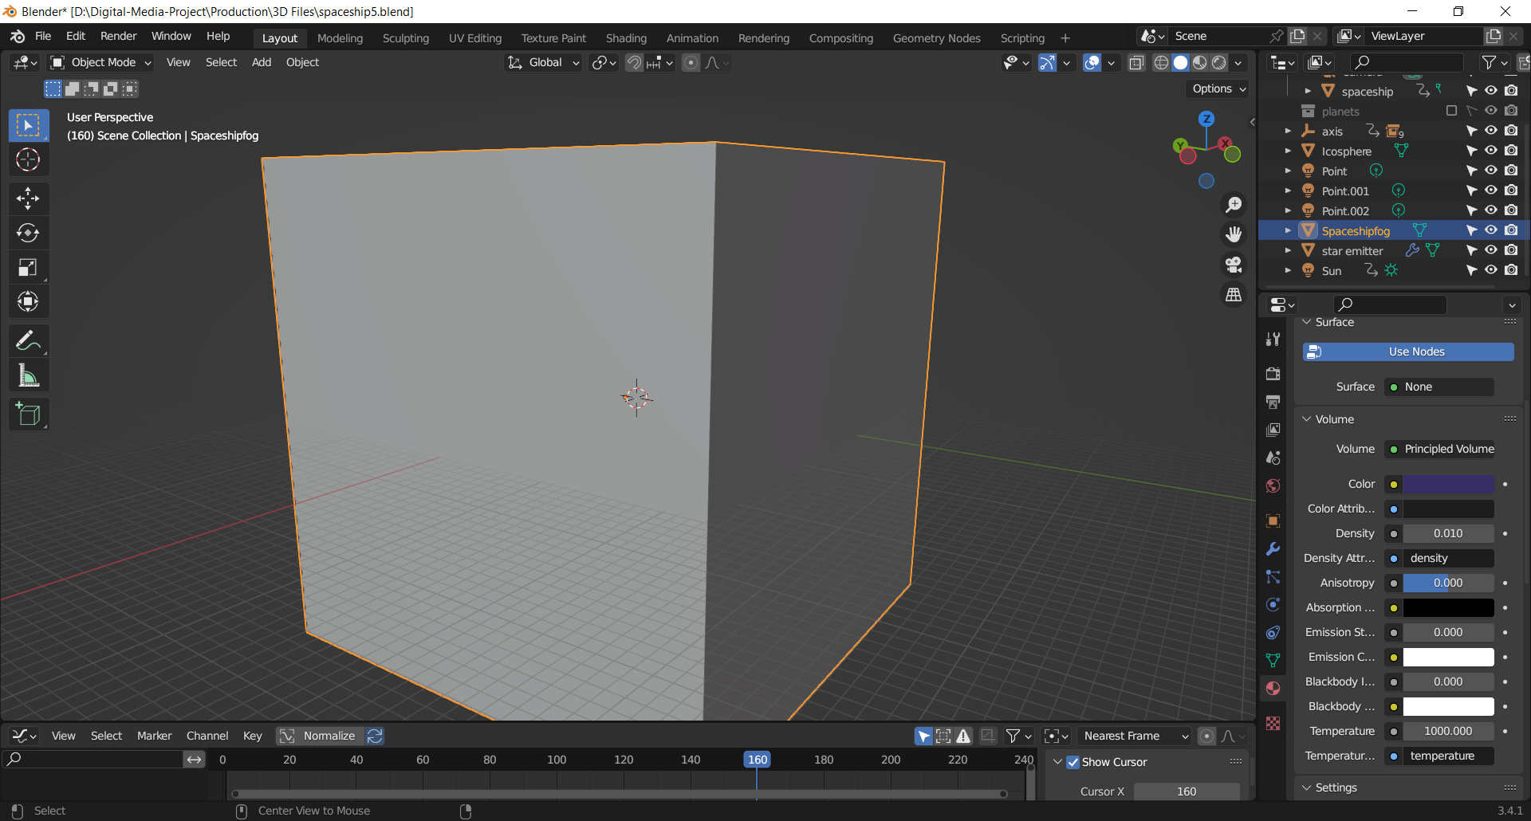

Figure creating outer space

After that I wanted to add stars to the scene, so I used an icosphere and set its value to 1 and rescaled it accordingly. I then instanced the stars to a plane and angled the plane at an 80 degree which allowed the stars to flow from up to down. I also added an emission node to the stars to make them glow. I also set the blend mode to alpha clip and Shadow mode to opaque, adding a transparent BDSF shader to the plane to make it transparent.

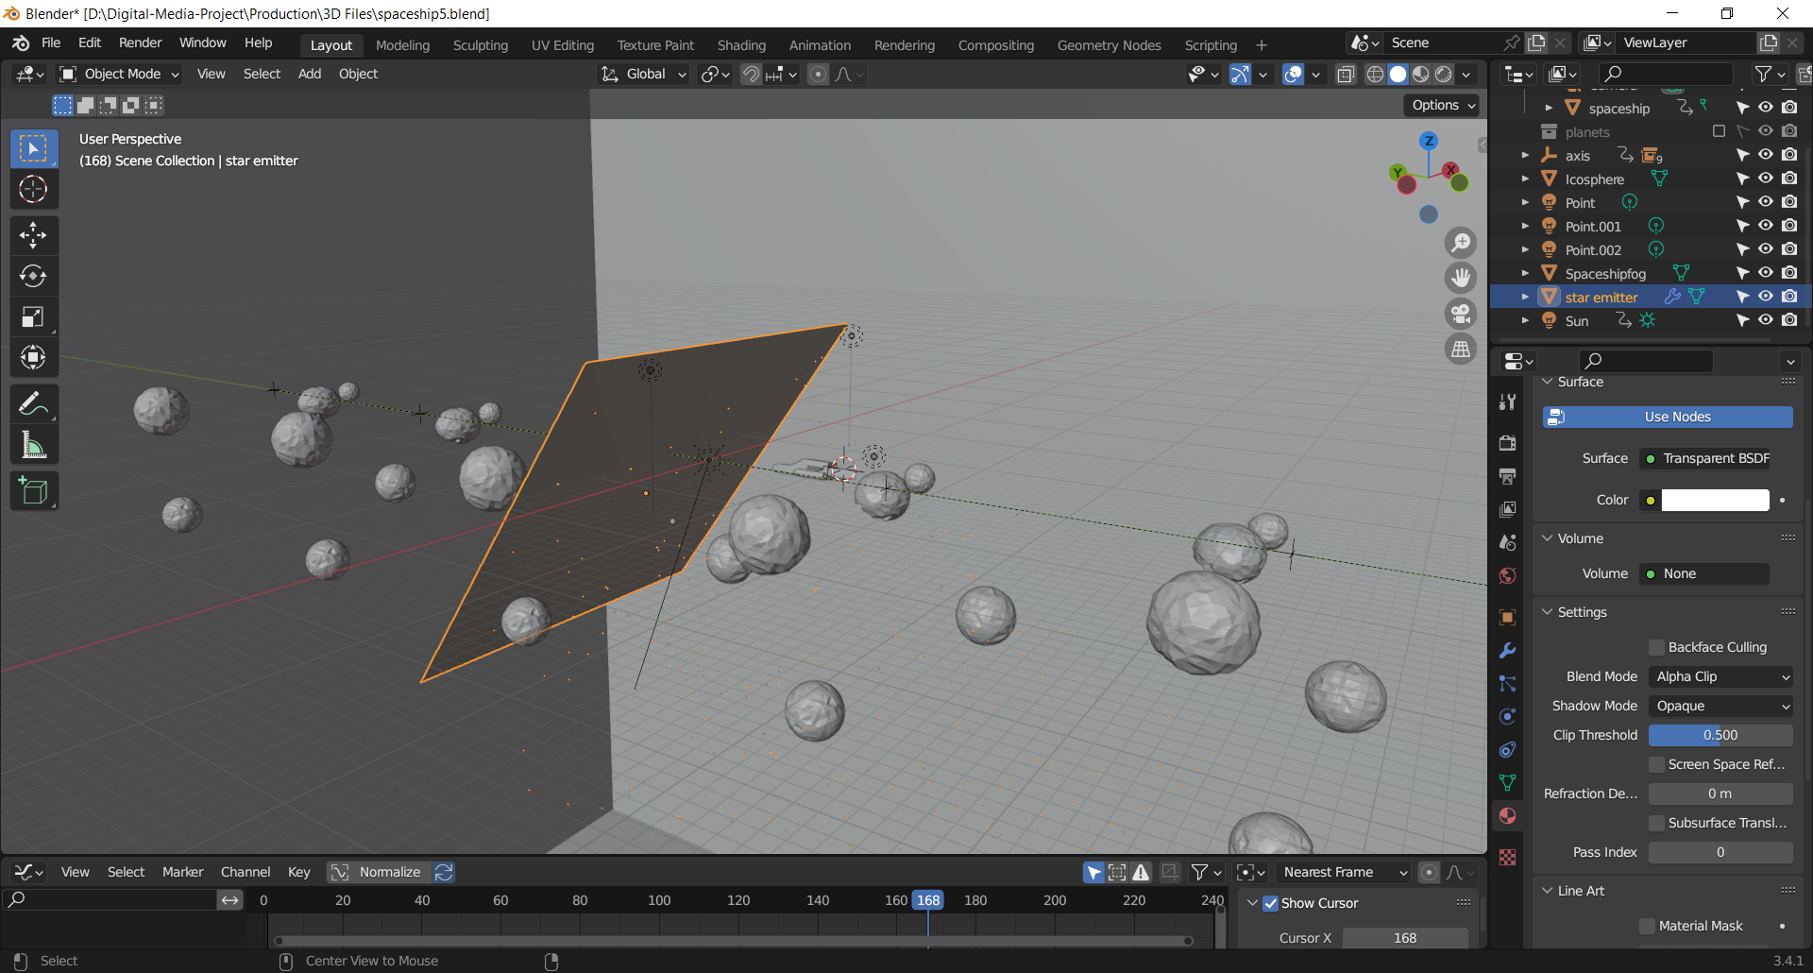

Figure instancing the stars

Then, I added PBR shaders to my spaceship and planets. I increased the metalness of my PBR shader on the window and the missiles of the spaceship. For the planet I increased the roughness and decreased its metalness.

I also added a mix shader to the planet and added an emission shader to it to make them glow from their outer shell. I also added Fresnel node to the emission node which allowed me to calculate how much light is reflected on an object. So, I set the value lower to reflect lower light to give the asteroids their own natural lights.

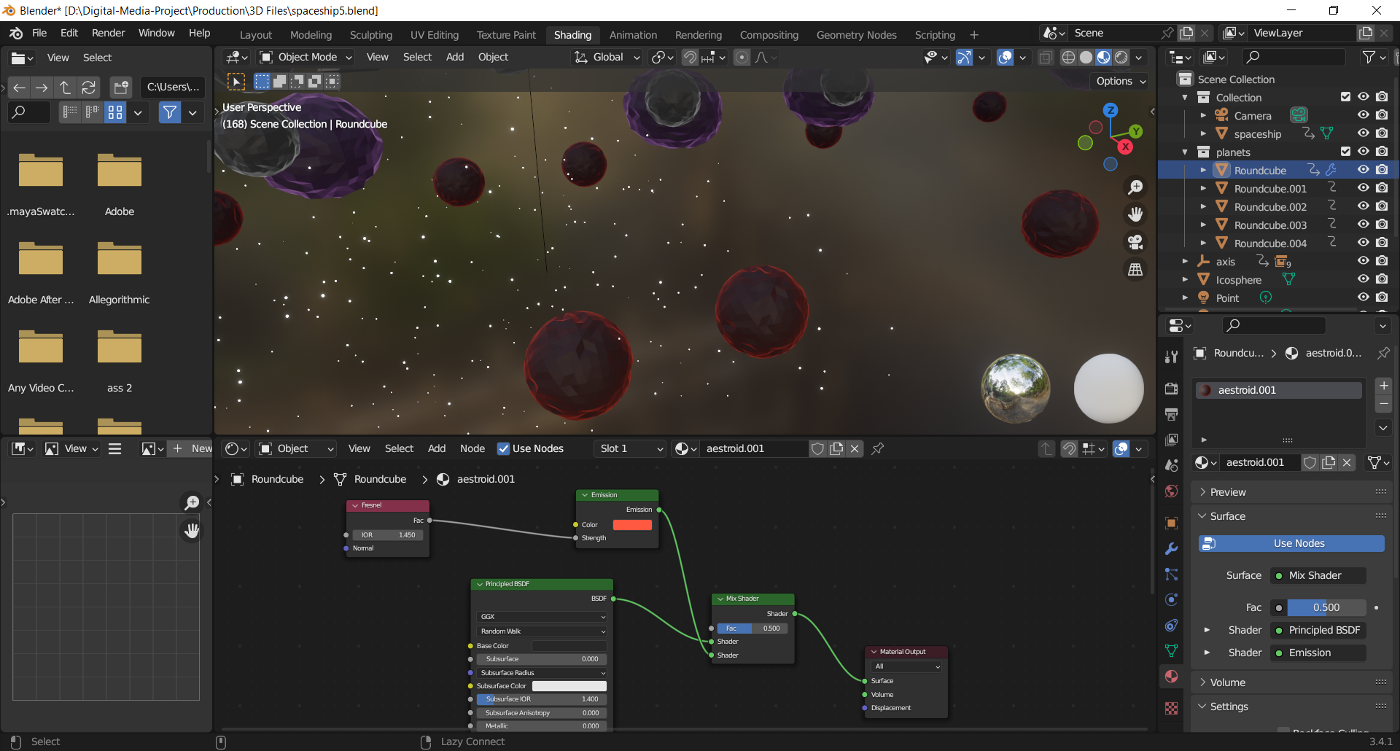

Figure applying outer glow at the node editor

Then, I added three lights to the scene. I added a point light behind the spaceship to give I also positioned two other point light at the left and right side to give space light passing by the planets. I set their values accordingly to match with my scene. I also set the background colour similar to my lighting and made it look more and give aesthetic to my outer space.

For the render setting I turned o Ambient Occlusion for more extra details, bloom for the emission to brighten up my spaceship’s tail flames, and screen space reflections with reflection turned on. I set the render and viewport sample to 240 per pixels for rendering.

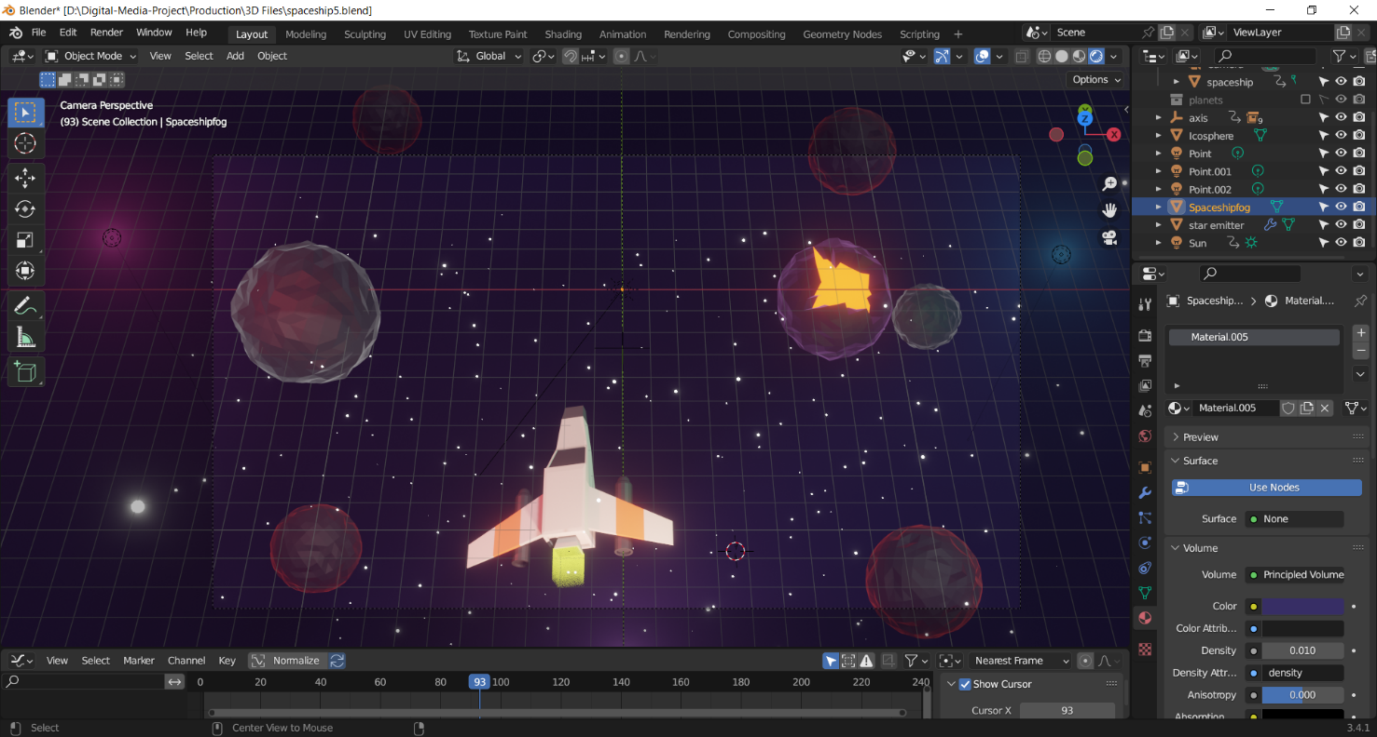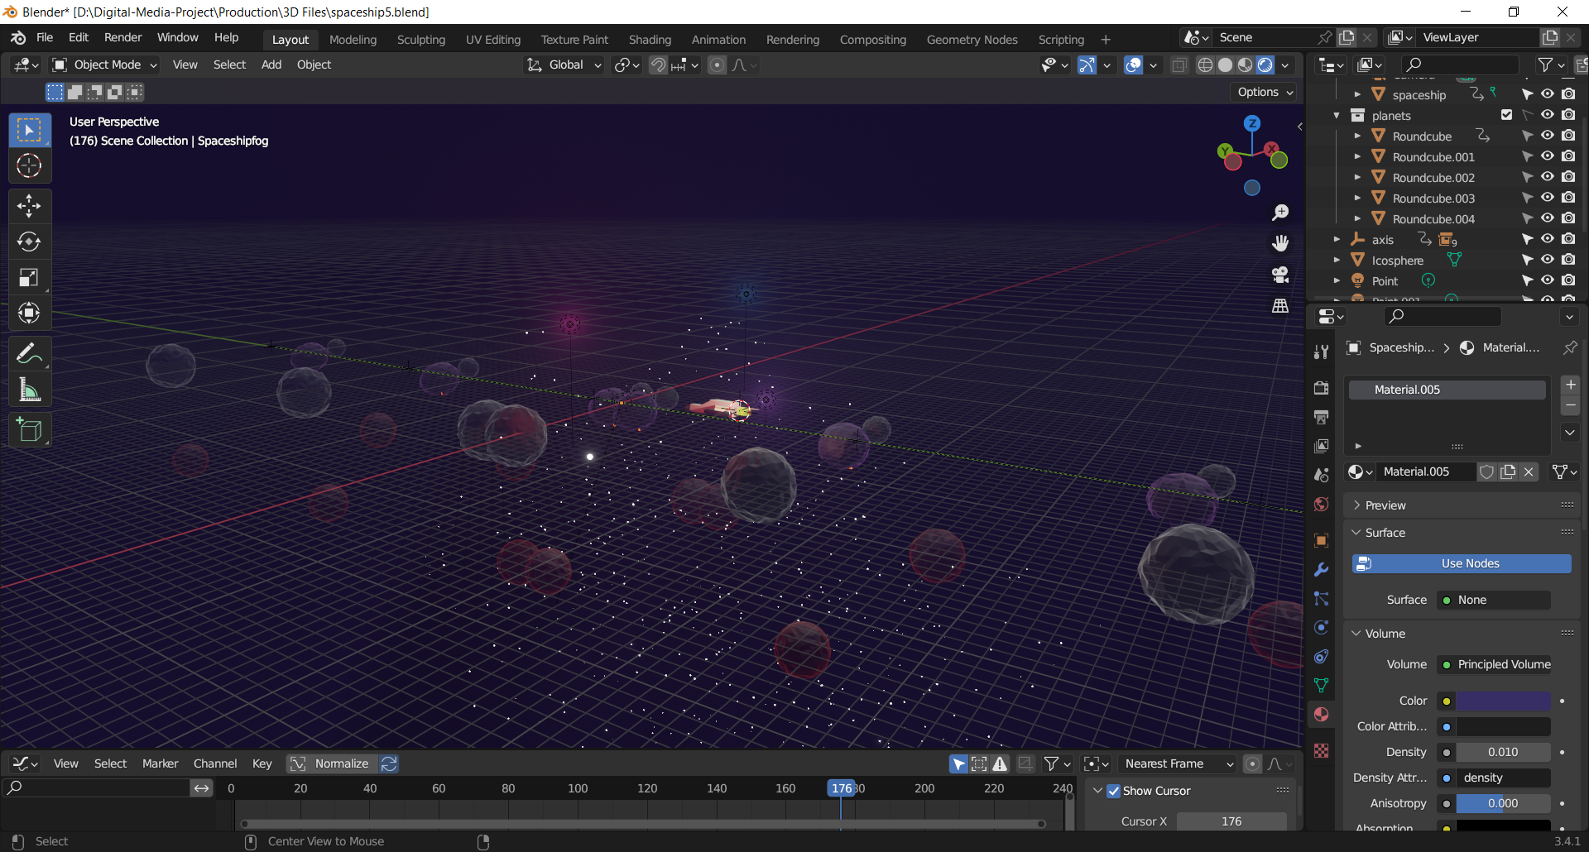

Figure Final output

### 8.2.7 Low poly stylized campfire

The last and final asset for my project is a campfire pack. For this, I wanted to create a night fire camp in the forest. So, first I started with the particle effect for creating fire. I created a cube and then resized it and froze its scale. After that I created a plane and resized it, and made it transparent. After that I duplicated the cube onto four other objects. Each one of them were going to be used to create parts of the flame. The first one was going to be the bottom, the second the middle flame, the third and ember and the fourth the upper part of the flame.

I then instanced the flame to the particles and set the number of particles to 1000. On the emission tab I set the lifespan to start from 1 to 540 frames. I set the velocity to 0 and gravity to -0.1. I set the scale render to 0.4.

For the shader, I created a procedural ramp texture, and set it as Blend. I set the value of Coordinates to Strand/Particles. This allowed me to map the texture on the background by using normalized strand texture coordinates on the axes. Then on the color ramp I added three different ramps and manipulated them to my liking.

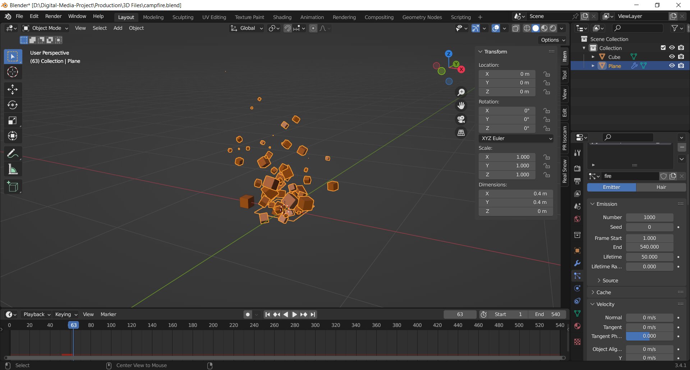

Figure adjusting the values for emitter

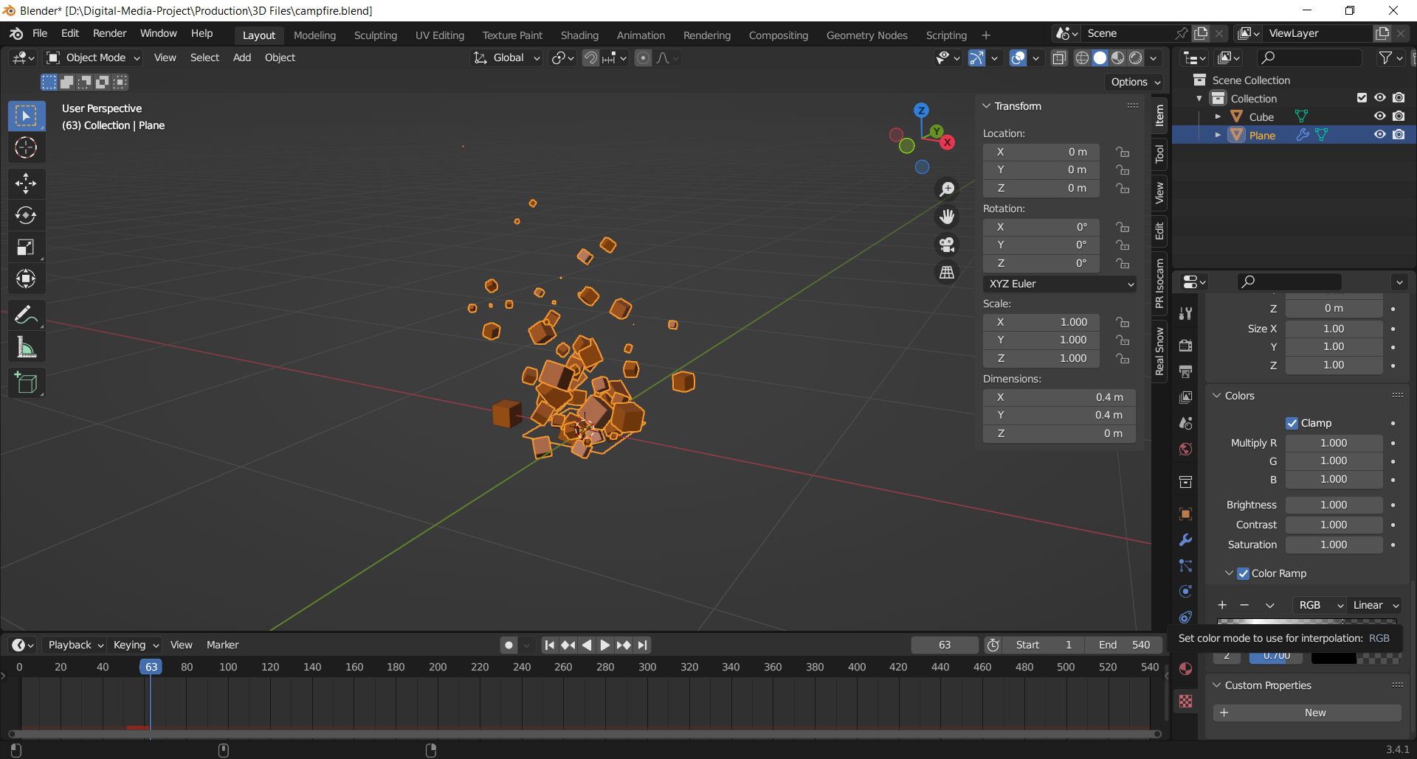

After that I used the same properties for all three others by duplicating their particle systems, and manipulating their color ramp to my liking. I also created a low poly stone with the use of a bisect tool to add details, like my previous pack for this modelling as well I set the origin of the model from median point to 3D cursor which allowed me to duplicate and rotate the object. Then shortly, I added a plane to the surface below.

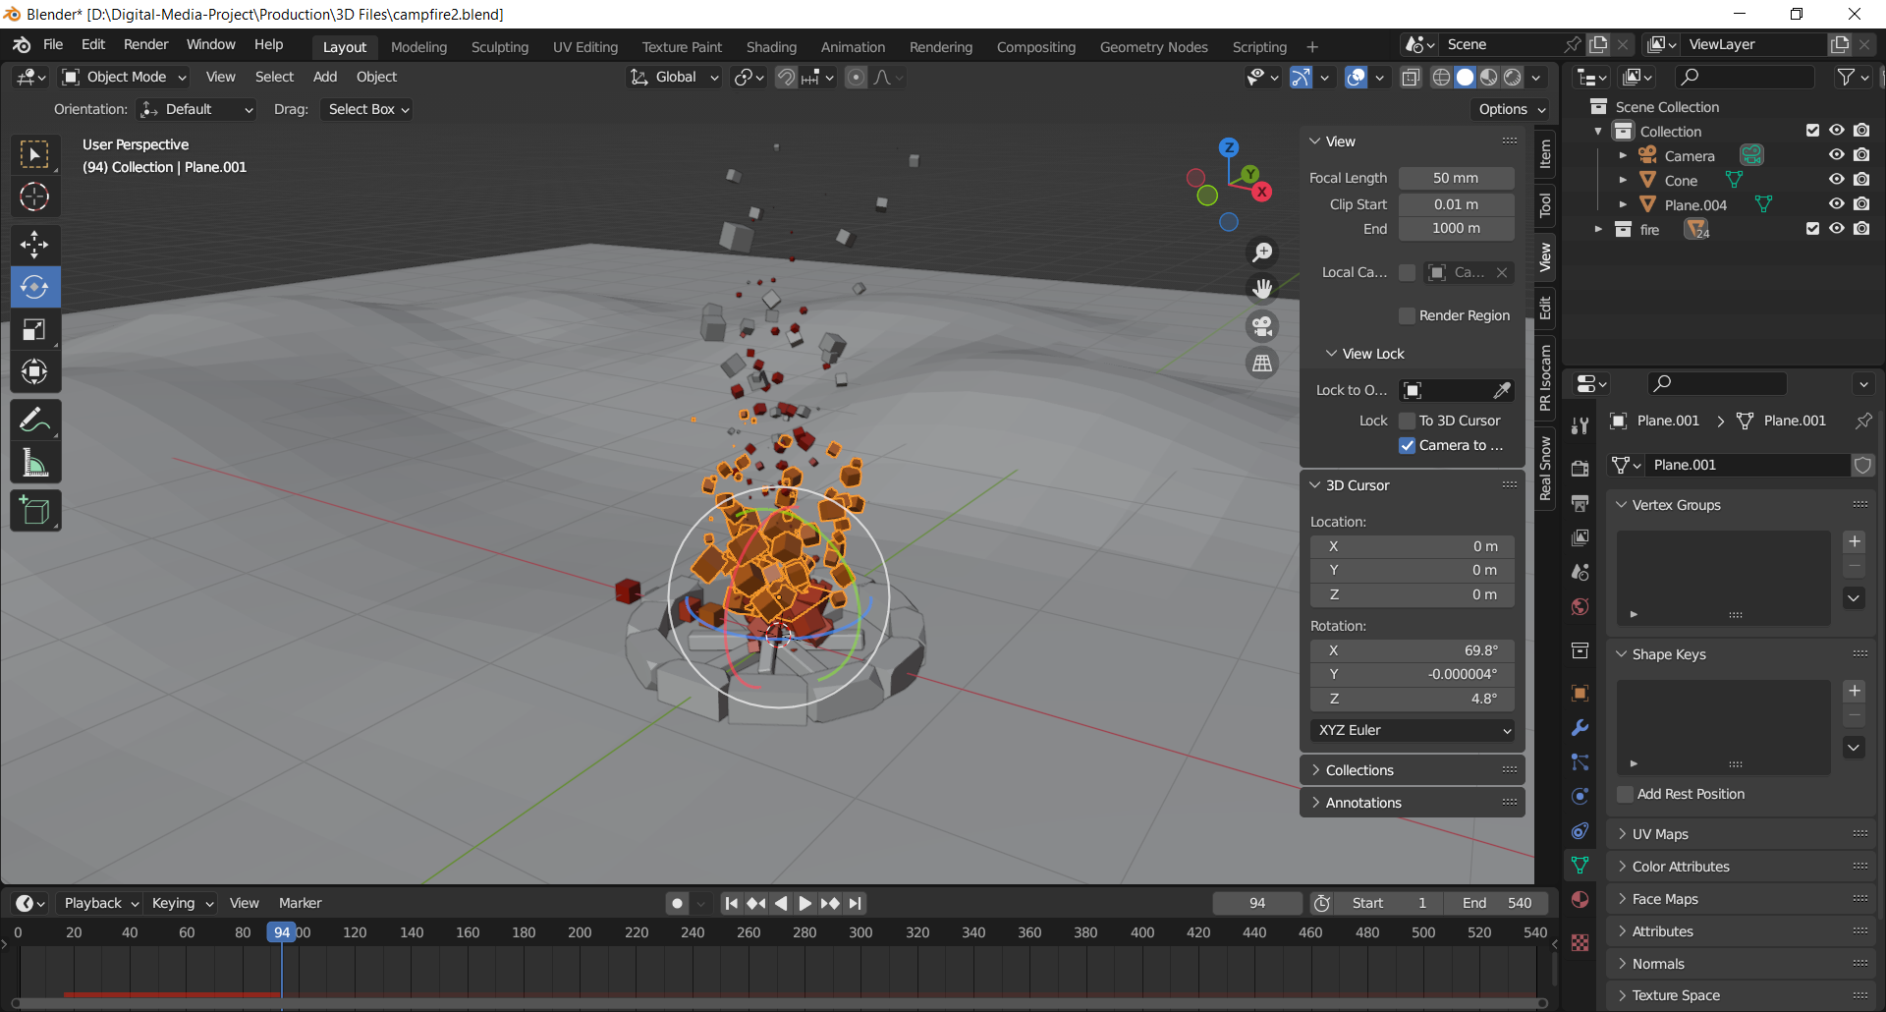

For the ground to make it rougher and terrain look, I selected the faces at random through the use of proportional editing, and used it to elevate the faces.

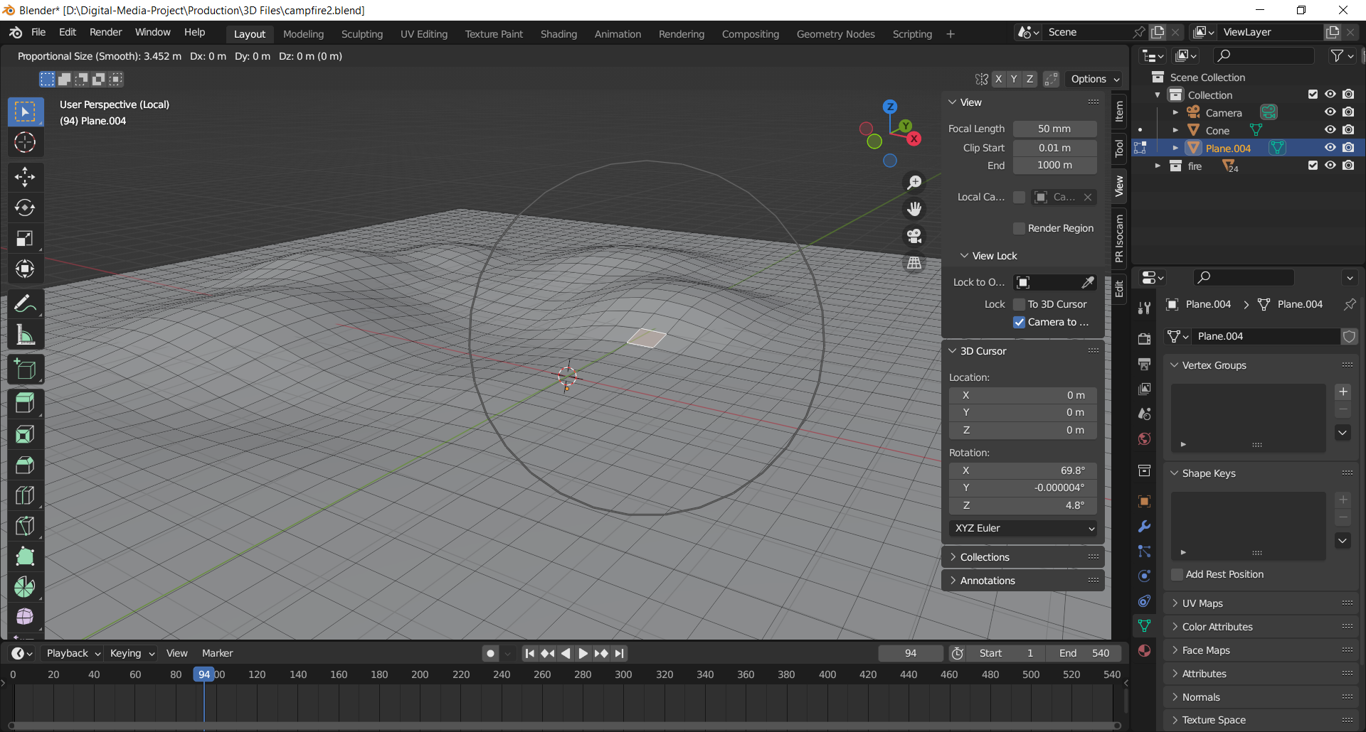

Figure creating the plane using proportional editing

I then moved onto the modelling of pine trees for the forest. I modelled a very common and one of the most used pine trees designs for the project. To give them more realistic look I selected the faces at random and used proportional editing to shake their design up.

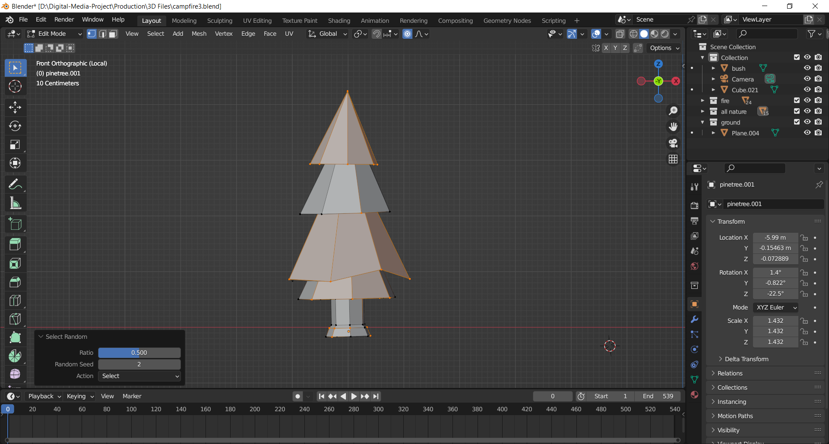

I then set the camera to a perspective view of 120mm of focal length to capture the scene.

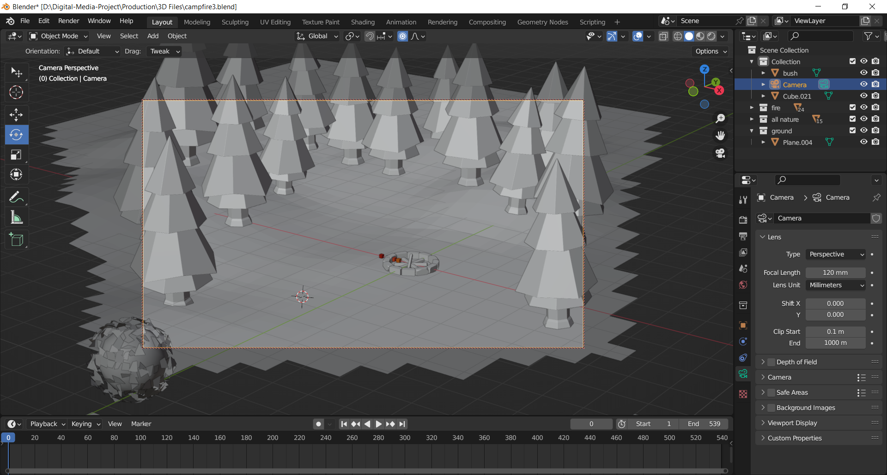

Then, after that I wanted model bushes and animate them blowing. So, I added an icosphere and manipulated its setting. I then duplicated it selected the faces at random and deleted them, to create an outline of vines and grasses.

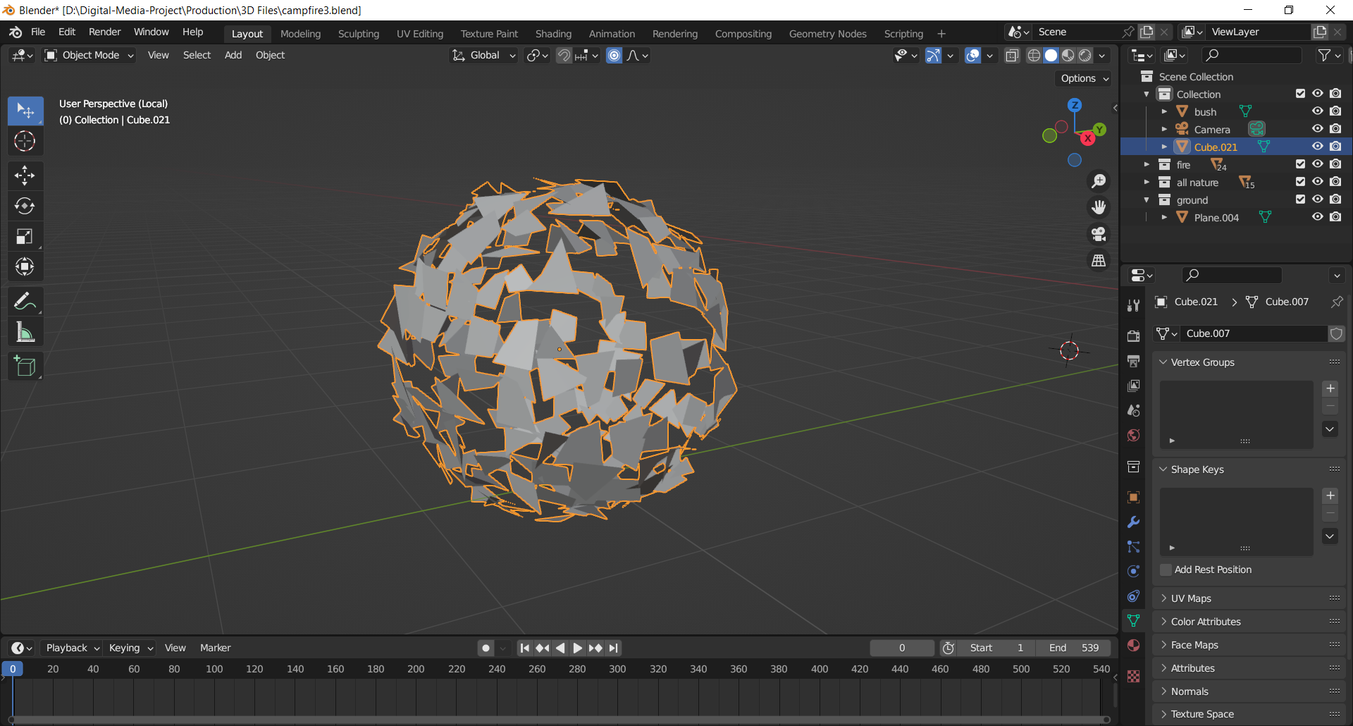

After that I combined them together into one whole mesh. I then added a displace modifier to it. For that I firstly added an empty axis and paired it with it. After that I applied the modifier to the axis, I set the procedural texture as to clouds. This created a field to reshape the objects geometry. This allowed me to maintain its strength which controlled the intensity at which the bush moved. I then duplicated the bush two other times which, was reshaped and resized to fit into the scenery.

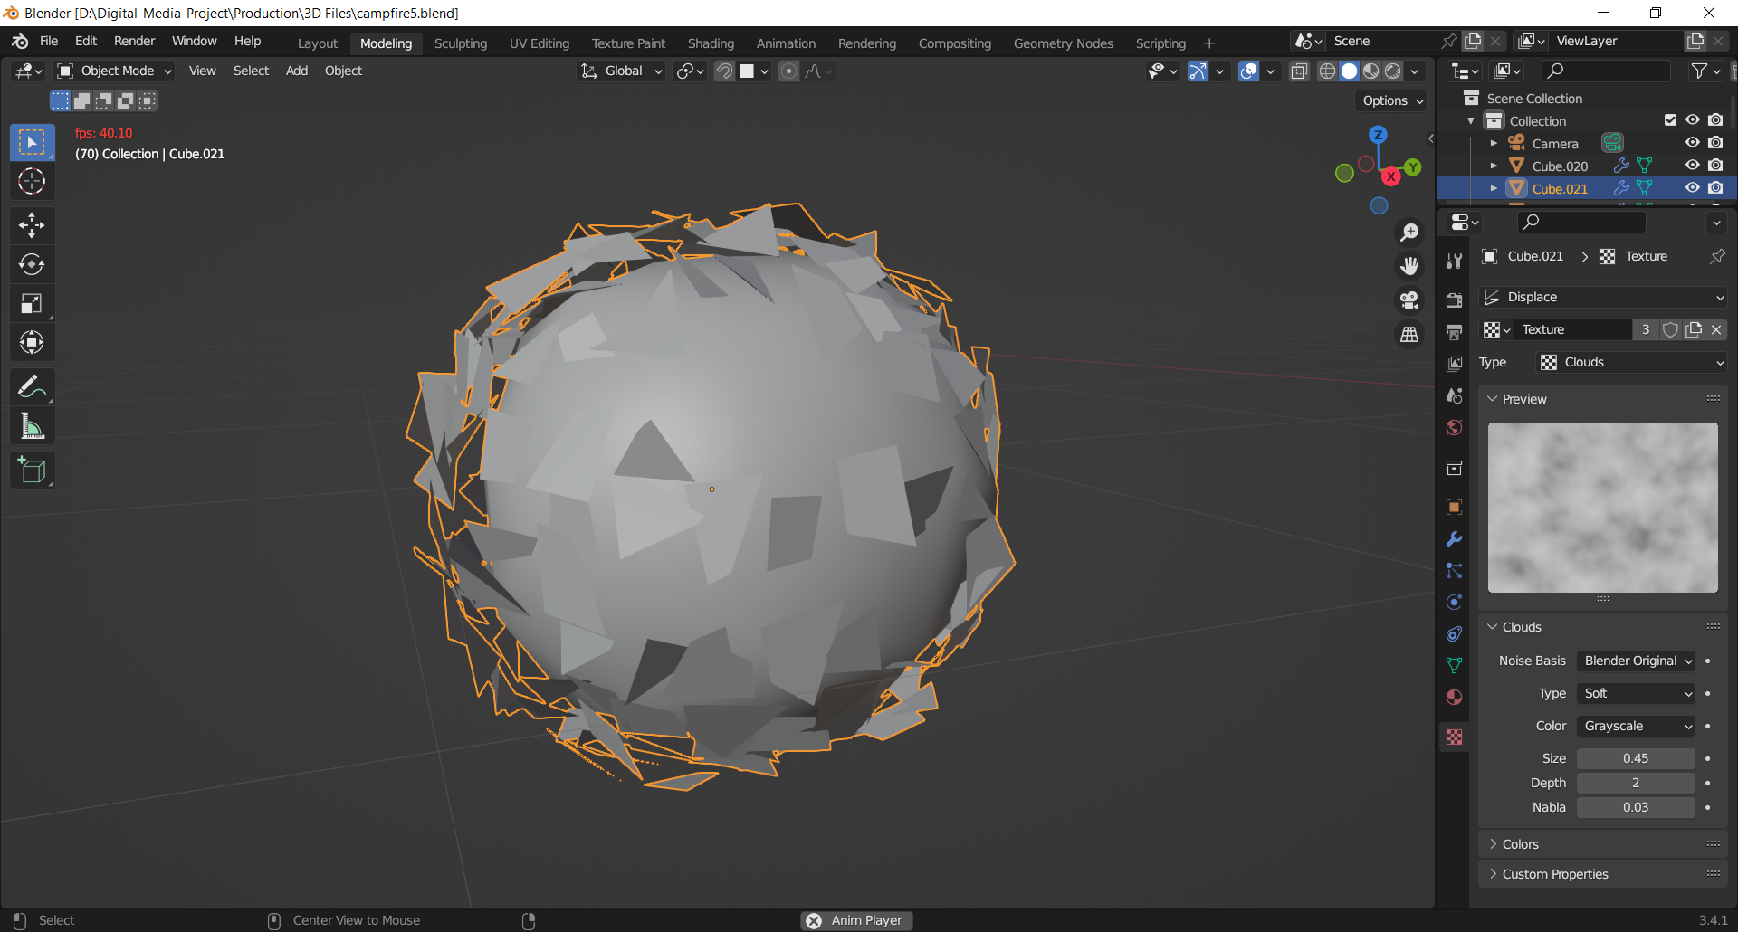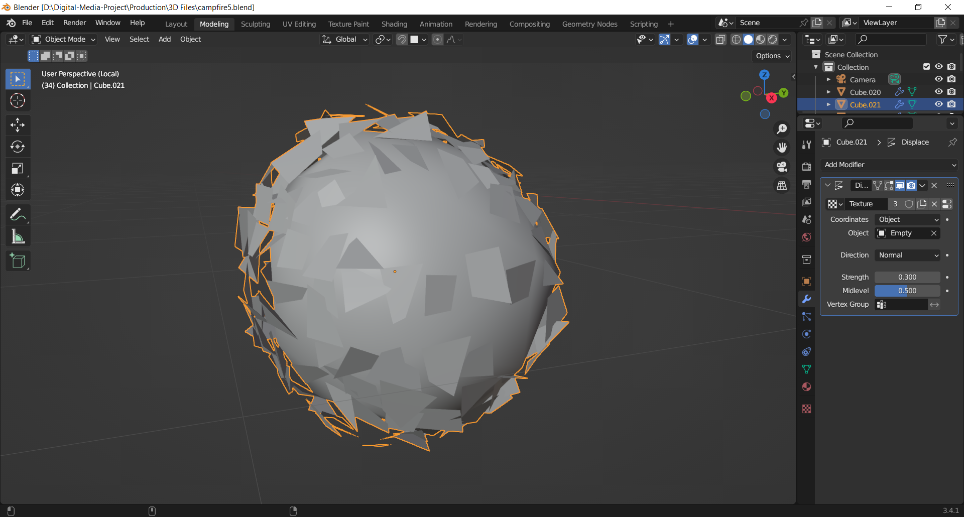

Figure adding displace texture

Then I modelled a log as well, for this I sed a cylinder and applied bevel to its edges. Then, I positioned it in accordance to my environment. I also placed low poly stones and grass to make the scene completely look like a forest.

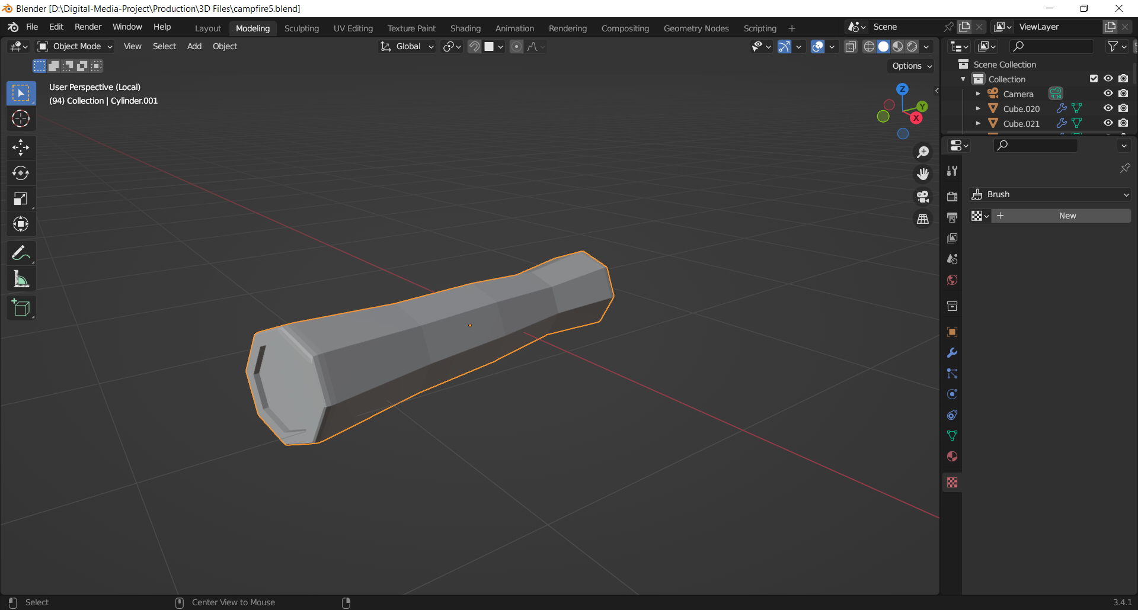

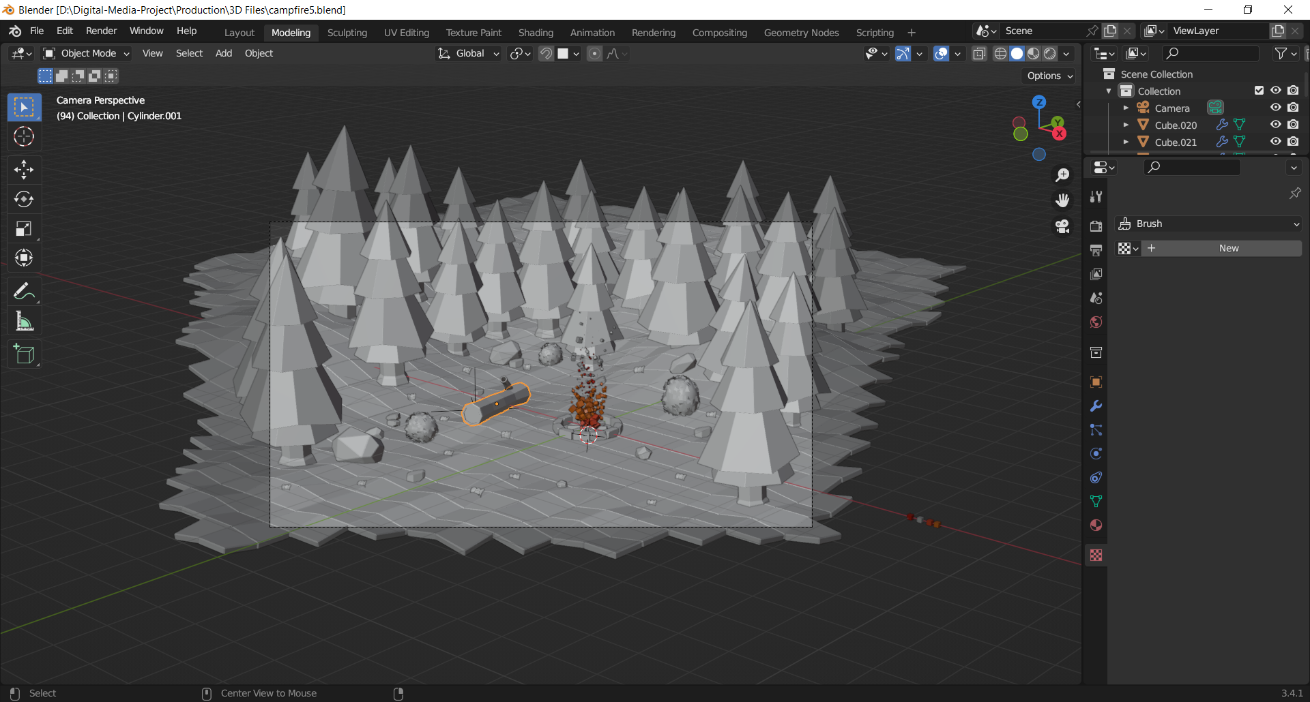

After completing the modelling aspect of the scene, I moved on to the shader tab. For the ground I PBR shader followed on by a multiply shader which was connected to the color ramp. The mapping node which was connected to the Gradient texture was manipulated on the scales of x- axis. Then after adding two ramps to the color ramp and setting up their value, I connected the node to the multiply node which was also connected to the base color of the Principal BDSF.

In order to make two parts of the grass have distinct colors, I had to firstly select the faces at random and make every one of the polygons independent. So, I added another two shaders. I added an Object Info node and another Color Ramp node. I then connected the color of the color ramp to the one of the two sections of the previous used the multiple node. This allowed me to make a checker box for the ground. I could play with colors in the color ramp, so I added two nodes which and made one part of the grass darker and the other lighter.

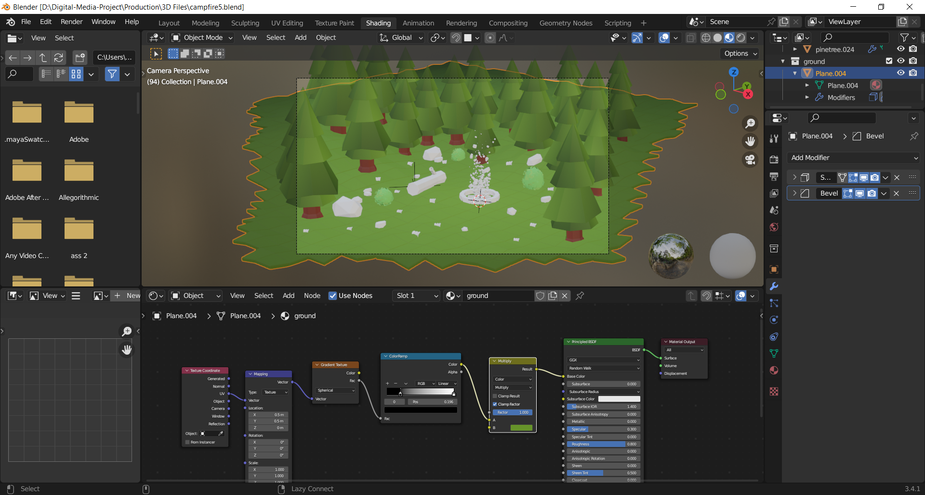

Figure using the multiply shader

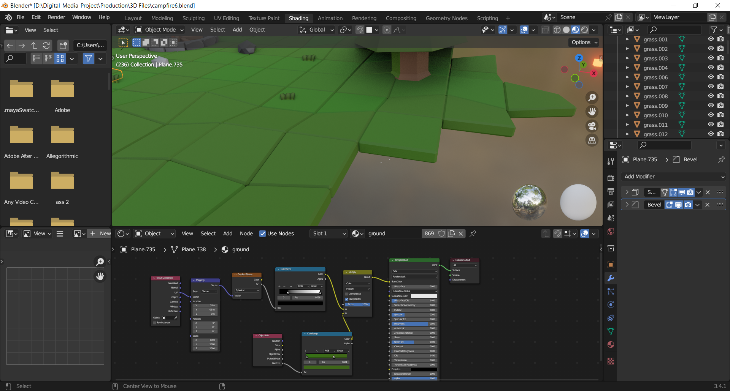

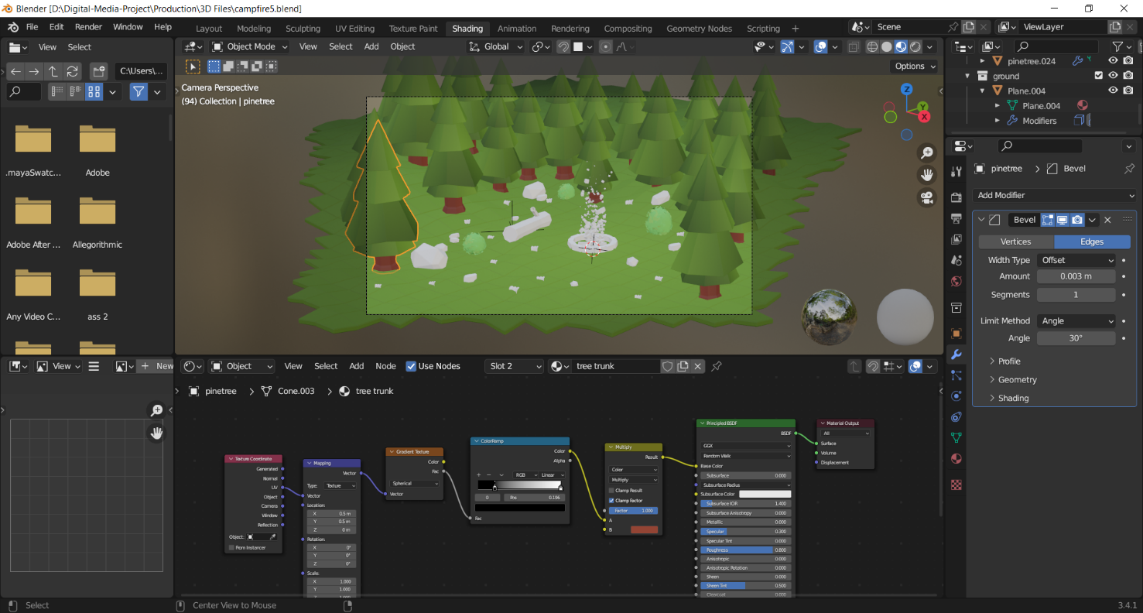I duplicated the same shader for the tree as well and changed its value. For the tree trunk I changed the base color from green to dark brown.

Figure duplicating and adjusting the materials

I again duplicated the same shader for the grass and stones as well, and altered their colors at the color ramp. I did the same as well for the logs, the tree branch and the stones sued for lighting up the fire. Then, I added texture to both meshes of the bush which were combined together.

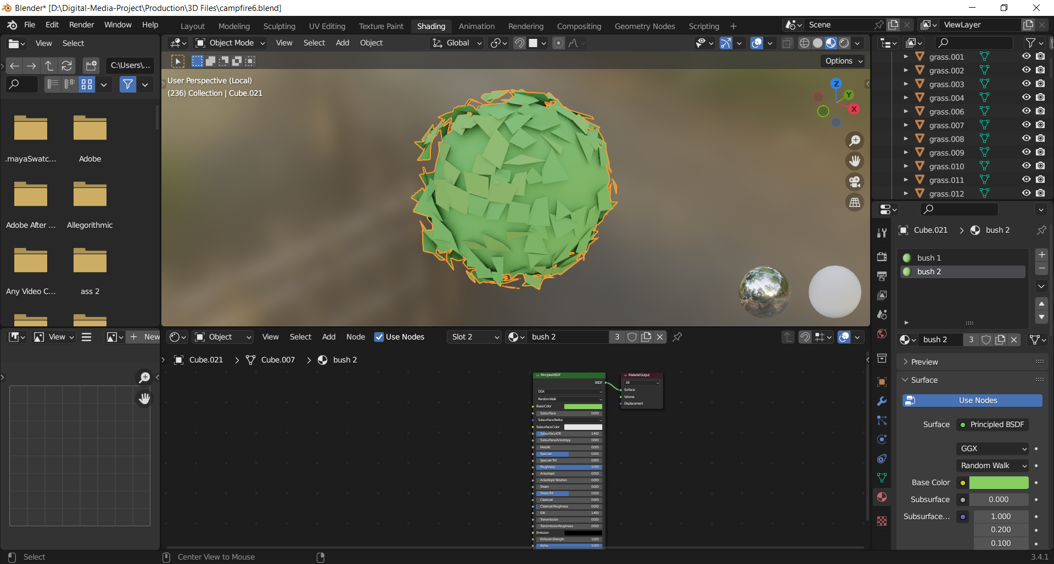

Figure applying shader to bush

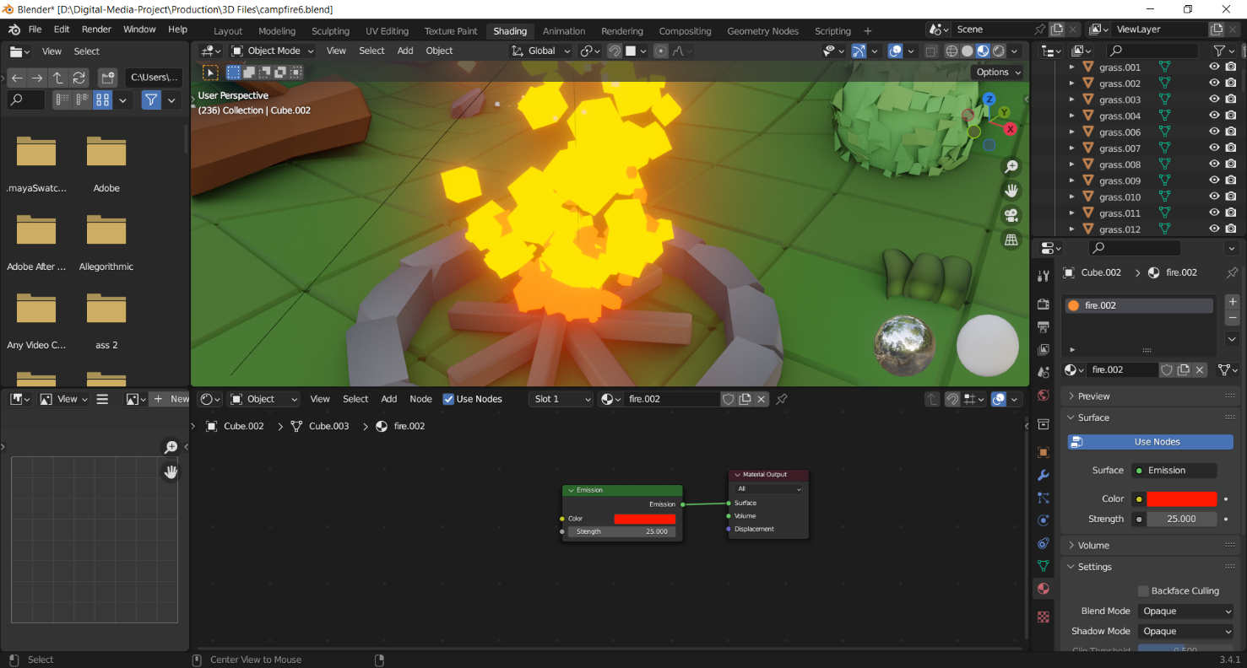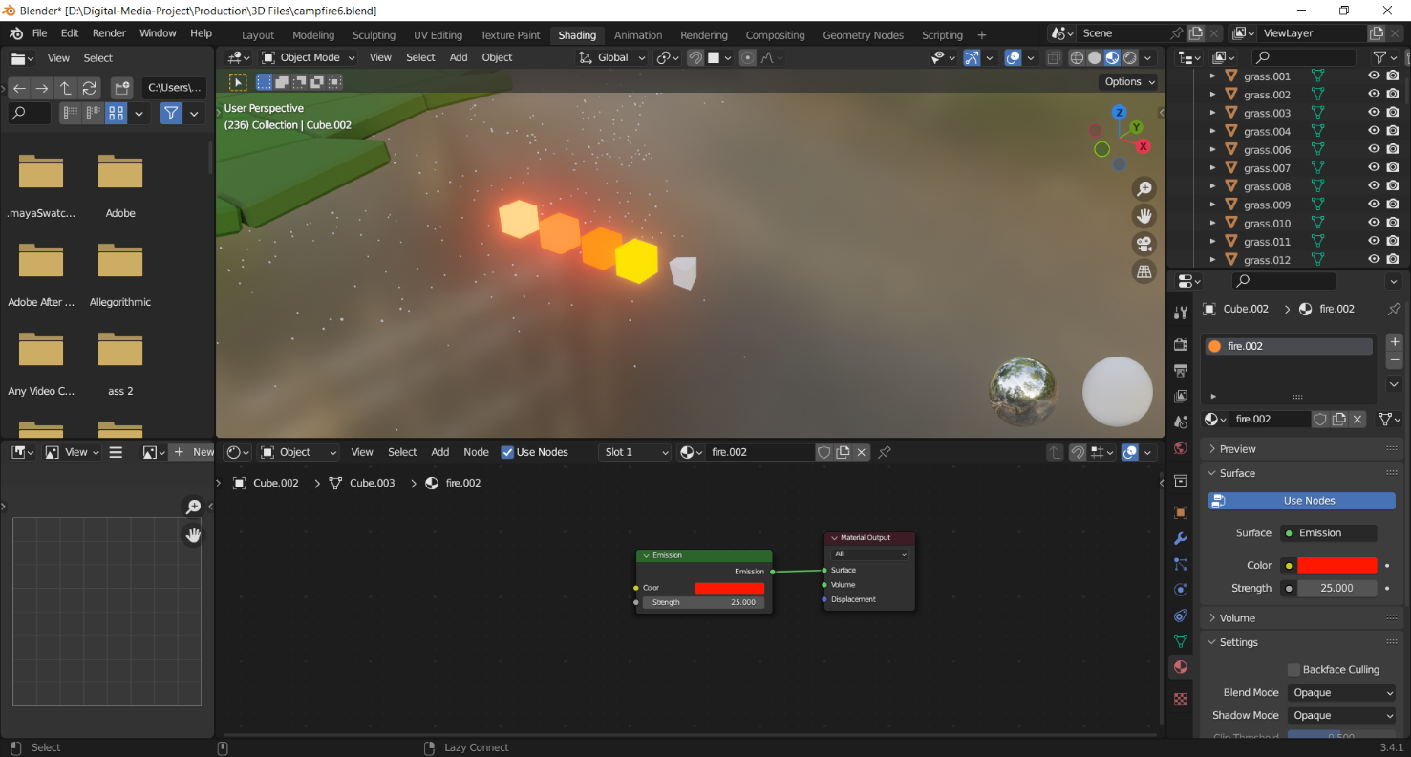I then added emission to all the four particle effects of the flames. To make them glow I set the value of their strength to 25 turned on the bloom on the render settings.

Figure applying shader to fire

After the shading for the models were completed, I wanted to add dust particles and fog to the scene. Since, the scene on this environment is supposed to be a windy night time, I used a cube and disconnected its shader. I then applied principled volume to its volume setting. Then, I played with the value of the density and changed the color to fit a more night environment.

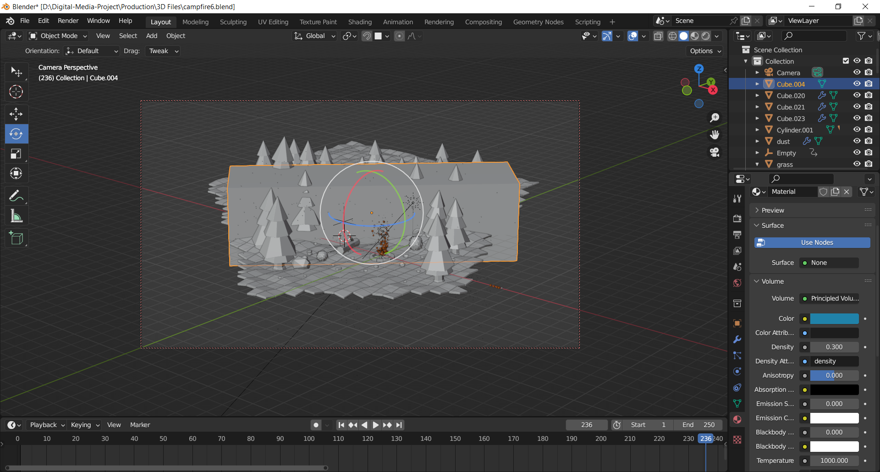

Figure adding cube for fog

I then used a single sun light and positioned it above on a 30-degree angle and set the color to light blue and the strength to 0.6 to match with my environment. I also set the background to in contrast to my lighting which blended well together. I also added a point light above the fire to cast shadow around its surrounding and added animation for the movement. To manage the shadow, I went onto the clip start option and decreased its value.

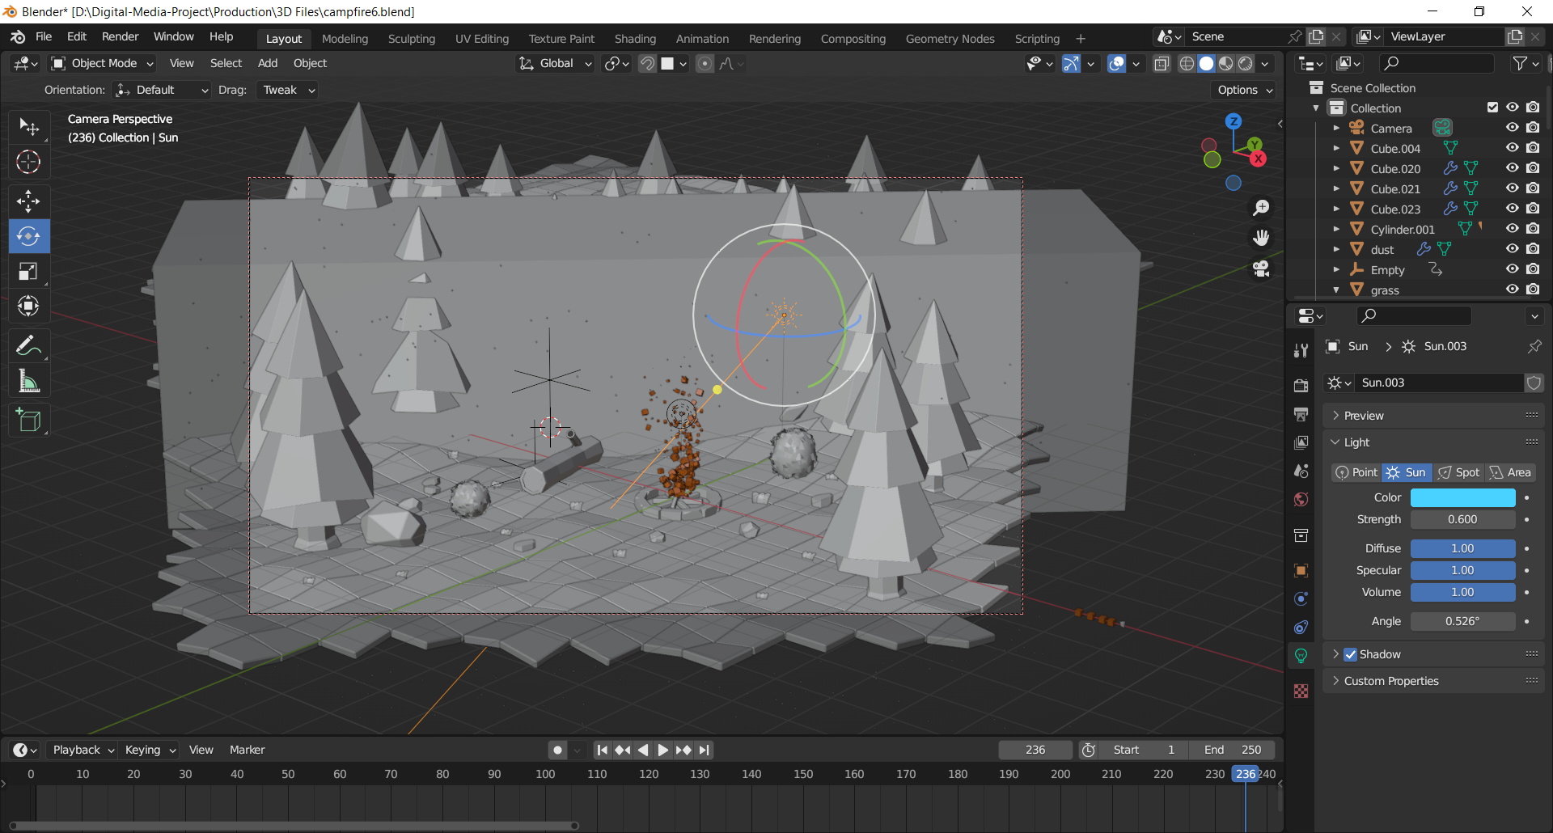

Figure adjusting the light

Then to add dust particles to my scene, I used an icosphere. Afterwards, I resized and scaled it down and froze the scale. Then I modelled a cube and made it big enough with to blend well with my models. For this cube as well, I disconnected the shader, set it on as a principle volume on its volume setting and manipulated the color and density to match with its surrounding. In addition, I set the Blend mode and shadow mode to Opaque to make it transparent. Because the dust particle animation needs to happen after the flames have already been fired, I set the frame range to 70, as this is where the flames have already blazed on.

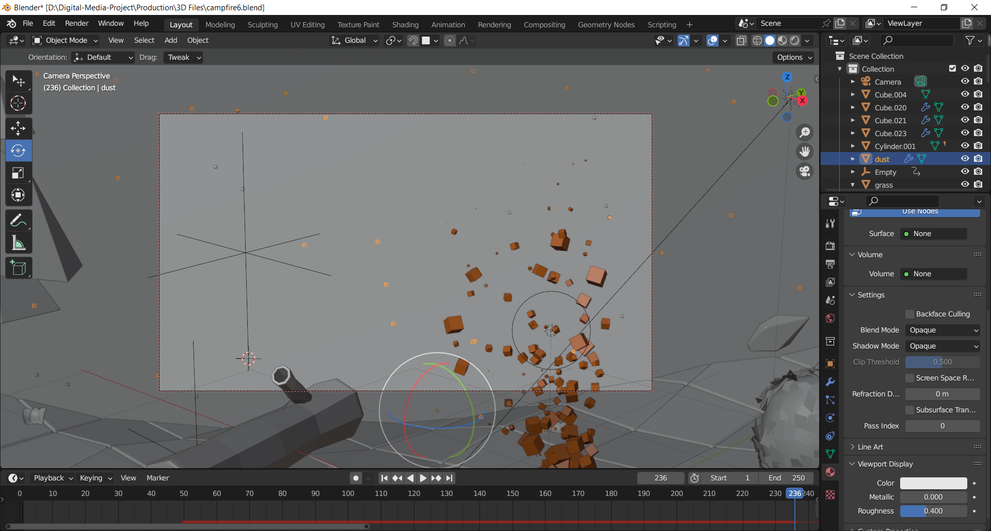

Figure checking the scene

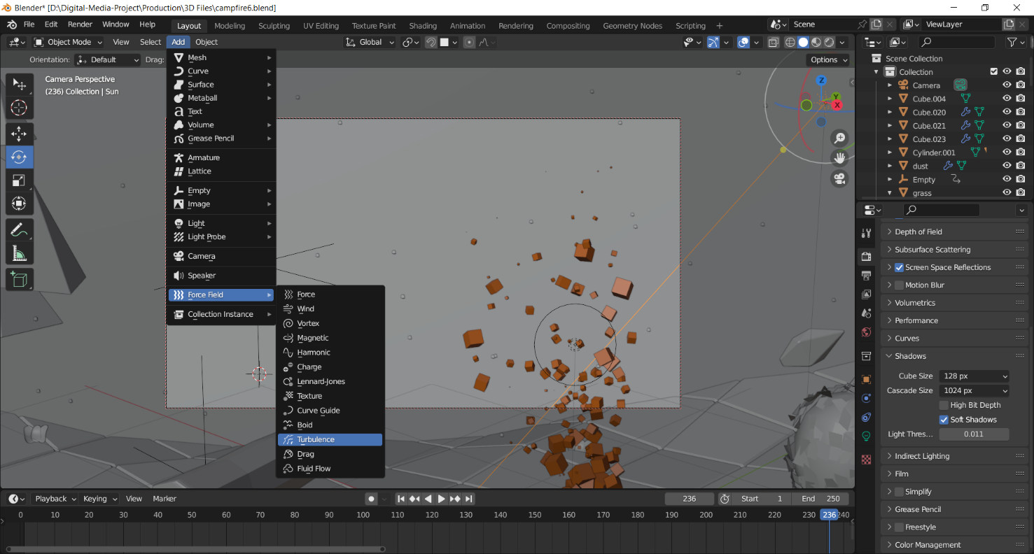Since, the gravity was turned off for the dust particles, I added a turbulence and manipulated its setting accordingly to my scenery.

Figure adding turbulence

After all the lighting and shading was completed, it was time to set the value for rendering. I set the value of render and viewport sampling to 120 per pixels. I also turned on Ambient occlusion, Bloom to make the dust particles and the fire to glow up and screen space reflections which calculates the total reflections. I also set the shadows cube size to 128px and Light Threshold to 0.011.

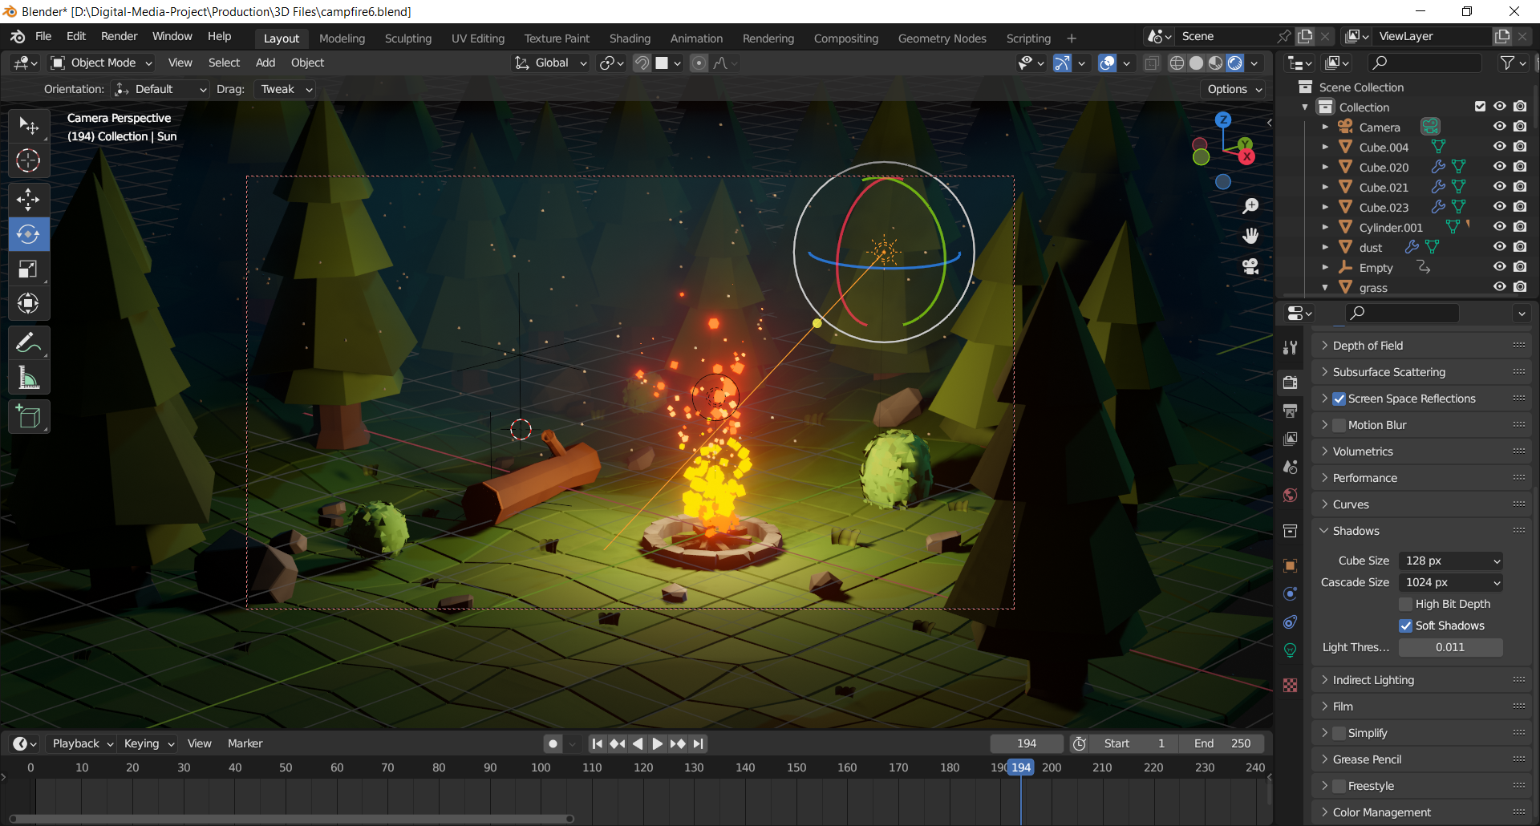

Figure final output

## 8.3 Post Production

# 9. Conclusion

This concluded the 50% documentation for Digital media project. This coursework has described all about the game assets, it’s history and research of game development, how it has grown in the modern world along with its scope.

This project has required concentration and dedication on every level of it’s production phase. This project has helped me learn and gain knowledge of the utilization of assets in the indie game industry. It helped me in understanding about the scope and capabilities of my project. I hope to put my skills and knowledge in my future work.

# 10. Bibliography

Abbitt, G. (2021, 04 21). *3 Vital Tips to Improve Low Poly Work*. Retrieved from YouTube: https://www.youtube.com/watch?v=xOIQzgg5ebs&ab_channel=GrantAbbitt

Blender. (n.d.). Retrieved from https://docs.blender.org/manual/en/latest/render/eevee/introduction.html

Blender. (2019, 02 12). *Three Point Lighting - Blender 2.80 Fundamentals*. Retrieved from YouTube: https://www.youtube.com/watch?v=RDbrOpnIY7Q&ab_channel=Blender

brainchildpl. (2020, 07 10). *TIMELAPSE - Lowpoly VIKING hut | Blender Speed Modeling*. Retrieved from YouTube: https://www.youtube.com/watch?v=tv9KojMy5P4&t=492s&ab_channel=brainchildpl

ex NIHILO digital. (n.d.). *HOW TO USE THE KNIFE TOOL IN BLENDER*. Retrieved from ex NIHILO digital: https://exnihilodigital.com/tutorials/knife-tool/

Kottmann, N. (2020, 11 09). *Stylized Smoke with Curves | Curves Encyclopedia in Blender Chapter 06*. Retrieved from YouTube: https://www.youtube.com/watch?v=RyLt83yPT7Y&t=259s&ab_channel=NikKottmann

Nguyen, L. (2022, 05 07). *How to copy animation data from one object to another in Blender*. Retrieved from Render GPU: https://irendering.net/how-to-copy-animation-data-from-one-object-to-another-in-blender/

Pluralsight. (2014, 01 06). *All About the 3-Point Lighting Technique for 3D Visualizations*. Retrieved from PLURALSIGHT: https://www.pluralsight.com/blog/film-games/understanding-three-point-lighting

STYLY MAGAZINE. (2020, 08 11). *Blender 2.8: Introduction to Shader Editor*. Retrieved from STYLY MAGAZINE: https://styly.cc/tips/blender_shader_beginner/